**The Collation and Graphical Representation of Magnetometer Data to Track Solar Activity Using a Web-Based Application**

Final Report for CS39440 Major Project

*Author*: Oliver Roy Thomas Earl (ole4@aber.ac.uk)

*Supervisor*: Mr. Dave Price (dap@aber.ac.uk)

8th May 2018

Version 1.2 (Release)

This report is submitted as partial fulfilment of a BSc degree in  
Computer Science with German (G4R2)

Department of Computer Science

Aberystwyth University

Aberystwyth

Ceredigion

SY23 3DB

Wales, United Kingdom

**Declaration of Originality**

I confirm that:

* This submission is my own work, except where clearly indicated.
* I understand that there are severe penalties for Unacceptable Academic Practice, which can lead to loss of marks or even the withholding of a degree.
* I have read the regulations on Unacceptable Academic Practice from the University’s Academic Quality and Records Office (AQRO) and the relevant sections of the current Student Handbook of the Department of Computer Science.
* In submitting this work, I understand and agree to abide by the University’s regulations governing these issues.

Name Mr. Oliver R.T. Earl

Date 24/04/2018

**Consent to share this work**

By including my name below, I hereby agree to this dissertation being made available to other students and academic staff of the Department of Computer Science, Aberystwyth University.

Name Mr. Oliver R.T. Earl

Date 24/04/2018

**Acknowledgements**

I dedicate this work to my Mum, to my Dad, to my Nan, to my brother Thomas, to my sister Phoebe, to my three pug-dogs Toby, Toffee, and Luna, and naturally to the farthest reaches of my extended family.

I am grateful to academic and technical staff from the Institute of Mathematics, Physics, and Computer Science at Aberystwyth University for taking the time out to talk to me about my project, most notably regarding retrieving measurements from amateur radio-based equipment and the magnetometer itself.

Additionally, I am thankful for the patience and understanding of academic staff from both the Department of Computer Science and the Department of Modern Languages at Aberystwyth University as I attempted to juggle both major and minor disciplines of my undergraduate degree over these last few years, especially when both my appearance and outward behaviour were oftentimes dictated by a combination of sleep deprivation, and perhaps slightly excessive caffeine consumption.

Furthermore, I wish to express my sincerest gratitude to Dave Price who enthusiastically agreed to be my supervisor for this Major Project. Despite my stress, which was sometimes overwhelming, he was incredibly approachable and reassuring, a refreshing source of encouragement, particularly towards the end, and granted me a large amount of flexibility with this endeavour.

Thank you to my colleagues at Aberystwyth University, Aberystwyth University Students’ Union, Aberystwyth Nightline, and the Nightline Association for their pertinacious support and sense of purpose that they have bestowed upon me during my time as an undergraduate.

Finally, I wish to extend my deepest and most heartfelt thanks to my beloved friends cheering me on, or at least photoshopping my face onto memes, either here with me in Wales or wherever they might be in the world.   
  
Thank you very much.

*Vielen herzlichen Dank.*

*Diolch yn fawr iawn.*

**Abstract**

The Institute for Mathematics, Physics, and Computer Science (IMPACS) at Aberystwyth University make use of an FGM-3 magnetometer (Appendix D), currently based, at this time of writing, on Frongoch Farm in Aberystwyth, free of any electromagnetic interference. The purpose of the instrument is to periodically take a measurement of the Earth’s magnetic field – data that can be analysed by researchers and students during solar events and disturbances such as solar flares and coronal mass ejections, to explore the impact these events may have on the Earth’s magnetosphere [1].

The aim of this project is to produce a web-based application that can retrieve data from the remotely-hosted magnetometer instrument and make it more readily available to the aforementioned students and staff, both in the form of a web-based application where data can be explored and graphically represented, as well as programmatically, by the use of an API (Application Programming Interface) [2] capable of converting and returning desired data into a significantly more processible form, such as JSON. (JavaScript Object Notation) [3]

This is a far preferable outcome to the current process of data retrieval: consisting of manually connecting to a file share hosted by the computer directly linked to the magnetometer, retrieving unlabelled CSV (Comma Separated Value) files, and manually extracting the data. For second year Physics undergraduate students, who often undertake assignments involving this data (Appendix C), this is incredibly timesaving.

The web application, coined *Borealis*, can establish a connection to the computer, and retrieve new entries from the magnetometer each day when the log is complete. This data is then refined, collated, and stored in a relational database. While the core application is complete and functional, additional functionality involving connectivity to further data sources were originally planned and could be implemented in further iterations of the software.

*Keywords*: magnetometer, magnetosphere, magnetic field, solar activity, web application, Chart.js, API, graphing

**Contents**

1. Background, Analysis & Process 10

1.1. Background 10

1.1.1. Introduction 10

1.1.2. Personal Motivation 10

1.2. Project Analysis 11

1.2.1. Project Aims 11

1.2.2. Foreseen Constraints 12

1.3. Process Methodology 13

1.3.1. Initial Plans and Scrum 13

1.3.2. Migration to Feature-Driven Development 15

2. Design 16

2.1. Programming Languages, Frameworks, and Libraries 16

2.1.1. Introduction 16

2.1.2. PHP 16

2.1.3. Python 16

2.1.4. Node.js 17

2.1.5. Ruby 17

2.1.6. Miscellaneous Technologies 17

2.1.7. Frontend Languages and Frameworks 17

2.1.8. Final Decision 18

2.2. Persistent Storage 18

2.3. Development Environment 19

2.4. Security Requirements 20

2.5. Version Control 21

2.6. Overall Design 21

2.6.1. Introduction 21

2.6.2. Architectural Pattern 22

2.6.3. Intended Structure 23

2.7. Feature List 24

2.8. Detailed Design 25

2.8.1. Introduction 25

2.8.2. Composer Autoloader 26

2.8.3. Magneto 27

2.8.4. Config 30

2.8.5. Connector 33

2.8.6. Locale 34

2.8.7. Renderer 36

2.8.8. Retriever 39

2.8.9. Magnetometer 42

2.8.10. MagnetometerController 43

2.8.11. API 46

2.8.12. DataSource and InternetData 48

2.8.13. Directory Structure 49

2.9. Development Order 50

2.10. Relationships and Dependencies 50

2.11. Use Cases 52

2.12. User Interface Design 53

2.12.1. Introduction 53

2.12.2. Twig Template Engine 53

2.12.3. Bootstrap 4 and Theme 54

2.12.4. Conceptual Designs 54

2.12.5. Final Designs 54

2.12.5.1. Homepage and About 54

2.12.5.2. Navigator 55

2.12.5.3. Graphing Tool View 56

2.12.5.4. Tables View 57

2.12.5.5. Settings 57

2.12.5.6. API 58

3. Implementation 59

3.1. Introduction 59

3.2. Configuration Changes 59

3.3. SMB Connectivity 60

3.4. Retrieving Magnetometer Data and Data Depth 61

3.5. Overcoming PHP 7.x.x Conditioning 62

3.6. Template Debugging 63

3.7. Additional Data Sources 64

3.8. Navigator jQuery 64

3.9. PHPDoc 64

3.10. Review of Implementation Stage 64

4. Testing 65

4.1. Overall Approach to Testing 65

4.2. Software-Aided Testing 65

4.2.1. Unit Testing 65

4.2.2. Linting 65

4.2.3. Difficulties Encountered 66

4.3. Manual Testing 66

4.3.1. Graphing Interface Testing 66

4.3.2. Stress Testing 66

4.4. API Testing 67

4.5. Known Bugs 67

5. Critical Evaluation 68

5.1. Introduction 68

5.2. Identification of Requirements 68

5.3. Design and Implementation Retrospective 69

5.4. Suitability of Tools 69

5.5. Code Quality 70

5.6. Project Achievements 70

5.6.1. Short Analysis of Data Findings 70

5.6.2. Adaptability 72

5.6.3. Emotional Resilience and Self-Motivation 72

5.7. Project Shortcomings 72

5.7.1. Discipline in Agile Methodology 72

5.7.2. Workflow and Continuous Integration 73

5.7.3. Further Improvements to Testing 74

5.8. Project Conclusion 74

6. Appendices 77

A. Third-Party Code and Libraries 77

B. Ethics Submission 78

C. Undergraduate Classwork by D. Langstaff 80

D. FGM-3 Magnetometer Technical Documentation 84

E. Hand-Drawn Conceptual Designs for Graphing Tool and Navigator Views 107

F. Apology email to Information Services following web server downtime caused by excessive data consumption 109

G. PHPUnit Test Results 110

H. Linting Results 111

I. Manual Testing Table 120

J. Stress Test Table 122

K. API Testing Table 124

7. Annotated Bibliography 125

**Table of Figures**

Figure 1‑1 Feature-Driven Development Process Model[27] 15

Figure 2‑1 Central system information as viewed from PuTTY on Windows. 20

Figure 2‑2 Example commits within the project Git repository. 21

Figure 2‑3 Model-View-Controller Architectural Pattern [51] 22

Figure 2‑4 Rudimentary initial UML (Unified Modelling Language) diagram demonstrating data flow and separation of concerns. 23

Figure 2‑5 Autoload subsection of the composer.json file. 26

Figure 2‑6 Autogenerated Magneto Class Diagram. 27

Figure 2‑7 CSRF Watchdog Private Method. 28

Figure 2‑8 Error Public Static Method. 29

Figure 2‑9 Autogenerated Config Class Diagram. 30

Figure 2‑10 Graphing Tool Debugger that becomes available when the debug flag is set. 33

Figure 2‑11 Autogenerated Connector Class Diagram. 33

Figure 2‑12 Private database property and characteristic singleton instance Public Static Method. 34

Figure 2‑13 Autogenerated Locale Class Diagram. 34

Figure 2‑14 Sequence Diagram for Language Determination algorithm. 35

Figure 2‑15 Public Static Method for setting program locale. 36

Figure 2‑16 Autogenerated Renderer Class Diagram. 37

Figure 2‑17 route() switch case for graph, demonstrating what methods are called and what data is injected into the view prior to rendering. 38

Figure 2‑18 Reset Session Private Method 38

Figure 2‑19 Autogenerated Retriever Class Diagram. 39

Figure 2‑20 Retrieve Data Public Method. Used to begin capturing data from the magnetometer. 40

Figure 2‑21 Process Data Sequence Diagram demonstrating data processing algorithm for retrieved magnetometer data stored in CSV file. 41

Figure 2‑22 Autogenerated Magnetometer Class Diagram. 43

Figure 2‑23 Autogenerated MagnetometerController Class Diagram. 44

Figure 2‑24 Get Objects from IDs Public Method. 44

Figure 2‑25 Get All Public Method Algorithm Sequence Diagram. 45

Figure 2‑26 Autogenerated API Class Diagram. 46

Figure 2‑27 Handle Request Algorithm for API Sequence Diagram. 47

Figure 2‑28 XML Print Private Method, complete with PHP alternative logic syntax. 48

Figure 2‑29 Class Diagram demonstrating relationships between classes. 50

Figure 2‑30 Web Interface vs API Use Case Diagram. 52

Figure 2‑31 Homepage Twig Template. 53

Figure 2‑32 Homepage/About page Design 55

Figure 2‑33 Navigator Design 55

Figure 2‑34 Code snippet from Navigator Twig template demonstrating JavaScript enforcement. 56

Figure 2‑35 Graphing Tool Design 56

Figure 2‑36 Code snippet from Chart Twig Template, demonstrating code insertion 57

Figure 2‑37 Tables View Design 57

Figure 2‑38 Settings Design 58

Figure 2‑39 API Design 58

Figure 3‑1 Git commits showing addition and removal of Writeinifile library displayed in JetBrains PhpStorm. 60

Figure 3‑2 Code snippet from Config Save Config to Disk Private Static Method 60

Figure 3‑3 Code snippet from spike work using the SMB library. 61

Figure 3‑4 Code snippet Previous algorithm for retrieving magnetometer data. 62

Figure 5‑1 Display All View - Displaying All Magnetometer Data 71

# Background, Analysis & Process

## Background

### Introduction

The Institute of Mathematics, Physics, and Computer Science (henceforth IMPACS) have installed a system, consisting of a FGM-3 magnetometer sensor (Appendix D) connected to a Windows workstation in an isolated area of Frongoch Farm, Aberystwyth - off-campus and away from any sources of electromagnetic interference that could affect accuracy. The magnetometer takes measurements approximately every minute – recording data to a CSV (Comma Separated Value) file containing a timestamp, a measurement of the Earth’s magnetosphere, and the temperature of the instrument in Celsius. This type of timestamp is, according to D. Langstaff: ‘A timestamp indicating the number of seconds elapsed since 12:00am Friday, January 1st, 1904.’ (Appendix C). This makes them out to be LabVIEW format timestamps (also notably used by the Apple HFS+ (Hierarchical File System) filesystem) since they use a different epoch (reference date; era) to the more common UNIX format. [4]

The readings taken by the magnetometer are used by researchers and students of IMPACS primarily for following patterns in the Earth’s magnetosphere in response to solar events or disturbances, particularly solar flares [5] – defined by NASA as a ’sudden, rapid, and intense variation of brightness.’ [6] Similar events of note are solar eclipses, and importantly coronal mass ejections – which are described by the National Oceanic and Atmospheric Administration as a ‘large expulsion of plasma and magnetic field from the Sun’s corona.’ [7]

The aforementioned researchers and students are currently required to manually establish a connection to the computer, running Windows 10, directly linked to the FGM-3 by means of mounting a hosted SMB (Server Message Block – a network protocol used for sharing files and printers [8]) share that software running on the computer saves the previously described CSV data files. There is currently no alternative means to programmatically retrieve data. As demonstrated in Appendix C, IMPACS undergraduates are routinely tasked with retrieving data and graphing their findings by hand as part of their learning.

### Personal Motivation

When it became time to decide upon a Major Project topic, two criteria were used to govern the consideration process.

The first is that the project topic would be interesting. Whilst this might be in the eyes of many an obvious and almost mandatory criterion, many undergraduate students both within this year group and of previous years often undertake projects that they believe will highly benefit their academic degree, or their career path, with no genuine interest for the field their topic lies in.

It was of tremendous importance for a topic to be interesting. As noted by R. Boyd in the context of the Scrum development methodology: ‘If teammates aren’t enthusiastic, no process or methodology will help.’ [9]

The second criterion is that the topic has the potential to have an impact following its completion, regardless whether it takes the form of a software engineering, or research project. It is intended for this project to potentially be of use to academic staff and students within IMPACS, or to provide the foundation for future research involving the use of magnetometers and additional data sources to take and graph readings, and to determine visual trends in the Earth’s magnetosphere.

The flexibility of the project and broadness of the project area was incredibly attractive. Since there were no predetermined languages, frameworks, or use cases specifically mandated for this project, besides namely the use of the FGM-3 magnetometer (Appendix D) and providing a means to make the data collected by the instrument (and any additional data sources) more accessible or manipulated in a way that would prove useful to those who wish to use it.

To summarise, the project area demonstrated a great area of flexibility and allowed for a great deal of self-determination in what software was to be delivered, as well as the functional requirements constituting a finished piece of software. Furthermore, it pertains to an incredibly fascinating area of science, without also having a strong Mathematics or Physics background as a prerequisite.

## Project Analysis

### Project Aims

The primary aim of this project is to produce a web-based application that will retrieve measurement data from the FGM-3 magnetometer and make it available to researchers and students of IMPACS both in the form of a web interface – providing data in the form of graphs and tables that can be explored in detail, as well as programmatically, by means of an API that can be requested to return data in the form of JSON (JavaScript Object Notation [3]) and/or XML (Extensible Markup Language [10]) that would be significantly easier to work with in a scientific or data processing context.

As the application is only intended for use internally within the institute, it should be built in as lightweight a form as possible, without the need for heavy frameworks and tools, so that it may run on a web server, such as on the Users subdomain (commonly referred to as ‘Central’) - a shared web space run by Aberystwyth University, that may have limited resources and potentially critical web hosting features disabled, or on a virtual machine where access to specific technologies and runtimes may not be guaranteed.

Additionally, as the application would be used within the institute, it will be necessary for the application to have localisation support – and be capable of switching between both English and Welsh language mediums in accordance with the Welsh Language Scheme of Aberystwyth University, which in turn is written in accordance to the Welsh Language Act of 1993. [11]

Although not core intended functionality, it would be highly beneficial if the program is capable of retrieving, collating, and graphing data from other sources that could be displayed alongside and/or compared with that retrieved from the magnetometer, for academic and educational purposes. This data should also be made available via the API. Potential candidates include online databases containing readings of magnetosphere or ionosphere strength or activity – one such example is the Geomagnetic Data Master Catalogue made available by the World Data Centre for Geomagnetism. (Edinburgh) [12]

Another possibility was the inclusion of data from amateur radio-based equipment. The phenomena of the Earth’s ionosphere being affected by geomagnetic disturbances such as solar flares are well-documented, in particular such events can allow for very low frequency (VLF) radio waves to reflect off of (or ‘bounce’) from the consequently highly ionised ionospheric layers. [13] Data could be collected by monitoring the latent energy on a radio antenna, by monitoring a spectrum of frequencies, or by monitoring a specific frequency, and correlating the data with that collected from the magnetometer to determine trends and whether similar behaviours can be observed with HF (High Frequency) and VHF (Very High Frequency) radio waves and frequencies. The software involved would likely come from the open source GNU Radio (GNU’s Not UNIX) suite. [14]

### Foreseen Constraints

As it is impossible to know fully where the web application could be run, engineering the software to run with a minimal number of prerequisites as possible as previously stated is an intelligent design choice. However, this will have implications when determining programming languages and frameworks that can be considered for developing the application with.

In the case of Central, it is not possible to enable the use of mod_rewrite, a URL (Unicode Resource Locator) rule-based rewriting engine module used by the Apache 2.x web server software, [15] which typically is enabled at the directory level using .htaccess configuration files. [15] The significance of this, is that it is a prerequisite for many commonly used web frameworks, such as the very popular Laravel framework for PHP (PHP Hypertext Preprocessor) – workarounds exist, but issues may crop-up with routing functionality. [16]

This functionality is supposedly disabled for security reasons. It could be speculated that the decision behind this specific configuration was due to the sheer number of content management system installations, such as the popular WordPress, for blogging and easy to modify websites. While convenient, abandoned or otherwise outdated, insecure installations can pose significant security risks to the server [17] and are commonly exploited by malware looking to hijack the Apache rewrite engine to propagate spam; [18] with this functionality disabled, the risk is partially mitigated.

The primary challenge that will be encountered during the development of the software lies within the core functionality of the software – the retrieval of data from the magnetometer. Previously as evidenced by Appendix C, it was previously possible to retrieve data by means of FTP (File Transfer Protocol) but following a complete overhaul of the adjoined computer system, including a fresh installation of the Microsoft Windows 10 operating system to replace the archaic Windows XP configuration, this functionality was superseded by SMB filesharing. While this proves more user friendly for those possibly intimidated by accessing files via FTP, since SMB shares are more easily mounted through the Microsoft Windows File Explorer, [19] it comes at a cost for programmatic access. Whilst most web languages have some form of support for the FTP protocol [20], functionality for establishing connections to SMB shares is not included and would require a third-party library if one exists, or additional programming.

The computer connected to the magnetometer will be on the university network, and therefore behind a security firewall – completely inaccessible to those without VPN (Virtual Private Network) access, or to computers that are within this network. This creates further necessity that the program is run on Central, or on a computer or virtual machine within the network and cannot be stored on a third-party hosting service or PaaS (Platform as a Service) configuration.

Moreover, retrieving data from a computer connected to a radio antenna, should that additional functionality be implemented, would pose a similar challenge. Unless the computer is connected to the network with a comparable file sharing system set up, a means of connecting to and downloading data from it would be required. Alternatively, it was informally suggested by academic staff within the Department of Physics, that a script or small application could be set up that would run on the computer and send data to the web application, such as by means of the HTTP (Hypertext Transfer Protocol) POST request method. Receiving data in this manner however would require some form of token authentication system to ensure data received is authentic and does not pose a security threat to the application and its underlying system. [21]

## Process Methodology

### Initial Plans and Scrum

Due to experience working as a member of a Distributed Scrum team in industry, resultantly fostering a familiarity and comfort with the agile methodology, Scrum was originally intended to be the procedure utilised for this project. Scrum is an agile methodology, as described by G. Moer of Microsoft specifically as ‘a framework used by teams to manage their work’ and that it consists of an iterative lifecycle characterised by fixed time-periods known as ‘sprints’. The list of deliverable items is stored on the ‘product backlog’ and what is worked on is determined at the beginning of each sprint. Members of the team communicate with each other daily in a ‘Scrum meeting or stand-up’. [22] Scrum is so named as its approach differs greatly to the traditional ‘Waterfall’ style methodologies that at the time dominated software engineering; an agile approach that how like in rugby, ‘the ball gets passed within the team as it moves as a unit up the field.’ [23] Distributed Scrum is simply Scrum where development teams are geographically dispersed. [24]

While a powerful and popular agile methodology, Scrum did not feel like the right fit for this project. Scrum, like many other related methodologies place a great deal of emphasis on collaboration and communication with other members of a development team to maximise ‘agility’, the ability to embrace inevitable change and produce deliverables to their deadlines. R. Kasturi reminds us that one of the key phrases of the Agile Manifesto is ‘Individuals and interactions over processes and tools’, [25] further reaffirming this importance of working together.

As this project involved working independently, there would be nothing besides the methodology itself to ensure ‘discipline’ – ensuring adherence to the agile process and not simply reverting to ‘hacking’ – throwing together code in the shortest amount of time and neglecting important processes like code reviews. Scrum teams even include such a role for ensuring the process is adhered to and that the team operates in the most efficient way possible, the Scrum Master, defined by F. Attanasio as the ‘framework custodian.’ [26] Furthermore, Scrum places a great deal of emphasis on customer satisfaction in the form of repeated software delivery. As this is not a priority for this project, the benefits from fixed iterations are mostly redundant. Acknowledging from experience the intrinsic difficulties of remaining disciplined in software development, chiefly whilst developing solo, a more flexible approach that focused more on functionality as opposed to fixed iterations and teamwork was necessary.

### Migration to Feature-Driven Development

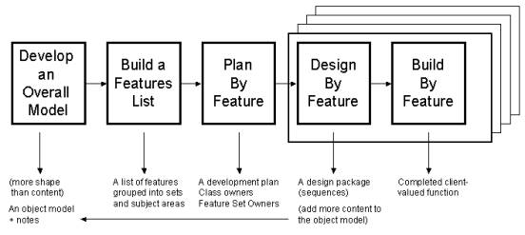

Figure ‑ Feature-Driven Development Process Model[27]

Feature-Driven Development was decided upon as the agile methodology to be used in this project. As the requirements for the project are well understood and that it would not prove problematic attempting to develop an overall model at the start of development, FDD appeared to be the appropriate middle-ground between discipline and agility – traditional plan-heavy models such as Waterfall and agile methodologies like Extreme Programming. The only major alteration to the methodology however is that all major and supporting roles were taken on by a single person. [28] The five processes outlined in Figure 1.2 are as follows:

**1: *Develop an overall model***

This primarily consists of class and sequence diagrams, often referred to as a ‘high-level walkthrough’ of the system. [29]

**2: *Build a features list***

Features for the project are expressed in the form of <action> <result> <object>. These are broken down into smaller features if the actions would take a significant amount of time. [29]

**3: *Plan by feature***

This involves the order in which features are developed, but since the project is being developed by a single developer, there is no need to distribute items to developers to maximise development efficiency and to make use of developers’ strengths. [29]

**4: *Design by feature***

The overall model is improved with the additional information gained so far. This also involves producing additional sequence diagrams for individual features. [29]

**5: *Build by feature***

The implementation of classes and their underlying methods and functionality, carrying out unit tests where possible (substituted with manual testing where tests were not created) and pushing to the project repository. [29]

# Design

## Programming Languages, Frameworks, and Libraries

### Introduction

There are numerous programming languages that are well-suited for the task of providing a web-based interface and graphing tool, interfacing with and retrieving data from the magnetometer, (also potentially additional sources) and an API to which requests can be sent.

### PHP

PHP is one of the oldest server-side open source programming languages for the web, originally created in 1994 by Rasmus Lerdorf in the C programming language. [30] Since then it has grown dramatically and is used on more than hundreds of millions of domains across the Internet. Most notably it is used for the popular content management system WordPress, and countless web frameworks such as CodeIgniter and Laravel. The programming language offers an incredible degree of flexibility thanks to its large number of built-in functions that usually do not require additional modules to be installed [31], providing the language with a stellar quantity of possible use cases, ranging from small command line tools and dynamic webpages, to enterprise level web applications and RESTful (Representational State Transfer) services of which can be written in a procedural or object-oriented style.

While the programming language is in its seventh major revision, only the latest version of PHP 5.6 is available on Central. While this poses no major security threat at this time of writing as there is continued support for this iteration of the language until January 2019, [32] it nevertheless poses a strong limiting factor in what frameworks can be used to develop the application.

A strong example is the Laravel framework; incredibly well-suited to this task due in part to its MVC (Model-View-Controller) [33] architectural pattern. Tasks such as fetching data from varied sources can be implemented using services, processed, and saved using models and controllers, and so forth. [34] Unfortunately, it requires PHP 7.x.x to run.

### Python

The Python scripting language created in the early 1990s by Guido van Rossum from the Netherlands [35] is the language of choice for many scientific and data processing applications thanks to being easy to learn, powerful, lightweight, and yet have access to countless libraries and frameworks to further extend functionality. Python is so popular that it came first in the IEEE Spectrum Top Programming Languages of 2017 survey. [36] The most prevalent backend framework is Django, that in likeness to many other web frameworks, makes use of the MVC architectural pattern. [37]

### Node.js

One of the fastest growing backend technologies is Node.js, an open source environment based on the Google Chrome V8 JavaScript engine that executes JavaScript on the server-side. While JavaScript as we know it has existed since the 90s, Node.js itself is a far newer technology, having made its debut in 2009. [38] As the usage of Node.js allows for JavaScript to be on the backend in addition to the frontend of a web application, quite often in the form of a MEAN (MongoDB, Express, Angular, Node.js) stack of technologies, this combination permits for a high-performance system with a wealth of opportunities for code reuse and an adherence to the DRY (Don’t Repeat Yourself) principle. [39]

### Ruby

Ruby is a programming language developed in 1995 by Japanese software engineer Yukihiro ‘Matz’ Matsumoto, who wanted to produce a programming language that placed emphasis on a natural, beautiful syntax, as opposed to a simple one. Rails is a rapid web framework built for Ruby in 2003 by David Hansson – it too utilises an MVC architectural pattern. [40] In likeness to Django and Laravel, Rails is perfectly suited for developing RESTful services and enterprise level applications. Noteworthy examples of apps developed in Rails include pre-2009 iterations of the social networking site Twitter, and the Three Rings volunteer management suite [41].

### Miscellaneous Technologies

While not under a substantial amount of consideration, it is important to note the existence and popularity of numerous other technologies for the web, including Java, Microsoft ASP.net, (Active Server Pages) Perl, and ColdFusion, each with their own strengths and unique selling points. [31]

### Frontend Languages and Frameworks

Decision making and research for the frontend of the web application is more straightforward. The most complete graphing/charting JavaScript library is Chart.js, featuring full responsive design support, multiple chart types and makes use of the HTML5 (Hypertext Markup Language) canvas functionality for maximum cross-browser support. [42] This will serve as the library that powers the program’s data graphing functionality. There exist numerous options for HTML and CSS (Cascading Style Sheets) frontend frameworks that will govern the appearance and styling of the web application – the most popular candidates of which are Twitter’s Bootstrap, and Zurb’s Foundation. Due to multiple years of experience designing websites with the former, this was opted as the ultimate choice, although either would have proven more than satisfactory. Both frontend frameworks require the use of the jQuery JavaScript library to facilitate interaction with the DOM. (Document Object Model) [42] [43]

### Final Decision

The ultimate decision to use PHP for development was taken due to two primary factors. The first of which is familiarity; with around fourteen years of experience scripting with PHP it abolishes the potentially lengthy process of familiarisation - not just in terms of language syntax but also coding standards, development environment, and workflow tools such as automated testing and dependency management. It could be argued that other languages, particularly Python, are more suited to the project’s aims due to the wide availability of data processing libraries and pre-existing widespread usage as a scientific scripting language, but on the other hand K. Sierra argues that ‘when we talk about “the best tool for the job” we should look not only at “best for the task” but also “best for those who must use it”’. [44]

The second deciding factor is compatibility. As previously explored, the software is likely to run on an IMPACS provided computer or virtual machine, or on Central. Central only supports PHP 5.6 and does not carry runtimes for any of the other programming languages, so a virtual machine or dedicated server would be required.

To mitigate the possibility of the software running on an environment as restrictive as Central, the decision was made to write the software in standard ‘vanilla’ PHP, making use of only necessary frameworks and libraries that will be compatible with available database technologies and the version of Apache web server running. Should a far better environment present itself at a later point, the program can be straightforwardly refactored to take advantage of PHP 7.x.x functionality.

## Persistent Storage

The application, after retrieving data and carrying out any necessary conversion or processing from a select data source then saves entries as records in a relational database.

PDO (PHP Data Object) is the interface used for accessing databases in PHP. It is database agnostic, meaning that the same functions for issuing queries, etc. can be used without prior knowledge of the type of relational database used – this is taken care of by a PDO database driver, of which there are many, including support for MySQL, (Structured Query Language) PostgreSQL, Microsoft SQL, and SQLite. [45]

For development, an IMPACS-hosted MySQL database will be used, but it is intended that the type of database can be specified in a settings or configuration file, so that any supported database by the environment’s PHP installation may be used.

## Development Environment

Application development will be carried out primarily on two systems. The JetBrains PhpStorm IDE (Integrated Development Environment) is a powerful cross-platform software package specifically designed for PHP software development that provides debugging, code analysis, refactoring, version control, and Composer dependency management support out-of-the-box. [46]

In addition, the cross-platform Visual Studio Code editor by Microsoft is also used for making quick modifications to source code files and text documents. Microsoft Word 2016 for both Windows and macOS is used wherever possible for rich text editing. If any image editing is required, Adobe Photoshop CS6 for macOS will be used wherever possible.

The technical specifications of the computers used for development are as follows:

**Desktop:**

* Mac Pro 3,1 (Early 2008) running macOS 10.13.x High Sierra
* 2x 2.8GHz Quad-Core Intel Xeon E5462
* 32GB 667MHz DDR2 RAM
* NVIDIA GeForce GTX1050 Ti
* Solid-State Drive

**Laptop:**

* Custom-built laptop running Windows 10 Education x64
* 2.5GHz Intel Core i7-4710MQ
* 8GB 1066MHz DDR3 RAM
* NVIDIA GeForce 860M
* Solid-State Drive

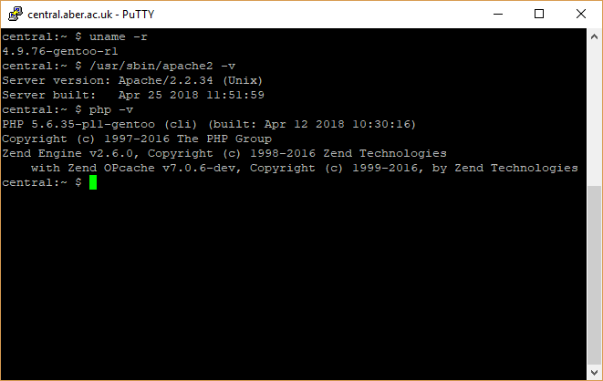

Figure ‑ Central system information as viewed from PuTTY on Windows.

It can be seen from the above figure that at this time of writing, Central appears to be running the Gentoo GNU/Linux operating system, with the Apache 2.2.34 web server, and PHP 5.6.35.

## Security Requirements

The application, while interfacing with both a relational database and with data sources which both require authentication to download data therefrom, is not planned to include any functionality to create, update, delete, or otherwise modify data. As this data is not confidential and will be used by a wide number of students and academic staff, authentication with the application itself is not necessary for viewing its content. As measurements will be taken to protect even non-identifying / confidential data, this will fully comply with the Data Protection Act 1998.

Nevertheless, precautions must be made to ensure that common cyberattacks against web applications are mitigated. The inclusion of prepared statements, and both client-side and server-side validation and sanitisation of incoming data can help prevent SQL injection attacks where an attacker may attempt to inject SQL queries or script into a HTML form in order to modify, delete, or add malicious entries to the underlying database. [47]

Additional security measures applicable to this type of web application include CSRF (Cross-Site Request Forgery) protection on forms to help prevent malicious POST requests [48] and the inclusion of integrity parameters for JavaScript or CSS includes that are retrieved from CDNs, (Content Distribution Networks) that prevent content to be loaded if there is a suspicious mismatch in file checksums.

## Version Control

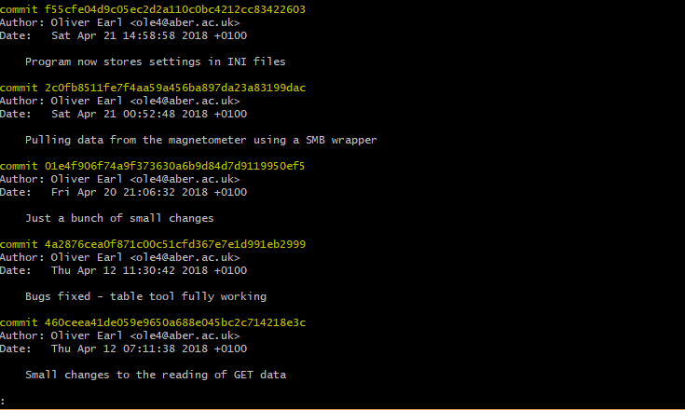

Figure ‑ Example commits within the project Git repository.

The source code in its entirety for the project is stored within a Git repository. Git is a widely used, open source distributed version control system (DVCS) that was originally developed by Linus Torvalds in 2005 for use with the Linux kernel and its source code. [49] Changes to the source code are uploaded (‘pushed’) to an academic Bitbucket account (the repository’s remote repository) where they can be browsed or downloaded (‘pulled’) by both the developer and the project supervisor. Bitbucket is a Git repository management system by Atlassian. [50]

As a complementary precautionary measure, the repository is securely kept within a personal Dropbox account, a cross-platform cloud-based storage solution that uploads and synchronises changes to files and folders within it to all associated computers and mobile devices running the software, allowing for seamless development across multiple platforms. [51]

## Overall Design

### Introduction

The application is split into three main controller modules, Magneto, Renderer, and Retriever. Magneto is the internal name for the main class of the application, as that is what the application was referred to internally and serves as the root namespace for the application. Eventually the program was renamed to ‘Borealis’ since the program was intended to retrieve data from more than just magnetometers, but the internal name stuck. This class could be considered the main ‘app’ class, or the primary controller of the application and is the first to bootstrapped once autoloading is complete.

The Renderer class is the controller that handles the view of the application and uses a templating system to render the view from template files; it separates the view from the rest of the application by only injecting what the view needs into it, such as fetched data from the model, sanitised data from the user, locale data, etc. It is also responsible for routing requests, rendering the correct views, and injecting required data accordingly.

The Retriever class is a controller responsible for retrieving data from data sources. As only FGM-3 magnetometer data retrieval was successfully implemented on time, the Retriever class was only designed to retrieve data from it, but future refactoring could be an option to enable further support for alternative sources, such as those from amateur radio and sources from the Internet.

Additional supporting classes are called upon by these controllers for smaller functions, such as the model for magnetometer, retrieving and saving program settings, and functions pertaining the program’s localisation functionality.

### Architectural Pattern

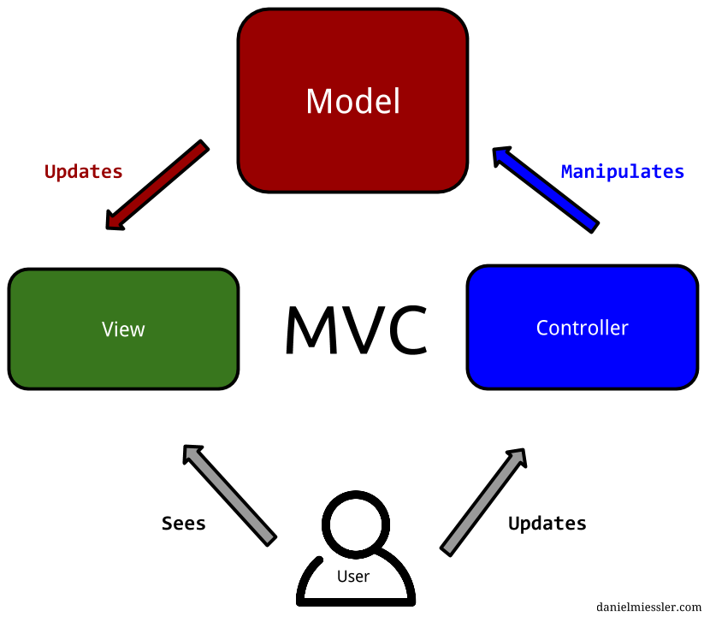

Figure ‑ Model-View-Controller Architectural Pattern [51]

Like many web applications, the MVC architectural pattern is likely to fit the application best. This separation of concerns will separate the complex project into three distinct areas:

* The **model**, or domain, which concerns data, such as object models that represent data stored in the database.
* The **view**, which provides the template and interface which the user interacts with
* The **controller** which manipulates the model and as put by D. Miessler, ‘facilitates content being moved back and forth between them [the Model and View]’ [52]

### Intended Structure

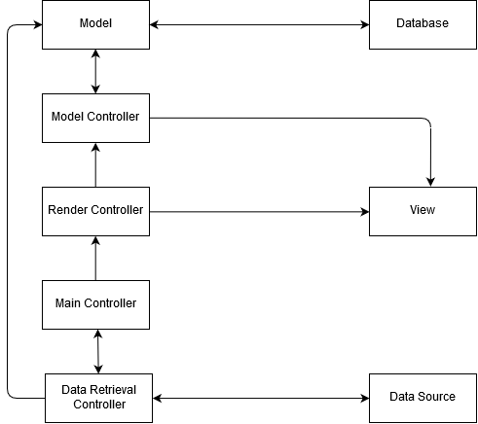

Figure ‑ Rudimentary initial UML (Unified Modelling Language) diagram demonstrating data flow and separation of concerns.

During the initial planning of the application, one of the first things considered was how the flow of data would work, ensuring that concerns remained separate and that logic designed for one specific area of the program did not overflow into the next to maximise code efficiency and maintainability.

As demonstrated by Figure 2-4, multiple controllers are used to communicate with the model layer depending on whether that data is being retrieved for rendering into a view that the user can interact with, or whether data is incoming from a data source, such as a magnetometer.

Although not always the norm in MVC, in this instance the view is given model data from a dedicated controller that is responsive for formatting data returned from the model into something expected by the view.

This overall model does not include functionality outside what is considered core (explored more in Feature List 2.7) to the program, such as the workings of localisation.

## Feature List

In line with the second process in the Feature-Driven Development methodology, ‘Build a Feature List’ [29], the following is a full feature list intended for the application. In addition, each of the features has been given a classification of ‘Core’ and ‘Complimentary’. This is a simplified derivative of MoSCoW analysis commonly used in software engineering, particularly the Dynamic Systems Development Method methodology (DSDM), where the ‘must haves, should haves, could haves, and won’t haves’ are identified in a software project. [53] The full method would be unnecessary to implement however, as ‘won’t haves’ are redundant due to there being no additional development cycles following the deadline of the project, and since there are so few pieces of core functionality, it could be considered trivial to differentiate between ‘must have’ and ‘should have’.

To reiterate, the format of identified features is <action> <result> <object>. If a feature is too large, it is broken down into subsections. [29]

* **Magnetometer Retrieval**
  + Connect to and retrieve data from the magnetometer. (Core)
  + Determine when data requires retrieving. (Complimentary)
  + Allow forced data retrieval by means of an override. (Complimentary)
* **Frontend Interface**
  + Navigate and choose data to render in a graph (Core)
  + Specify desired data using HTTP GET parameters (Complimentary)
  + Display stored data in the form of a graph. (Core)
  + Display stored data in the form of tables. (Complimentary)
  + Display all data at once in the form of a graph. (Core)
  + Display latest data in the form of a graph. (Core)
  + Add means to export currently displayed data as JSON. (Core)
  + Add means to export currently displayed data as XML (Complimentary)
  + Add a Settings page to change basic settings of the frontend. (Complimentary)
  + Add an About page with information regarding the project and program (Complimentary)
  + **Localisation**
    - Add a means to change the language between English and Welsh. (Complimentary)
    - Add a means to detect whether the user’s web browser language is English or Welsh and choose language accordingly. (Complimentary)
    - Website locale is stored within files that is printed onto the page according to what language is loaded. (Complimentary)
* **Program Settings**
  + Program settings are saved to and retrieved from a persistent file.
* **Security**
  + Provide sanitisation to incoming data (Core)
  + Provide client-side validation on inputs (Core)
  + Provide basic CSRF protection (Complimentary)
* **API** 
  + Return JSON of requested data entries using GET or POST (Core)
  + Return JSON of latest data entry (Complimentary)
  + Return JSON of all data entries (Complimentary)
  + Return XML in place of JSON for all the above (Complimentary)
  + Handle errors and malformed requests accordingly (Complimentary)
  + Receive and process commands such as manual magnetometer retrieval (Complimentary)
* **Other Data Source Retrieval (*Unimplemented*)**
  + **Amateur Radio / Radio Antenna Retrieval**
    - Receive data from amateur radio / radio antenna connected computer (Complimentary)
  + **Internet Retrieval**
    - Receive data from Internet-based sources (Complimentary)
    - Manually specify choice of Internet source (Complimentary)

## Detailed Design

### Introduction

This section will go into detail each of the major classes of the application, their notable methods and will elaborate upon interaction with third-party libraries where applicable.

This section overlaps very heavily with the Implementation side of the report, particularly due to significant discussion of code, functions, classes, and language functionality, such as the wealth of built-in functions within PHP. It was felt that this overlap, although unorthodox, would help efficiently and fluently describe the application, the algorithms and flow of execution therein, and design choices taken due to working knowledge of the programming language and its feature set.

The program features two primary entry points, index.php and api.php, the former autoloads, and bootstraps the Magneto class responsible for setting up the application, whereas the latter file following autoloading carries out a different route of execution specifically for returning data programmatically.

### Composer Autoloader

Composer is a dependency management tool for PHP that relies on a JSON file, named composer.json to install any third-party libraries, frameworks, or other dependencies that the application needs so that they can be installed or updated by issuing a single command, making deployment of the application simple, without the need of storing hundreds of megabytes or more of third-party code within a program’s repository. Dependencies can be installed on a global basis, such as for helpful workflow tools, or more commonly on a per-project basis. Similar popular dependency managers for other languages include npm for Node.js and Bundler for Ruby. [54]

Composer produces an autoload file, autoload.php that is included within both entry-points of the program to automatically make available the classes and namespaces of third-party libraries, eliminating the need of painstakingly including each individual file as they are needed. In this project, Composer is also used to PSR-4 autoload the namespaces pertaining to this application, so that use commands can be issued, and classes resolved without complex require chains. [55] PSR-4 is the fourth PHP Standard Recommendation enacted by the PHP Framework Interop Group, who describe this recommendation as a ‘specification for autoloading classes from file paths.’ [56] This mapping of directories to namespaces in PSR-4 style can be seen inside the composer.json file as follows:

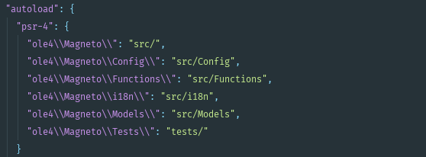

Figure ‑ Autoload subsection of the composer.json file.

This autoload functionality is crucial for the correct development of object-oriented applications with PHP.

### Magneto

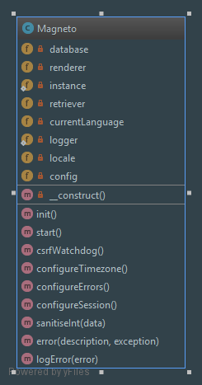

Figure ‑ Autogenerated Magneto Class Diagram.

A public static init() method is called from the index.php entry point to begin bootstrapping the program. This method is responsible for setting up the program time-zone, session handler, and error handling. Following this, it instantiates and returns the application, which then begins to set up other areas of the program. During the setup of error handling, the program configures the popular Monolog/Logger third-party logging library, used for logging application events and error messages to logfiles. [57]

First the configuration array is retrieved from a static method in the Config class, then the program language and its associated locale file are retrieved from the Locale class. Then a PDO instance is retrieved from Connector. Finally, the Renderer and Retriever are instantiated and the start() method is called.

The start() method is the primary method for the class that carries out any required functionality Therein lies calls to methods in the Renderer and Retriever classes to begin their subsequent functionality, covered in detail within their subsequent sections, but not before the program calls an internal method, csrfWatchdog(), which determines whether any POST data has come from an authentic user request, and if not due to a suspected cross-site request forgery attack, throw an exception that ceases program execution.



Figure ‑ CSRF Watchdog Private Method.

This method inserts a cryptographically secure 32-bit token into the user’s session if one does not already exist. The token is also inserted into all forms contained in the program’s views. Although C. Shiflett recommends the combination of PHP’s MD5 algorithm function in conjunction with the built-in uniqid() and rand() functions [48], we now know these to be cryptographically insecure, in part due to the following:

* MD5 is considered ‘broken and unsuitable for future use’ by the Carnegie Mellon University Software Engineering Institute [58]
* rand() is widely considered predictable, detailed as such in a heavily detailed report by J. Roper about cracking random number generators. (RNG) [59]
* uniqid() only adds a set amount of entropy (lack of predictability; chaos) by default and is considered inappropriate for cryptography by The PHP Group itself [60]

Consequently, the more reliable randomness provided by a combination of base64_encode() and openssl_random_pseudo_bytes() that are used to safely generate a token. If POST data exists, then the token is checked. If a mismatch with that stored in the session is found, or if it merely does not exist, the program calls the internal error function.

This function, a public static method, is one of the most notable in the class due to its program-wide usage, is called in catch blocks for exceptions and when an error or unexpected condition is encountered anywhere in the program.



Figure ‑ Error Public Static Method.

The only exception to its normal pattern of execution is for when the CSRF protection is tripped, causing the method to throw an exception itself and end the program. For the purpose of ensuring that even error messages themselves are localised, the method will retrieve locale files itself. If there are matching localised error messages it will use them, otherwise defaulting to those provided by the method arguments.

The error method will add the exception to session storage which is injected into the view and displayed as a Bootstrap styled alert. It will also use the Monolog library to write an error message to the dedicated error logfile in the storage directory.

Finally, it is of note that the Magneto class also contains a static method for sanitising integers, which is used frequently through the application particularly for sanitising ID values used for retrieving magnetometer records.

### Config

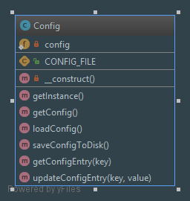

Figure ‑ Autogenerated Config Class Diagram.

Config is simply a wrapper class for the program’s settings, providing the necessary functionality for making modifications to it during runtime, fetching specific values, saving changes to disk as well as the initial loading of the configuration.

It was originally intended that the program’s configuration would be saved in INI format, a common plaintext file format used for storing program initialisation values that can be easily parsed by PHP into associative arrays. Eventually this implementation was replaced with a modest config array file technique that is explored along with the reasoning behind this choice and the details behind its exact implementation its subsequent section 3.2 in the Implementation chapter. The program configuration values are as follows, with a brief description: (The keys to chiefly important config entries have their keys highlighted in **bold** and are elaborated upon further following the table. Entries in *italics* cannot be edited anywhere in the program and are considered constant values.)

|  |  |  |  |
| --- | --- | --- | --- |
| **Config Array Key** | **Data Type** | **Array Value** | **Description** |
| **debug** | Boolean | true | Debug mode flag. Determines whether certain operations such as error reporting behave differently. |
| *appName* | String | ‘Borealis’ | Application name |
| *appVersion* | String | ‘1.4.0’ | Version of the program |
| *appDescription* | String | ‘Data collation and graphing tool with API for magnetometer data.’ | Description of the program |
| *appAuthor* | String | ‘Oliver Earl’ | Author of the program |
| *appAuthorEmail* | String | ‘ole4@aber.ac.uk’ | The email address that belongs to the author of the program |
| **maxElements** | Integer | 4 | Number of magnetometer entries that are displayed in the Navigator view |
| *hostname* | String | ‘db.dcs.aber.ac.uk’ | Hostname used for database connectivity |
| *dbName* | String | ‘ole4’ | Name of the database |
| *username* | String | ‘ole4’ | Username used for database authentication |
| *password* | String | ‘REDACTED’ | Password used for database authentication |
| *dbType* | String | ‘mysql’ | Type of relational database, can be any supported database type for which PDO has access to a driver, such as ‘mysql’ or ‘postgres’ |
| *magnetometer_hostname* | String | ‘imapspc0017.imaps.  aber.ac.uk’ | Hostname for the computer connected to the magnetometer |
| *magnetometer_username* | String | ‘imaps\ole4’ | Domain and username used for SMB authentication |
| *magnetometer_password* | String | ‘REDACTED’ | Password used for SMB authentication |
| *magnetometer_share* | String | ‘magdata’ | Remote share that is to be mounted containing magnetometer data |
| **magnetometer_latest** | String | ‘111’ | Three-digit code representing the day of the year, used to determine latest retrieval |

maxElements determines how many input boxes are displayed in the Navigator view, the view that allows the user to choose what data entries they would like loaded into the Graphing Tool, or in tabular format.

magnetometer_latest is updated whenever the program retrieves data from the magnetometer. It is a three-digit code that represents the day of the year. This will be covered in more detail in the Retriever subsection.

If the debug flag in the program settings is set to true, errors and exceptions will be raw printed to the screen instead of just being rendered as Bootstrap alerts, in addition to being logged, and an additional debugger becomes available in the Graphing Tool view.

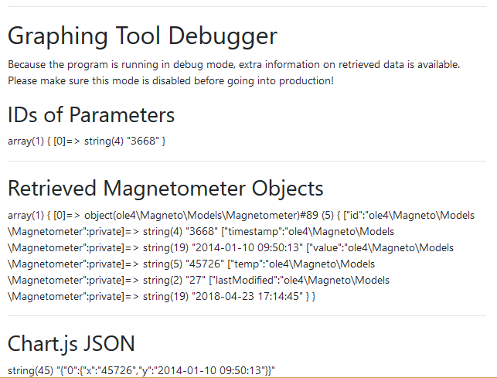

Figure ‑ Graphing Tool Debugger that becomes available when the debug flag is set.

This debugger shows data into the view pertaining to saved entries from the database, their unique IDs, and the generated JSON necessary for rendering that has been injected into Chart.js, the JavaScript charting framework.

### Connector

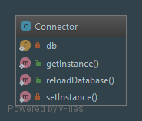

Figure ‑ Autogenerated Connector Class Diagram.

The Connector class initially sets up a PDO object with aforementioned values stored in the configuration file and returns it. It also has the ability to destroy the database object so that it can be reloaded – a functionality that was originally intended for supporting changing database config values live.



Figure ‑ Private database property and characteristic singleton instance Public Static Method.

The PDO object static private property $db exists as part of a singleton, a creational design pattern used for ensuring that only one instance of a class exists at one time by privatising the constructor, preventing external instantiation outside of a dedicated public static method. [61] The method getInstance() will launch the necessary private static setInstance() method if the database object has not yet been instantiated, otherwise it returns the one already in use. This helps prevent instantiating more than one unnecessary database connections, and in the case of ever being able to change the database settings, more than one database connection at a time.

This database functionality was originally self-contained within the Magneto class, but it was abstracted to its own class so that it could be more readily injected into other classes that required a connection to the database.

### Locale

The Locale class has two main jobs. The first is to determine and keep track of the program’s language, which is either English or Welsh. The second is to provide localisation files containing localised versions of application text strings.

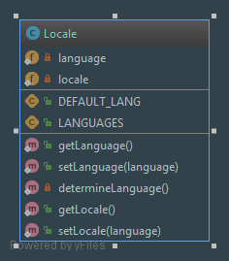

Figure ‑ Autogenerated Locale Class Diagram.

setLanguage() is one of the two key methods in this class as it will first determine whether the language is already pre-set by calling determineLanguage() – this first checks the session for language data, if this data does not exist, the program will determine the user’s web browser language and use that value. Should it be neither English or Welsh, it defaults to English. Ultimately if the user has submitted a language choice by clicking on a link or specifying in the URL as a GET parameter under ‘language’ (i.e. index.php?language=cy), this will be chosen as the program’s language.

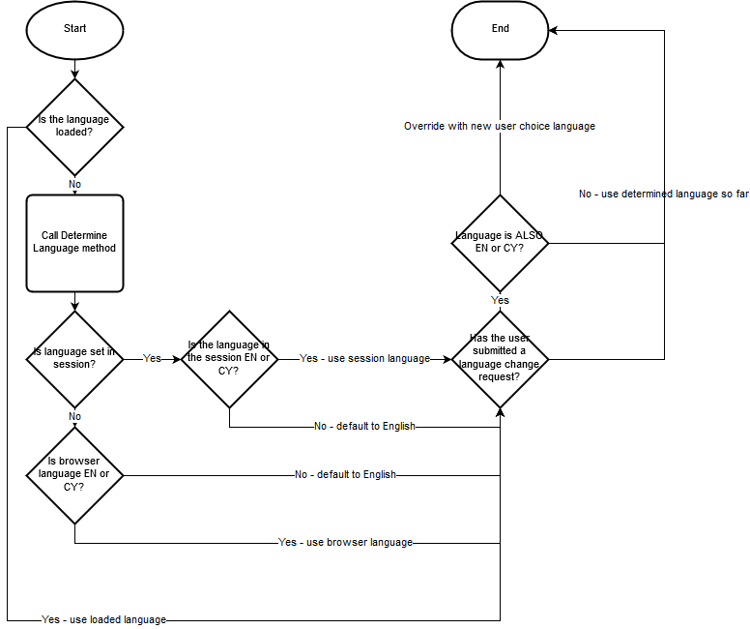

Figure ‑ Sequence Diagram for Language Determination algorithm.

As demonstrated by the sequence diagram, the language determination algorithm outlined in setLanguage() and determineLanguage() determine at multiple levels if a predominant language has been established and makes attempts to detect it through the user’s browser or session data, using English as a failsafe should there be any suspicious anomalies or an unsupported language being used. Any language request sent through, provided it is a supported language however will take precedence in order to facilitate the switching of application localisations.

The next step once the user’s language has been determined is to load locale files. As opposed to a Gettext internationalisation system that is frequently used in PHP projects to provide multilingual support, [62] the program uses a cruder but easier to implement directory containing JSON files for each supported locale. The JSON file contain identical keys, except with values representing localised text strings. This JSON file is decoded into an associative array that is injected into views and error messages. The design choice was due to the complexity of configuring Gettext in comparison, and as localisation was a Complimentary functionality, the KISS (‘Keep it Simple, Stupid’) principle [63] was kept heavily in consideration.



Figure ‑ Public Static Method for setting program locale.

setLocale() takes the current language as a parameter when called, but defaults to English as a failsafe. It then checks to see whether the appropriate locale file exists prior to attempting to gets its contents and decode the contained JSON into an associative array. If the JSON is malformed, or the locale file is missing or inaccessible, errors are issued.

### Renderer

The Renderer is one of the three main controller classes in the application and plays the role of developing and rendering the view, injecting necessary data into the view, and also takes on routing responsibilities. Routing involves handling necessary GET queries to direct the user to the correct webpage for the application.

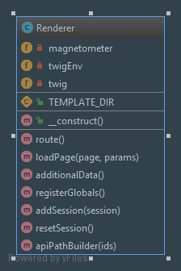

Figure ‑ Autogenerated Renderer Class Diagram.

The method serves as a wrapper for the Twig templating engine library, commonly known for its use within the Symfony framework. [64] This is initialised when the class is initialised, where it is most importantly passed the path to the templates directory where Twig templates for the views are stored. The loadPage() method acts as a wrapper for Twig’s render method, passing in the page that will be rendered along with an array of arguments that Twig expects as data injected into the view. This data is amalgamated and injected during routing, and global data accessible by all views is configured in registerGlobals().

registerGlobals() registers configuration data, a database connection, the current program language, the loaded localisation array, and a generated CSRF token for forms into the view using Twig’s addGlobal() method. [65] Additionally, arrays containing errors and success messages are injected, but this has no effect on the view if they are empty as they are by default.

The route() method is large and made up of a very complex switch statement in order to load the correct pages and both retrieve and inject the correct information into the view based on a page GET (i.e. index.php?page=about) in lieu of clean or ‘pretty’ URLs [66] generated by rewrite engine functionality enjoyed by many web frameworks. While large or excessive switch statements are considered a code smell in object-oriented programming languages as they indicate that functionality could most likely be implemented using polymorphism instead, [67] it is important to consider that there is a trade-off between having a simple but ‘smelly’ router that works for a relatively simple application, and a more complicated router whose implementation is much more complex, coming back to the aforementioned KISS principle. [63] Polymorphism is eloquently described by J. Skeet as something that ‘ allows the expression of some sort of contract, with potentially many types implementing that contract in different ways, each according to their own purpose.’ [68]



Figure ‑ route() switch case for graph, demonstrating what methods are called and what data is injected into the view prior to rendering.

As seen in the above figure, a number of values are retrieved before being inserted into the array of arguments to be passed into the view. For displaying entries in the Graphing Tool view, magnetometer entry parameters must be harvested, done in the additionalData() method. Once this data is collected, the $entries variable can be used to collect an array of Magnetometer objects from the database, which consequently can be used to generate JSON for use with the Chart.js library. Lastly, paths to the API entry-point for both JSON and XML are generated using the entry IDs and the unsophisticated apiPathBuilder() method.



Figure ‑ Reset Session Private Method

The addSession() and resetSession() methods are for the displaying of Bootstrap alerts – errors and success messages. A timer is used to ensure the message is displayed at least once before being unset. This takes place before views are rendered.

Twig templates, including their syntax, are elucidated in greater detail in 2.12 User Interface Design. Additional insight into the use of custom Twig filters is also elaborated upon in Implementation 3.5.

### Retriever

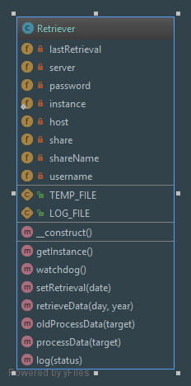

Figure ‑ Autogenerated Retriever Class Diagram.

It is a reasonable assumption to make that the Retriever class contains the most important functionality in the application. It is responsible for the retrieval and storing of data from data sources, namely the magnetometer. It was originally proposed that this class remains agnostic from which source data is retrieved from by making use of the previously described abstract class or interface, to propose a standard model that all data sources will either inherit from or implement. This would maximise the opportunity for code reuse and polymorphic functionality regardless of what children classes or implementations are used.

As only magnetometer functionality was implemented, that will be the scope of further discussion regarding this class, its methods, and its properties.

Retriever implements the SMB wrapper third-party library Sgrabaum/SMB, which is a fork of Icewind1991/SMB [69]. The primary reason for utilising this fork over the original library is due to the ease in which it can be installed using the Composer dependency manager without sacrificing functionality or being forced to use initialise and pull from the legacy PEAR (PHP Extension Application Repository) repository, [70] for the purposes of communicating with the magnetometer, mounting shares, and downloading data. The library has methods built-in such as get() for retrieving files, as well as other methods for reaching file-specific metadata, such as last modified dates and file sizes. The library is configured using magnetometer_ prefixed values passed in from the Config configuration array.

The Retriever is also a singleton class. When the watchdog() method is called, it checks whether it should attempt to pull data from the magnetometer by checking whether the current day differs from the value of the magnetometer_latest key stored in the configuration file, or whether there is an override flag in GET. (index.php?override=yes)

When either of these criteria are met, the retrieveData() method is invoked.



Figure ‑ Retrieve Data Public Method. Used to begin capturing data from the magnetometer.

The method accepts both a day of the year and year as optional parameters, deriving them from today’s date and year if they are not provided. Files stored on the magnetometer are stored in the format DATA123.csv – where 123 represent a three-digit number corresponding to the day of the year, including trailing zeros, which make it necessary to format numbers as specific strings using PHP’s built-in sprintf() and date() functions.

When the file has been found, the file is downloaded using the SMB library’s built-in get() method, storing the file in a temporary CSV file in the storage directory. The pathway to this temporary file is then passed to the processing stage of data retrieval, processData().

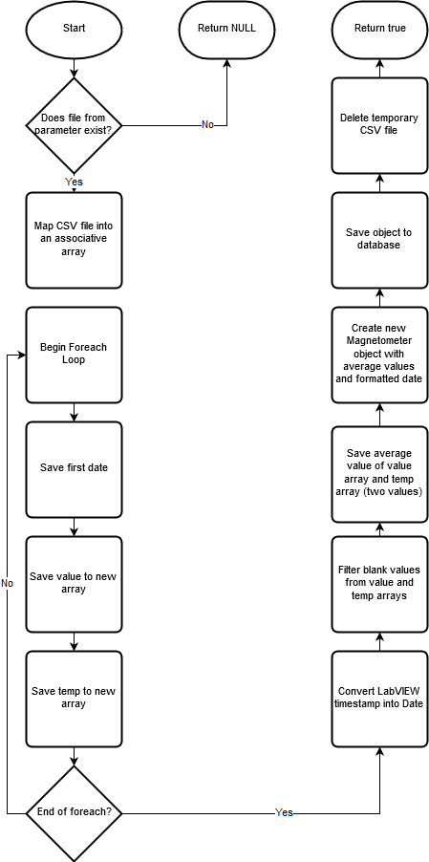

Figure ‑ Process Data Sequence Diagram demonstrating data processing algorithm for retrieved magnetometer data stored in CSV file.

By keeping the data processing functionality separate and requiring a path to a CSV file as a parameter, this makes for reusable code that can be recycled if the program were to be further developed in the future. It maps the entirety of the CSV contents to an associative array – with each entry in the multidimensional array representing a row that was in the file. The magnetometer value and instrument temperature are popped from the array as it is iterated through by a foreach loop and stored in separate arrays for future processing. A timestamp is also retrieved. At the end of processing, any blank entries are filtered out of the new arrays and new values are calculated by finding the average measurement for the magnetometer value and the temperature.

This information is used to instantiate a new Magnetometer object – keeping $id and $lastModified defaulted to NULL as they will be filled in by the relational database. The Magnetometer model class contains a method used to save this information to the database which is called, but not before checking whether the record already exists in the database. If it does, the data used so far is discarded and an error is thrown. Regardless of execution path, the temporary CSV file created earlier is then destroyed.

Specific design choices for filtering out blank values and using average values is expanded upon in Implementation 3.4.

### Magnetometer

The Magnetometer class is a part of the model layer of the program. It represents a daily entry from the FGM-3 magnetometer in the database. Its private properties are as follows:

|  |  |  |
| --- | --- | --- |
| **Property Name** | **Data Type** | **Description** |
| $id | Integer | Unique ID |
| $timestamp | String (Date/Time) | Date of entry creation |
| $value | Integer/Float | Reading in arbitrary value |
| $temp | Integer | Instrument temperature |
| $lastModified | String | Last Modified Date |

As explained in the previous section, when Magnetometer objects are instantiated, the $id and $lastModified properties can be left as NULL values so that they are filled in automatically by the database. In addition, although LabVIEW format timestamps are originally used by the magnetometer, they are converted to standard date string for database stored entries.

Besides mutator methods, there are three methods pertaining to date conversion. dateToUnix() converts parses date strings into UNIX timestamps, and the two remaining methods are for converting timestamps between the respective timestamp formats; making use of the epoch difference stored as a constant used for the numerical conversion. This value is 2082844800. [4]

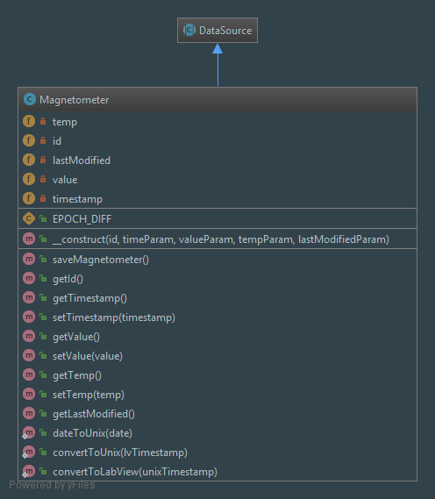

Figure ‑ Autogenerated Magnetometer Class Diagram.

The saveMagnetometer() public method is used for saving the current object to the database with the Connector PDO instance. The usage of prepared statements is the one of the most notable characteristics amongst this and all other database-interactive methods in the program – as described by D. Marcus, prepared statements work by preparing ‘an empty SQL query with empty values as placeholders’ and then to ‘bind values or variables to the placeholders. [71] Prepared statements help protect against SQL injection attacks. [47]

### MagnetometerController

The MagnetometerController class is a controller responsible chiefly for accessing the database, fetching data, and returning arrays containing newly constructed Magnetometer objects. One of the other key functionalities contained within is the generation of JSON intended to be inserted into Chart.js.

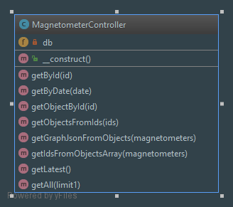

Figure ‑ Autogenerated MagnetometerController Class Diagram.

getById() and getByDate() retrieve a single magnetometer entry from the database by parameter and return it in the form of an associative array. getObjectById() will however return a Magentometer object.



Figure ‑ Get Objects from IDs Public Method.

This behaviour is made use of in other methods, such as getObjectsFromIds() which accepts an array of ID integers used for repeatedly calling getObjectById(), building an array containing Magnetometer objects which is subsequently returned.

For the Graphing View use case Chart.js utilises X and Y coordinate values for plotting points onto a graph. The getGraphJsonFromObjects() public method takes an array of Magnetometer objects, whereby it iterates through each object, further getting the object’s date to be used as the Y coordinate and the recorded value for the X coordinate. It ignores any blank or NULL entries to help avoid poisoning graphs with blank or corrupted data.

Rather than repeating code in best adherence with the DRY principle of software engineering [39], the getAll() and getLatest() methods attempt to make efficient use of their sibling methods to retrieve all entries stored in the database, or the very latest added, so far as to make use of one-another for this purpose as getLatest() merely calls getAll() but includes the optional Boolean parameter $limit1 set to true. The algorithm for requesting all, or just one magnetometer entry from the database is illustrated by the following sequence diagram:

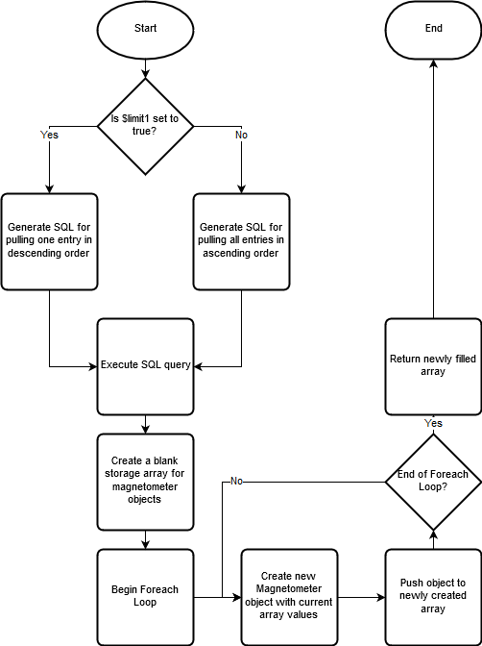

Figure ‑ Get All Public Method Algorithm Sequence Diagram.

The significance of the difference in order in both paths of execution is that when hunting for the latest entry in the database, in reality, the program queries for all the entries, but returns only the first it finds ordered by unique ID, if this were to be in descending order, it would return the oldest entry in the database. This is not completely fool-proof and relies on the assumption that entries are inserted into the database in chronological order and therefore the larger the ID value, the newer the magnetometer entry. This should be refactored to look for dates, but this could potentially take longer. In this battle of simplicity versus robustness, simplicity on this occasion was decided to be the more beneficial factor, which in turn corresponds with the KISS principle. For all entries, entries are returned in chronological order so that they can be read from top-to-bottom in tabular data, and elsewhere in the program to ensure data is rendered left-to-right in Chart.js, unless the user intentionally chooses data in an unorthodox order in the Navigator view.

### API

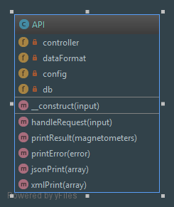

Figure ‑ Autogenerated API Class Diagram.

The API is a means of accessing stored database magnetometer entries programmatically. The class is outside of the ole4\Magneto namespace, as the file exists also as an entry-point with procedural script that returns a HTTP 400 (Bad Request) [72] if there is no included GET or POST information to be handled, otherwise, an API object is instantiated with the GET or POST super-arrays as parameters. If they are empty however, or at any point the new $api object encounters an error, the program attempts to return a HTTP 400 message, where possible with an associated error message.

The construction of a new API object calls handleRequest(), which is the primary method of the application, responsible for sanitising requests, invoking a MagnetometerController instance for the retrieval of data, and finally calling the printResult() helper method, which acts as a gateway to the jsonPrint() and xmlPrint() methods accordingly, depending on whether an XML flag has been set in the request. The default response is in JSON format.

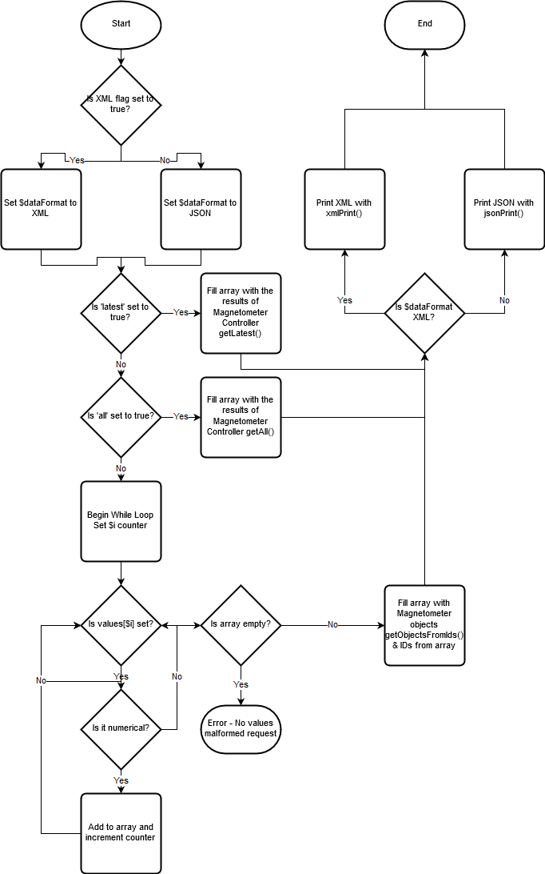

Figure ‑ Handle Request Algorithm for API Sequence Diagram.

Both jsonPrint() and xmlPrint() follow a similar pattern of iterating through Magnetometer objects, but their approach is slightly different. jsonPrint() iterates through each object and uses its getter methods to build a new multidimensional associative array. This is converted and printed as JSON using the built in PHP method json_encode().



Figure ‑ XML Print Private Method, complete with PHP alternative logic syntax.

xmlPrint() on the other hand has embedded XML within the method which is echoed out with embedded values included using getter methods. This mixture of logic and mark-up is discouraged in web development unless it is necessary such as in templates. [73] Additionally, it uses PHP alternative control structure syntax to maintain the highest level of readability [74] despite being an assortment of code and in lieu of a dedicated templating language e.g. Twig that is used elsewhere in the program (2.12 User Interface Design). Also note the alternative use of single versus double quotes – for marginally more efficient code, double quotes should be used where necessary or where variable evaluation (detecting variables in strings) is required, such as in this method. [75] Nevertheless, as the method is single-purposed, well documented, and functions as intended, this should not prove problematic, even with large API queries.

### DataSource and InternetData

DataSource is an abstract class that Magnetometer inherits from. It was intended that the majority of behaviour could be shared and would be stored within this abstract class that could be called upon or overridden by its children classes and for the polymorphic usage of data sources elsewhere in the program.

InternetData is a stub class that also inherits from DataSource. These two classes are explored in more detail in 3.7 Additional Data Sources.

### Directory Structure

The directory layout and structure of the application is as follows:

* Root Directory
  + assets
    - fonts
    - images
    - scripts
    - styles
  + doc
  + locale
  + src
    - Config
    - Controllers
    - Database
    - i18n
    - Models
  + storage
    - csv
    - logs
      * magnetometer
    - settings
  + templates
    - partials
  + tests
    - Config
    - Controllers
    - Database
    - i18n
    - Models
  + vendor

The assets folder stores static resources used by the application, such as stylesheets, JavaScript scripts, images, and fonts.

Doc contains documentation generated by the phpDocumentation tool, which generates comprehensive HTML documentation based on the application’s PHPDoc. (Explored more in Implementation)

Locale contains JSON files for each supported language – English and Welsh. The values contain localised versions for each key.

Src and its subdirectories contain PHP classes that make up the application.

Storage contains several types of data. The csv directory temporarily stores CSV files as they are processed by the Retriever class. The program error logs can be found inside the logs directory, with magnetometer retrieval activity being logged into its own subdirectory and logfile.

Twig template files that are explored in 2.12 User Interface Design are stored in templates, with partial template files (includes) being stored in partials so that they can be reused by other views.

The tests subdirectory directly corresponds with the src subdirectory – containing PHPUnit test classes for each program class that has unit tests written for it. This is looked over in detail within 4.2.1 Unit Testing.

The vendor folder contains third-party libraries, tools, and dependencies retrieved by Composer, including but not limited to Logger, the Twig templating engine, and the SMB connectivity library.

## Development Order

The order of development begins with core functionality within Magneto, Renderer, Config, and Connector classes to ensure a working prototype is ready in time for the mid-project demonstration. All other behaviour such as Retriever can be implemented afterwards, as where dummy data can be seeded and used beforehand since Renderer is intended to behave the same regardless of where data comes from. Testing is intended to be done alongside project implementation. (See fourth chapter, Testing)

## Relationships and Dependencies

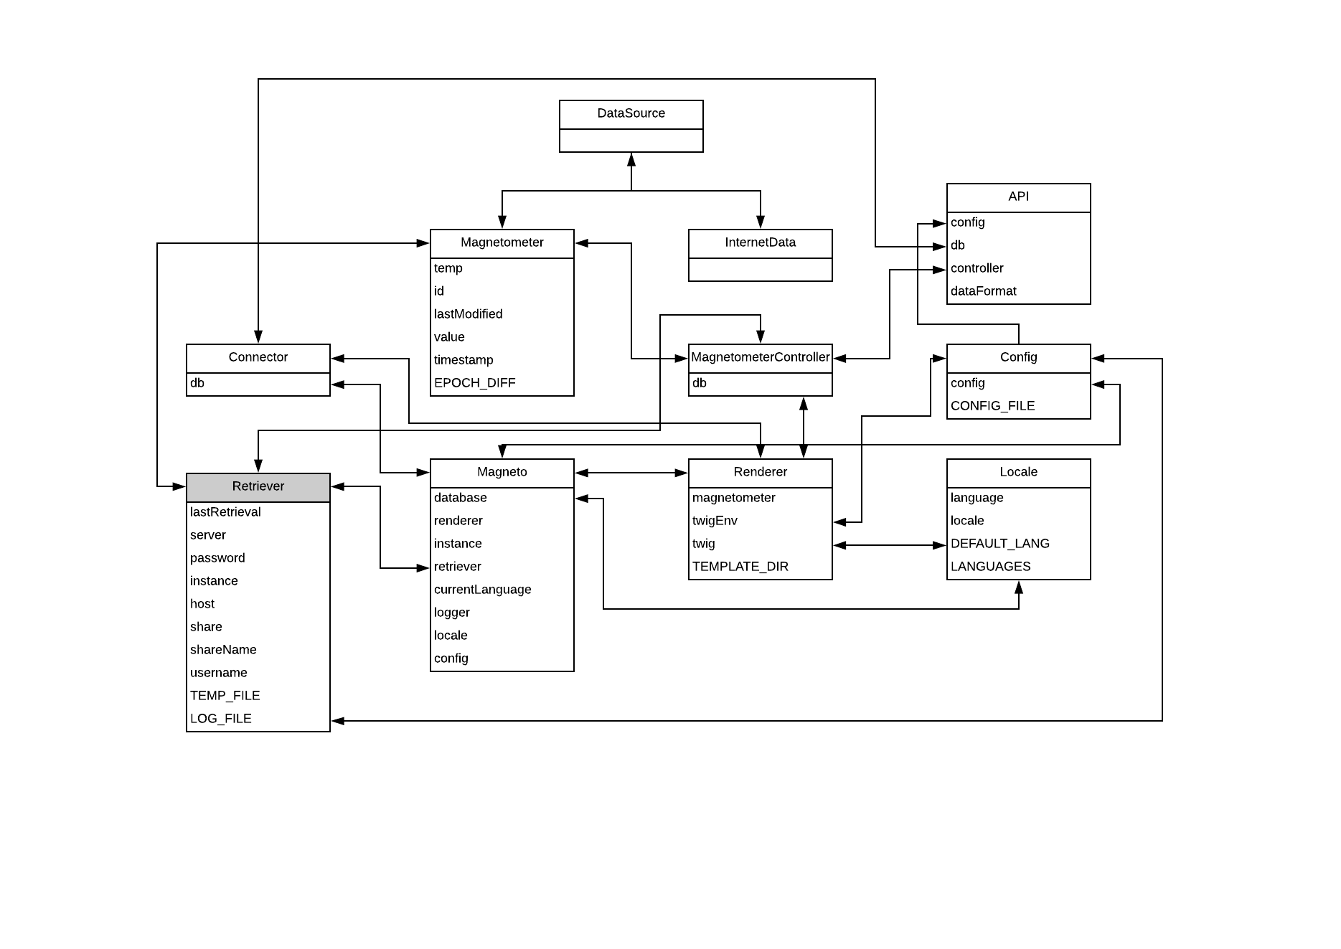

Figure ‑ Class Diagram demonstrating relationships between classes.

This figure provides a glimpse at the dependencies of the application and how other classes depend on each other. Although it would appear at first glance to be chaotic, each relationship can be broken down into reasoning as to why it exists. The following table aims to do establish each class’ dependencies, including third-party libraries not included in the previous diagram. This does not include dependencies on built-in PHP classes, such as PDO, or Exception.

|  |  |  |
| --- | --- | --- |
| **Depending Class** | **Dependency** | **Purpose** |
| Magneto | Connector | Initial database setup |
| Locale | Initial language and locale setup |
| Config | Initial config setup |
| Retriever | Begin watchdog services |
| Renderer | Begin routing services |
| Logger Classes | Configure logging services |
| API | Config | Initial config setup |
| Database | Initial database setup |
| MagnetometerController | Database retrieval |
| Config | Magneto | Error handling |
| Connector | Magneto | Error handling |
| Locale | Magneto | Error handling |
| MagnetometerController | Magneto | Error handling, sanitisation |
| Magnetometer | Corresponding model class |
| Connector | Database retrieval |
| Magnetometer | Connector | Saving to database |
| DataSource | Parent class |
| InternetData | DataSource | Parent class |
| DataSource | None | N/A |
| Renderer | Config | Injecting config into view |
| Connector | Injecting instance into view |
| Locale | Injecting locale into view |
| MagnetometerController | Retrieving data and injecting into view |
| Twig Classes | Templating Engine and rendering views |
| Retriever | Config | Updating latest entry in config file |
| MagnetometerController | Querying database for existing records |
| Magnetometer | Saving to database |
| SMB | Magnetometer services and SMB connection |

## Use Cases

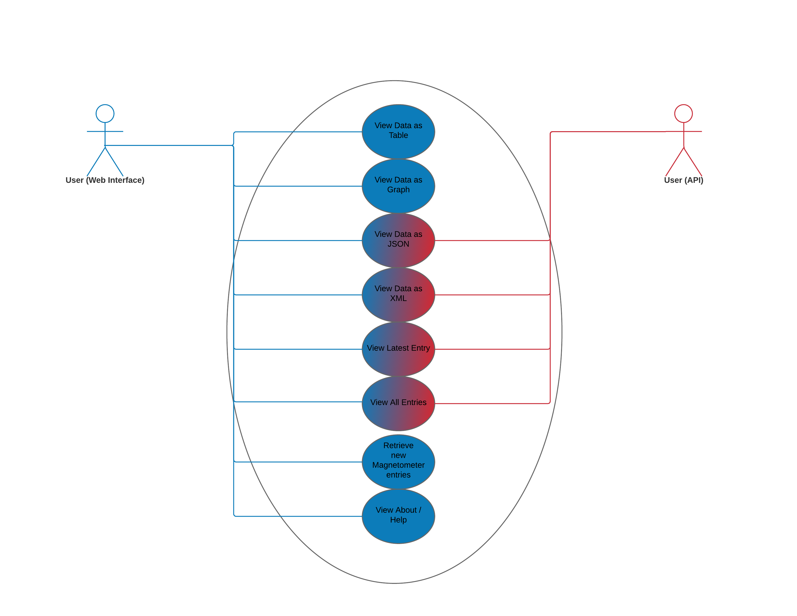

Figure ‑ Web Interface vs API Use Case Diagram.

There are two identifiable primary use cases for the application. Although the program as previously discussed is written for students and researchers of IMPACS, whether the program is being accessed through its web interface or programmatically via its API presents different functionality, albeit all functionality present on the API is also present on the web interface.

The above diagram shows tasks in blue that are available only from the web interface: viewing data in tables, viewing data in graphs, retrieving new magnetometer entries, and viewing about / help.

Those with a red-blue gradient are available through both entry-points and are viewing data as JSON, viewing data as XML, viewing the latest entry, and viewing all entries.

## User Interface Design

### Introduction

The criteria for designing an interface were decided on early in development – the web interface must be simplistic, informative, and as responsive as possible. Responsiveness is a web design approach that was originally defined by E. Marcotte back in 2010 as a design that responds to the device and screen resolution the user is using. [76] Although the design did not change much throughout the project’s lifecycle as designs could not be dictated by client desires, the design has changed slightly nevertheless.

### Twig Template Engine

As deliberated beforehand, the Twig templating engine is a popular PHP templating engine developed by those behind the Symfony framework. [64] The reason behind adopting this engine for the project is due in part to familiarity with producing Twig templates, but also due to compatibility, as Twig 1.x will run on PHP 5.6 and does not require any frameworks, including Symfony. It will happily operate alongside vanilla PHP if initialised correctly. [77]

While there are numerous benefits for using a templating system over standard PHP or HTML files for views, ranging from caching functionality to simply easier to read syntax, [78] but the primary criteria of interest are template inheritance and forced separation of concerns. [79] Template inheritance means that template files can be easily reused and not just included but also inherited from using {% extends %} syntax. Blocks can be assigned into templates that will be filled in by included or child templates that share those blocks. For example, the following code is taken from the homepage template, which inherits the layout from the master template, such as the HTML <head> and its child tags, footer scripts, navbars, etc. This filling-in behaviour is additionally incredibly useful for <title> tags.



Figure ‑ Homepage Twig Template.

If a developer wishes to access data within Twig templates, it must be passed as an entry in an array of parameters when Twig renders the view or assigned as a Twig global. Twig does not allow PHP to be executed in Twig files, nor does it allow access to the global scope. From the above figure, the arrays locale and config can clearly be seen, whose contents are being printed onto the webpage to facilitate localised content.

For clarity, Twig commands sit in-between {% %} tags. To merely print the result of a command or variable, double curly braces {{ }} are used. For comments, double curly braces containing hashes are used. For example: [64]

{# There is a block coming up, and this is a comment! #}  
{% block %} {{ variable }} {% endblock %}

### Bootstrap 4 and Theme

When working as a solo developer covering all aspects of an application, both backend and frontend, ‘business’ logic and presentation, it is important to be as time efficient as possible. As designs were initially conceptualised it was already clear what kind of layout was desired for the application, which thanks to Bootstrap is incredibly straightforward to develop, pre-existing code, mark-up and styling were downloaded from the Bootstrap 4 Dashboard example. [80] This pre-designed template was of considerable interest as it is demonstrated working alongside Chart.js, and meets the established criteria of responsiveness, simplistic, and informative, as there is plenty of room for additional buttons and controls, as well as tabular data.

Responsiveness is made simple with the use of the Bootstrap 4, whose grid layout system is based on the new CSS grid system to maximise efficient use of screen ‘real estate’ (screen space) and adapt to changing resolutions, different device viewports, and browsers as necessary. [81]

### Conceptual Designs

Two rough designs were produced on by hand on paper in pencil early in development (note the old internal name for the program present on the drawings, *Magneto*) once the Bootstrap 4 Dashboard template had been found, both were used in the initial brainstorming of the Graphing Tool view, and the Navigator view. Due to their large resolution (scanned A4 paper), they have been included as Appendix E.

### Final Designs

#### Homepage and About

The homepage and about page views share mostly identical templates apart from their textual content.

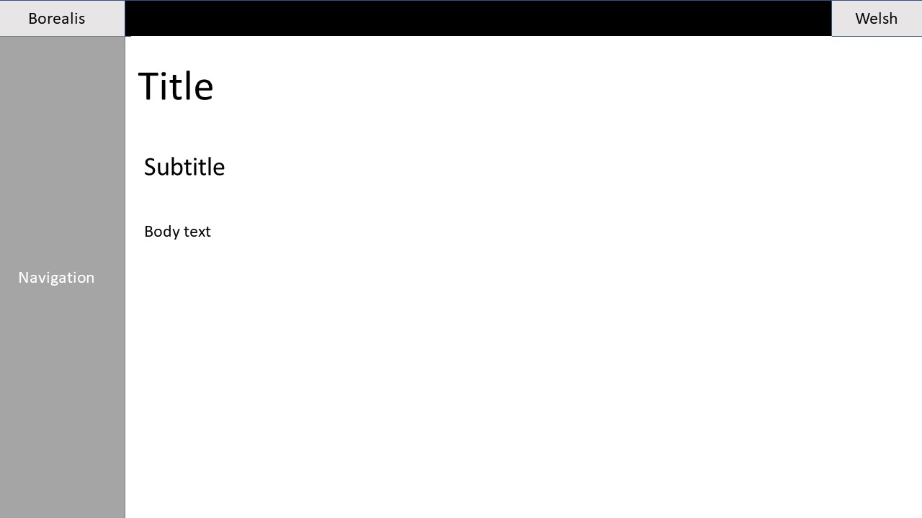

Figure ‑ Homepage/About page Design

#### Navigator

The Navigator view is the view responsible for displaying all magnetometer entries available on the database, and as many entry selectors as defined by the config key maxElements. Originally, this was going to update by means of jQuery DOM manipulation, where the user could dynamically add and delete elements to choose as many entries as they wanted without going to the Settings page, but this was changed due to time constraints. Nevertheless, it is reflected on the final design. Buttons for adding amateur radio and Internet (ESA / European Space Agency) sources are also present, albeit remain as unimplemented functionality in the software.

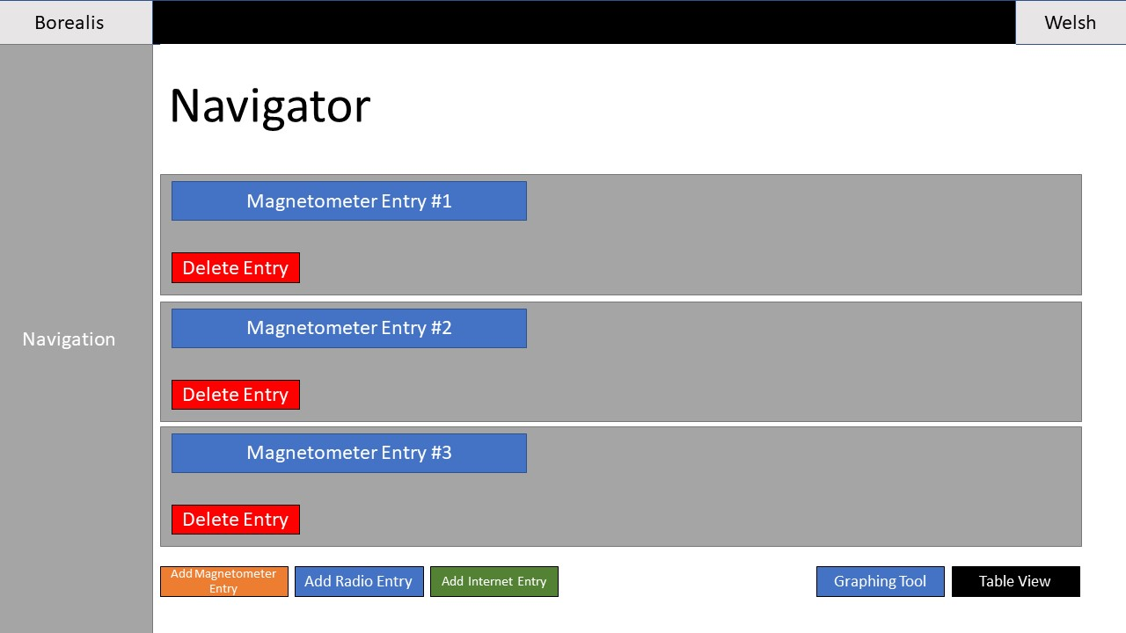

Figure ‑ Navigator Design

The Navigator and the Graphing Tool contain a creative trick to ensure that the application is only ran with JavaScript support enabled. An inline style is placed on the containing element for the main body of the program, the navigator form in this case, or the Graphing Tool container in the case of the latter, rendering it invisible. A small line of JavaScript follows it that removes the property from the element, so the process is instantaneous and is unlikely to be noticed, except by those with scripting disabled. Instead, they are treated to a message requesting they reenable JavaScript by means of the <noscript> tag.



Figure ‑ Code snippet from Navigator Twig template demonstrating JavaScript enforcement.

#### Graphing Tool View

The Graphing Tool is one of the primary functions of the *Borealis* application – graphically rendering data using the Chart.js JavaScript library. The majority of screen real-estate is given to the chart, with the Tables view embedded underneath, and buttons to facilitate the exporting of data to JSON and XML format. Although not present in this final graph, it was decided later in development to add the functionality to switch between line and bar graph formats dynamically and an extra button was added to facilitate this.

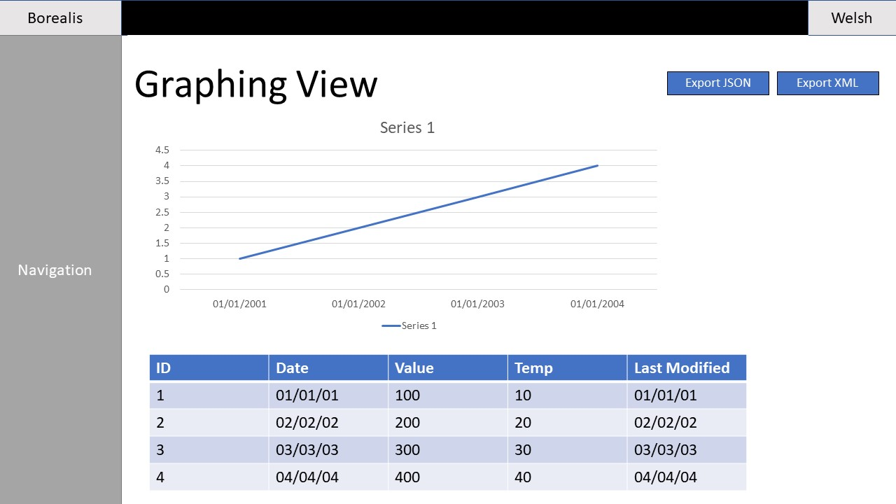

Figure ‑ Graphing Tool Design

The script responsible for rendering the Chart.js graph is kept in its own Twig template file that is included onto the Graphing Tool view. JSON is inserted directly into a JavaScript variable on the server-side before being sent to the user’s browser.



Figure ‑ Code snippet from Chart Twig Template, demonstrating code insertion

As visible from the above code snippet, the contents of the Twig array json, containing JSON generated by the MagnetometerController is inserted directly into the JavaScript variable data, processed by JavaScript’s built-in JSON parsing function. The raw filter is used here to properly escape the JSON as Twig prints it to the DOM.

#### Tables View

The Tables view can be viewed independently or as part of the greater Graphing Tool view as additional tabular data underneath the graph. This is facilitated by either directing Twig to render the Tables View directly and by using Twig to insert it within the Graphing View template as an include.

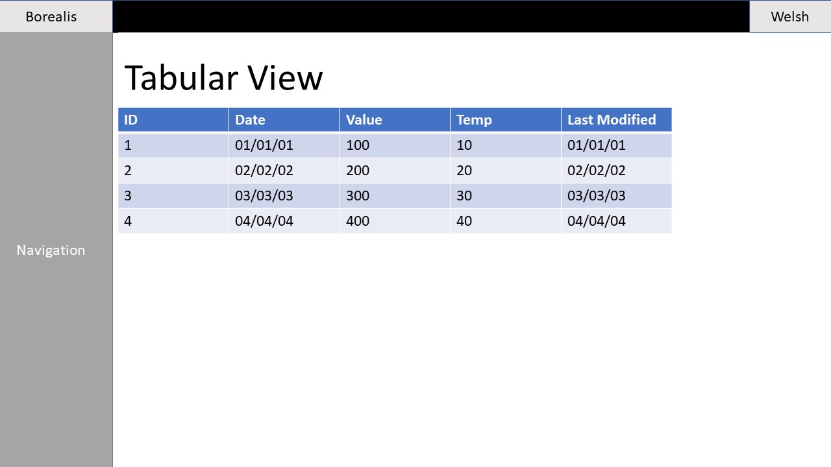

Figure ‑ Tables View Design

#### Settings

The settings view currently serves to adjust the number of elements (maxElements) displayed in the Navigator view. Although additional behaviour was initially concepted and is explored in more detail in Implementation 3.2 Configuration Changes. Malicious tampering is mitigated with the inclusion of both client-side and server-side validation, and CSRF protection.

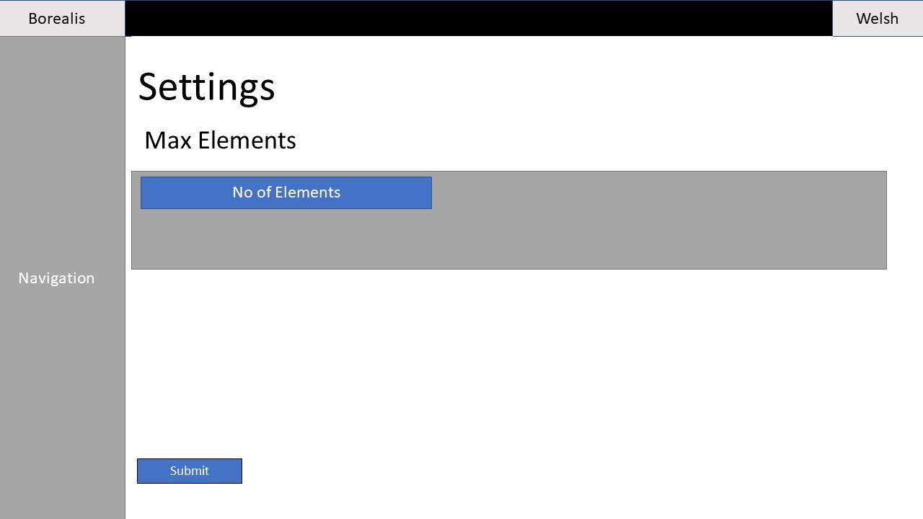

Figure ‑ Settings Design

#### API

A miniscule amount of design went into the appearance of the API segment of the program, as it was intended just to return plain JSON that would be rendered by the web browser or captured by an API client or terminal-based application. Similarly, XML returned by the API was not intended to contain any XSLT (Extensible Stylesheet Language Transformations) [82] to format it. However, a simple mock-up was designed to show what data returned by it may appear like in a web browser:

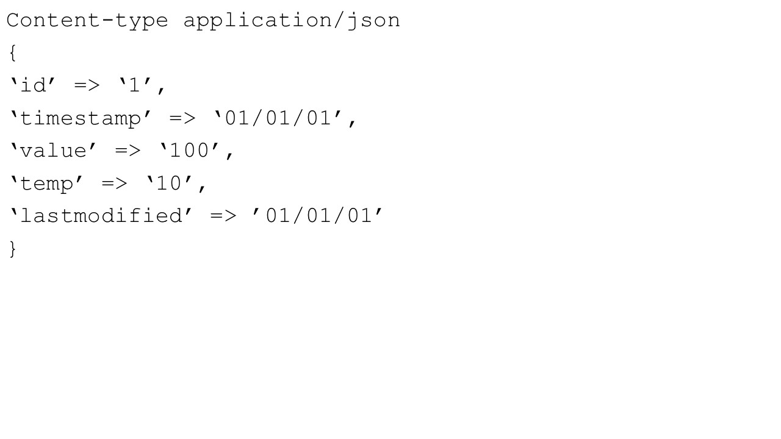

Figure ‑ API Design

# Implementation

## Introduction

In this section of the report, challenges faced during the implementation stage of the project as well as significant diversions from planning will be explored in detail. As previously covered in 2.8 Detailed Design, there is considerable overlap between the sections of Design and Implementation, however this section will focus more on specific issues and diversions from design that justify their own subsections.

## Configuration Changes

As briefly touched upon in the Config subsection of Design 2.8.4, it was originally intended for the application to store its configuration changes in an INI file, a plaintext format file that is widely used to store settings for computer programs of all mediums, including web applications. [83] PHP has built-in functionality for the parsing of such a file into an associative array, but writing entries, or updating existing entries is a more challenging procedure and involves manually locating and writing to entries that would be required when working with any kind of plaintext file. [84]

Not wishing to write a substantial quantity of potentially unreliable code for writing to such a file in order to continue adhering as closely as was possible with the KISS principle, [63] a search for an existing library or code package that would provide this functionality was initiated. After a short while, a library known as Magicalex/Writeinifile was discovered and had all the required capabilities for working with INI files whilst also being compatible with PHP 5.6. [85]

Unfortunately, a lot of difficulty was encountered when trying to get the library to work as intended. It was easy to install using the Composer dependency manager, however writing to INI files repeatedly left missing values or malformed file structure. While this was possibly down to programmer error, there existed a drought of documentation available for the bite-sized library outside of its README document and frankly insufficient time available to painstakingly debug. In the end, a decision was made to refactor the Config module to use a far more crude, but knowingly effective approach at reading and writing to a configuration file. The use of a dedicated associative array PHP file.

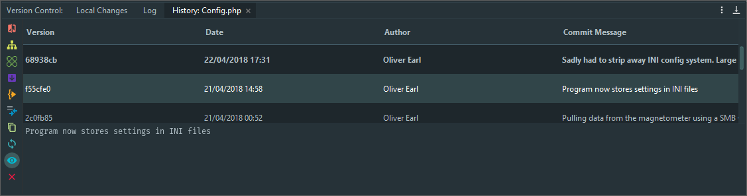

Figure ‑ Git commits showing addition and removal of Writeinifile library displayed in JetBrains PhpStorm.

This method is widely used and liked by experienced developers such as C. LaViska who published an article on his company’s website describing the step-by-step procedure and the benefits of using this technique. [86] However, the way in which data is written to it following changes is significantly more rudimentary, involving exporting the contents of the currently in-memory configuration and manually writing the remaining file syntax to the file itself.



Figure ‑ Code snippet from Config Save Config to Disk Private Static Method

While this use of file writing and concatenation is a code smell, it was an unavoidable evil during development to ensure that a consistent pace could be maintained, and that more essential functionality would not be left unimplemented.

## SMB Connectivity

During the initial stages of the project, prior to the refurbishing and system update of the computer connected to the magnetometer, data was accessed by means of FTP, making programmatic access simple, since PHP includes built-in functionality for the protocol. [20] When the system changed to incorporate SMB as its primary form of access, this meant that a great deal of research had to be carried out to figure out how retrieval was going to happen, and whether it was even possible.

Despite having redundancy plans including configuring software on the connected computer to POST data to the application directly, or to simply request that IMPACS restored access via FTP protocol, a silver bullet was discovered that made them unnecessary. A means of programmatically accessing SMB shares via PHP. This was the open source SMB library by S. Grabaum and R. Appelman, available for install via Composer. [69]

A spike work project was promptly assembled using sample code from the library’s README, the magnetometer share details, and my user credentials to see whether it would work – the expected output was to see all available files within a chosen directory printed to the webpage. Overjoyed jubilation was to follow as the attempt was a success, and work promptly began to construct the Retriever class using this library, fully assimilating it into the project.



Figure ‑ Code snippet from spike work using the SMB library.

If the SMB library had not worked as intended and the project following a more traditional Waterfall, design-heavy approach to software engineering, the project would have gone down a completely different route and would have required substantial design alterations to accommodate, particularly if FTP access could not be re-established. Thankfully in part due to methodology decisions, the project was always ready to adapt to differing means of data retrieval, especially given that this was not planned for concretely.

## Retrieving Magnetometer Data and Data Depth

One unexpected difficulty came up whilst developing the Retriever class and the overall functionality that governs retrieving data from the magnetometer that had a pronounced impact on development.

As previously elaborated, the magnetometer records data to CSV files, with entries approximately once a minute. Each line in the CSV file, each record, contains a LabVIEW timestamp, a measurement in arbitrary units and temperature in Celsius. Files are named FILExxx.CSv where xxx represents a three-digit number, from 001 to 365, representing the day of the year, including trailing zeroes. As of this time of writing, there exists four directories on the magnetometer share, dating back to 2014, each containing a file for most days of the year, the result is a maximum of 1424 CSV files, each containing up to potentially 1440 entries, for each minute of the day. During a database seed, this may have meant that up to over 2 million entries would need to be parsed and entered into a database. This was in the developer’s opinion to be too much data, especially given that for each entry, the timestamp would need to go through a two-step conversion first into a UNIX timestamp, and then into a standard date that would be recognised by the database.

This would also be difficult to represent at the interface. After just one day of database retrieval, one HTML selection box contained over at thousand entries for just one day. It is unlikely that a user would want to painstakingly select which minutes of the day they want to represent graphically. Rather, it is safe to assume they would rather select data for the entire day.

While this would be more than feasible to represent, and still retrieve data in its entirety, it was felt a more elegant solution was needed that would still accurately represent patterns and shifts without the need to save such a quantity of raw data. The algorithm was changed to determine the average value and temperature for each day (each CSV file) and record a single Magnetometer entry with these averaged values. It is hoped that despite this, trends and patterns in readings will still be pronounced when rendered in graphs.



Figure ‑ Code snippet Previous algorithm for retrieving magnetometer data.

During the first attempted full seed of the database using this algorithm, the sheer amount of data transfer temporarily caused the web server to be knocked offline, forcing further development to be done on a different working environment. While it was never formally confirmed that the software was at fault for the downtime, no downtime or maintenance had been planned, and later telephone conversations with staff at the responsible body for IT (Information Technology) services at Aberystwyth University, Information Services, yielded further uncertainty as to the cause. In any case, on the 21st of April as the incident occurred, an apology email was sent to Information Services explaining the situation and sincerely apologising for any inconvenience caused. (Appendix F)

## Overcoming PHP 7.x.x Conditioning

Giving up functionality that a developer might be used to in newer iterations of a programming language or framework is a challenge within itself. S. Ford at the Agile Alliance 2015 conference said that ‘working with legacy code is almost inevitable in today’s development landscape’. [87] Although PHP 5.6 is still supported by The PHP Group and receives active security updates as previously explored [32], this mainly serves to support legacy applications and environments. The truth is that web development is a fast-moving environment that is dictated by the constant evolution of web technologies spanning the entire stack, as evidenced by the rapid evolution of the World Wide Web itself over the past few decades. [88]

PHP is a dynamically-typed language, allowing for the unprompted casting of data from one type to another, such as integers into strings, and vice versa. Many argue that this lack of strict typing allows for more flexibility when developing, but this lack of verbosity can lead to unintended side effects not easily picked up by a debugger or by an IDE – the trade-off manifesting itself as there being less syntax errors but harder to find logic errors. [89]

Scalar type hinting was a welcome addition to PHP 7, allowing for a wider range of possible type hinting. Similarly, the steep rise in popularity of TypeScript, a strongly-typed superset of JavaScript that transcompiles back into JavaScript for running in the web browser [90] is evidence that developers enjoy the benefits of type safety to develop efficient, safe code. Not making use of this functionality, as well as return type hinting, as it is missing in PHP 5.6 was difficult to cease.

Furthermore, the null coalesce operator makes an enormous difference when it comes to writing code. isset() and is_null() are two of the most used built-in PHP functions used throughout the application due to the importance of checking for NULL values and responding accordingly. In PHP 7, this is made incredibly more straightforward:

PHP 5: $result = isset($foo) ? $foo : ‘Not set’;

PHP 7: $result = $foo ?? ‘Not set’;

In short, programming was made more tedious by the continuous need to be aware that a legacy version of PHP is being used, and to be more rigorous with testing when data type cannot be guaranteed.

## Template Debugging

For Twig versions 1.5 and above, an included dump filter allows the user to dump the contents of a Twig variable or results of a function to screen. This functionality was unavailable due to being restricted to version 5.9 of PHP, where the first major release of Twig was the only option. Resultingly, a custom filter bound to PHP’s own var_dump() functionality was required to be created to handle this functionality manually. While this was not a major issue, it was a minor inconvenience caused by legacy software.

In addition, due to the minimal debugging functionality that was available within Twig, a debugging tool in the Graphing View was added and is only displayed when the program’s debug flag is enabled.

## Additional Data Sources

It was intended from the beginning of the project’s inception that retrieving and displaying data from alternative data sources alongside magnetometer entries would be planned, but Complementary, functionality. When it became clear that this would not be able to be delivered even in a modest form without compromising the overall integrity of the program within the short time frame of the project, the primary focus was set on the magnetometer retrieval, and fragments of these abandoned features such as the abstract class DataSource and the stub child class InternetData can be found in the source code. These classes were initially intended, potentially alongside a Radio class, to become fully functional data classes with shared functionality and polymorphic logic.

The refocus on a singular data source however was not executed very efficiently, causing most of the code within what were intended to be agnostic modules, such as Retriever, to become primarily focused with the magnetometer classes and those alone. It would not be impossible to refactor the application to make stronger use of the abstract class and derivative children data source classes once again, but it will take longer and require more reverse-engineering than it would have done if implementation was done more carefully.

## Navigator jQuery

As previously discussed in the Navigator Design subsection, it was originally intended for data selection panels to be dynamically added or removed using jQuery. This partially-working functionality was ultimately deleted in favour of manually specifying the number of elements to display when it became apparent that there was insufficient time to get the functionality finished.

## PHPDoc

PHPDoc (sometimes stylised as PhpDoc) is an adaptation of Javadoc to help document PHP code. [91] Due to the belief in the importance of clear but well-commented code even in an agile workflow, all important classes, methods, and constructors have been provided with a PHPDoc block. Instructions are also provided in the project README on how to compile this into HTML using the phpDocumentor tool.

## Review of Implementation Stage

The implementation was a blend of successes and things that could have gone better. While the majority of the program was completed to more than just an acceptable standard, despite the aforementioned issues that were encountered along the way, aspects could have been done better in issues ranging from maintainable code authorship to adherence to agile methodology through the implementation stage itself. Overall, the implementation was a success in spite of the challenges faced by solo development. Further in-depth analysis will be provided within the Critical Evaluation section of this report.

# Testing

## Overall Approach to Testing

Testing is an integral part of software development and is a core activity of Feature-Driven Development’s five-step process. Following Build by Feature, unit testing and inspection is typically carried out to ensure features are as bug-free as possible and work as intended before being merged into the software build. [29]

Testing throughout the project can be broken down into two main components. Software-aided testing, and manual testing. Software-testing consists of the use of unit tests and code linters to ensure functionality is not broken as features are implemented, and that code remains relatively clean. Manual tests consist of carrying out tests by-hand with both expected and extreme inputs on both a program-wide and individual module basis; the test, expected outcome and results of which were stored in a testing table. Testing on the API was also carried out.

## Software-Aided Testing

### Unit Testing

Unit tests were developed for the majority of public classes for each method of the application. The unit testing framework used is PHPUnit, originally developed by Sebastian Bergmann based on the xUnit architecture shared with the popular Java testing framework JUnit with the purpose of helping to quickly identify code regressions as code is committed. [92]

The structure of the testing directory, which contains PHPUnit tests mimics that of the source ‘src’ directory in this project, with tests in place of where a class file would be. Test classes have taken the same name as the class they are testing, but with a ‘Test’ suffix. Similarly, the test counterparts for class methods contain a ‘test’ prefix. An example is for the class Magnetometer, the testing class MagnetometerTest also exists, and for its method saveMagnetometer(), there exists a testing method called testSaveMagnetometer().

PHPUnit tests can be run at any time with the command ‘composer test’ within the project directory.

Full unit test results can be found under Appendix G.

### Linting

Linting is the automatic analysis of code for potential errors, poor stylistic and logical choices, and code smells in source code. This is an especially crucial step for scripting languages such as PHP or JavaScript as they are not compiled – a process that will often alert programmers to potential errors and poor structure.

For PHP code, the linting tool used is PHP Mess Detector, which will provide a wealth of information in the terminal window. It can be run using the command ‘composer lint-php’ – this is already preconfigured to run on the ‘src’ directory.

It was originally planned to include CSS and JavaScript linting tools, but due to the small amount of code in the aforementioned languages it was decided to omit them. They would also require to be installed using the Node.js npm dependency manager, which would add unnecessary complications to the program structure and ease of program configuration.

Full linting results can be found under Appendix H.

### Difficulties Encountered

Tests were intended to be run on both on one of the development computers as well as on Central. This was necessary due to the firewall constraint explored within the first chapter of this report – tests ran on a development computer, even whilst connected to the campus network were unable to succeed in both establishing a connection to the magnetometer and to the database instance used. However, when attempting to run PHPUnit in the Central environment further problems ensued. As Composer was not installed globally, it was necessary to run it locally, but due to a problem seemingly involving the Linux system configuration Composer refused to run altogether. Attempts to manually run PHPUnit resulted in fatal PHP errors to do with directory resolution. As there was simply not enough time to diagnose and resolve these issues, only the set of results from a development computer have been included.

Linting revealed a multitude of stylistic and structural issues in the program source code, which should be rectified as soon as possible in future revisions of the program.

## Manual Testing

### Graphing Interface Testing

Manual testing of web application functionality was carried out. The behaviour was carried out using ‘expected’ data – data within the typical ranges that the program expects to receive.

The results have been recorded in Appendix I.

### Stress Testing

Additional manual testing using parameters or scenarios that the program does not expect to encounter was also carried out – this is to test the program’s fault tolerance and ability to cope with potential tampering, including CSRF violations.

The results have been recorded in Appendix J.

## API Testing

Specific testing to the api.php application entry-point have been conducted on the program – this is stored in its own testing table with both expected and unexpected values. This testing was carried out using APITester.com, which supports both GET and POST requests supported by the program and can record the responses that are returned.

The results have been recorded in Appendix K.

## Known Bugs

There are three serious known bugs that affect functionality and behaviour within the program that have are yet to be rectified and were identified using software testing. They may be fixed prior to project delivery, but as this is not guaranteed, they are documented here and are also reflected on in the testing results.

The first is regarding the magnetometer retrieval algorithm. Due to a potential flaw with how the application works with dates – formatting for them for use with magnetometer files, and then saving the date to the program’s config file to mark the current day’s retrieval as complete, the program may sometimes retrieve data more than once for a given day. This can lead to multiple entries, or more commonly errors indicating that a magnetometer entry already exists – this is an error message only intended to be seen when the user issues a manual override retrieval command and the latest entry already exists within the database. This bug presents no issues to program stability, but rather data integrity and must be rectified as soon as possible. It was found through manual testing and application usage.

The second bug identified is on the Graphing View. When working with a large amount of entries, the ‘Export JSON’ and ‘Export XML’ buttons can sometimes generate ‘Request URI Too Large’ errors. This is due to a flaw in the exporting algorithm. API paths are constructed using GET in mind, and too many entries can generate an exceedingly long URL that cannot be handled by the web server. To fix this, the buttons must pass information to the API using POST instead of GET. This bug was discovered during manual testing on the Graphing View using ‘Display All’.

The third and final bug discovered pertains to the API. Even with properly constructed POST requests, the API almost always returns Request 400 Bad Request, which it is programmed to do when receiving malformed request. Additional refactoring is required in the API to ensure that this functionality remains working. This was discovered during API testing and is shown in Appendix K.

# Critical Evaluation

## Introduction

In this section of the report, a critical analysis and evaluation of the success of the project, from the initial research, through the combined design and implementation of the software application, as well as the efforts taken to test the program throughout all stages of development. Additionally, the agile methodology that underpins the project will be examined in detail to identify whether it was applied correctly and suited the objectives of the project.

Finally, both the notable achievements and shortcomings of the project will be identified and explored in detail, before providing an overall conclusion to the project and personal evaluation and mark estimation of the work carried out.

## Identification of Requirements

Although the project began as flexible, broad topic area where requirements and use cases could be established by the developer themselves, provided certain criteria involving the usage of the FGM-3 magnetometer were met, the project’s requirements were both quickly and thoroughly established.

It was quickly identified that the project should benefit the pre-existing users of the magnetometer and the data it provides; making it easier for said data to be accessed, explored, and/or manipulated. The data was quickly found to be cumbersome to work with, so the program should make it simple to access programmatically for use by scientific applications and data processing tools.

Throughout the initial identification and objective analysis however there consisted a slight grey area that caused some unnecessary lack of clarity. This was determining under what environment or computer system the application would be running under – whether it would be running on a system such as Central, or whether the application would be able to be run on a dedicated computer or virtual machine that still had unhindered access to a database instance and to the magnetometer itself by being located also behind the university firewall – which was one of the biggest constraints discovered in the process.

While this lack of clarity was very well worked around and the most safe cause of action was taken, and ultimately a good, working piece of software was produced, had these factors been more concretely investigated, software could have been built to leverage technologies that might have been available on the aforementioned dedicated platform, such as PHP frameworks like Laravel, or other programming languages perhaps better suited, such as Python with Django, or Ruby on Rails, in their entirety, rather than developing it in a legacy distribution of a language without fundamental dependencies on modern third-party frameworks.

## Design and Implementation Retrospective

The design of the program went considerably well but was kept to the minimum mandated by Feature-Driven Development. After an initial plan and feature list were constructed, with basic plans for larger algorithms and patterns of behaviour constructed, Design by Feature could take place, with smaller algorithms and planned class-wide behaviour being modelled. Consequently, this report features plenty of detailed sequence and class diagrams elaborating the program’s design and intended functionality. There is a large amount of overlap between Design and Implementation, namely due to the continuously evolving design that continued to model the actual implementation as development proceeded – this is a major causation for the significant overlap between the two segments within this report.

The implementation of the program solely on the other hand was not without its shortcomings. Although the program is functional and meets the requirements that were set forth in the initial stages of the project, code and the functional layout of the program were not consistently developed with sustainability, ease-of-maintenance, and futureproofing in mind. While some areas of the program, such as the Renderer, would continue to work in a continued way as the program evolved and was expanded upon in potential future releases, other areas such as the Retriever especially would require significant refactoring to accommodate other data sources. It was initially planned that development would concentrate on polymorphic design, so that all classes derived from DataSource would be supported, but as development pigeonholed onto magnetometer retrieval specifically, this ceased to be the case.

In conclusion, although development was successful and produced code of a sufficient, industry-level quality, and a functional application, more could have been done to ensure the implementation went smoothly and was more consistent throughout. Additionally, the design phase of the program should have documented changes as they evolved throughout implementation, rather than solely existing in the state they are now.

## Suitability of Tools

The PHP programming language has been used for decades as a backend web application language, ranging from content management systems and blogging platforms such as WordPress, to RESTful services, and enterprise level applications.

Granted, many of these applications will run with a framework that leverage the power of the programming language whilst making complex applications easier to develop by means of control inversion and inclusion of complicated functionality. It is important to remember however that under the hood; the technology remains the same. PHP continues to be a popular language for the web, and while not as previously discussed as specifically designed for data processing as Python-based or Ruby-based solutions, the choice of language was sound.

Furthermore, JavaScript is the dominant language on the web, and by making use of the extensive Chart.js library and the HTML5 canvas, stunning, dynamic graphs can be generated using data retrieved from the backend.

Overall it is believed that the choice of technologies on all aspects of the application were solid.

## Code Quality

Every effort was taken during implementation to produce excellent quality code. While the presence of some code smells is an inevitability even in large software companies, a sizable amount of effort was taken to ensure that code was self-explanatory, in adherence to the PSR coding standards as closely as possible, (in the case of PHP code) and was properly commented for future developers or maintainers to fully understand the purpose of each important function and class.

The use of linting tools brought to light additional issues with code that should be refactored as early as possible, particularly with the overuse of static methods in methods, which is a common code smell. Nevertheless, the program operates fine minus a few identified bugs. HTML mark-up within templates has been formatted with great care and conforms to the HTML5 standard as closely as possible. No issues have been identified with CSS or JavaScript code within the project.

It can be safely concluded that while there are some persistent smells in the source code of the project, the quality is particularly good, with a prominent level of documentation that is expected of enterprise or academic level software.

## Project Achievements

### Short Analysis of Data Findings

Following the completion of the Borealis application, interest was quickly garnered at the visual representation of magnetometer data it displayed. It was immediately obvious upon initial inspection of graphed data that while data was mostly consistent, there were notable events that are hypothesised to correlate to real-world events.

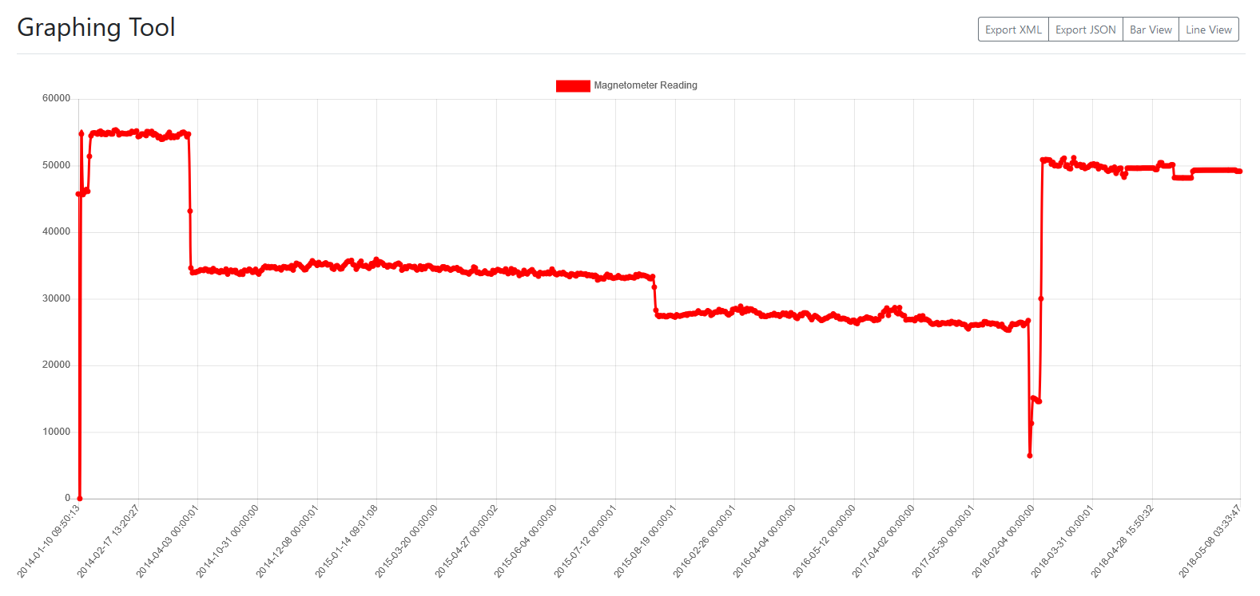

Figure ‑ Display All View - Displaying All Magnetometer Data

The first notable period, besides an anomalous entry reading of zero is according to D. Price of IMPACS during the initial usage period of the magnetometer whilst it was being hosted in an astronomy hut in Frongoch Farm.

Eventually the magnetometer was moved to the Physical Sciences building on Penglais campus, Aberystwyth University. The decline in readings is reportedly due to electromagnetic interference present from the building, most notably from the building’s elevator, causing the accuracy of magnetometer readings to decline substantially. Interestingly, after moving the instrument to another area of a laboratory, the reading declined again significantly, unbeknownst to researchers at the time.

The reasoning for the following short-term plummet in readings is not concretely known but is believed to be due to moving the device to another laboratory, potentially the underground Intelligent Systems Laboratory (ISL) – where it and the coupled computer system were refurbished and provided with a new operating system.

Following refurbishment, the entire system was returned to Frongoch Farm, where readings several years on are more reminiscent of the readings initially taken after its first deployment as the researchers knew by this point in time that more accurate readings would be available in an environment free of electromagnetic interference. The reason for the decline in value following re-deployment compared to its initial deployment is currently unknown.

The significance of these findings is that it validates one of the objectives of the application, and one of the desires for undertaking the project in the first place – providing substantial academic and/or scientific value to those working with the magnetometer or looking to track trends in magnetospheric activity in relation to solar activity, or perhaps more humorously, its location within a laboratory.

### Adaptability

The project, as explored in-depth throughout this report has presented a large amount of challenges, particularly during the implementation stage. Due to the adherence of the Feature-Driven Development agile methodology and not the use of concrete, Waterfall-like methodologies, rapid adaptations were able to be made when circumstances changed, such as the indefinite postponing of additional data source implementation due to time constraints and difficulties with the magnetometer functionality.

As such, rebounding from issues such as non-working libraries and working within the bounds of such tight software constraints and nevertheless producing a piece of software that successfully fulfils its desired features and functional requirements demonstrates a great deal of agility and adaptability; themes that are personally believed to be present in all stages of the project and contributed substantially to its success.

### Emotional Resilience and Self-Motivation

J. Atwood, most notable as one of the cofounders of the popular programming discussion message board Stack Overflow warns us of the failings of solo development in his blog: ‘Working alone means complete control over a software project, wielding ultimate power over every decision. But working on a software project all by yourself instead of being empowering, is paradoxically debilitating.’ [93]

An academic undertaking such as this project is not an easy feat. Unlike most real-world scenarios where groups of software engineers will work together, quite often in pairs or agile teams to accomplish work, working on something independently means that one person is solely responsible for ensuring that work is continuously delivered and that all features or functional requirements are met. Furthermore, said person is responsible for all aspects of the project, from analysis, to design, through implementation and testing.

Throughout the project, despite difficulties balancing its necessary workload with additional responsibilities, namely assignment work issued from the Department of Modern Languages, part-time employment, voluntary undertakings, and the day-to-day routine and requirements of undergraduate life, the project has been delivered in a punctual manner, and the developer has remained resolute, self-motivated, and enthusiastic throughout.

## Project Shortcomings

### Discipline in Agile Methodology

Although Feature-Driven Development was argued to be a more appropriately fitting methodology for this project over Scrum, which was initially proposed as the working methodology, the adherence to the methodology was not perfect.

While the overall adherence to the methodology was mostly successful and was as previously described a major contributing factor to the general success of the project, there were lapses in developer discipline, where the principles and guidelines of the methodology were not consistently followed. As time constraints became more pronounced and supplementary functionality was forced to be put on hold, there became more of an emphasis on producing working code and ensuring functionality was delivered, rather than strictly abiding by the agreed development methodology. A noteworthy example of this was the inconsistency of unit testing and the implementation of testing in its entirety.

In Feature-Driven Development, unit tests are expected to be produced along with features in the Build by Feature stage of an FDD iteration. Although some smaller classes do have comprehensive unit test files built in PHPUnit, some of the larger, more significant classes do not have as thorough counterparts. In defence of the implementation process however, this was partially due to a limit of public methods that could be tested, and not having anything more than a beginner’s understanding on how to set up tests to work with protected or private methods provided further limitations. As tests were produced lackadaisically and almost always retroactively, this hindered obedience to the methodology and hurt development overall.

On an additional note, further research has indicated that agile methodologies specifically adapted for use by solo developers exist, almost all of which are derived from Extreme Programming, where the focus on pair programming is shifted toward aggressive refactoring and working through problems systematically. [94] One such suggestion was made to incorporate rubber duck debugging – the act of talking aloud, often to a rubber duck or other inanimate object to help work out the cause of a problem, to mitigate the need for pair programming. [95]

### Workflow and Continuous Integration

It was initially planned to make use of JavaScript workflow tools, particularly task runners such as Grunt in development – taking care of the minification (and transcompilation if using superset languages like TypeScript) of JavaScript and CSS code, the automatic linting and tidying of PHP code, and using Git triggers to ensure that unit tests pass before code can be committed to the repository to help prevent code regressions.

The use of a fully-pledged IDE negated the need to use this kind of workflow as it itself can be configured to carry out tasks automatically and to run tests or use its built-in linter prior to committing changes. This meant that a Node.js installation wasn’t required, or an associated package.json file was not required to use now redundant JavaScript workflow tools. Furthermore, CDN usage was opted over the use of downloading and minifying (or transcompiling) of frontend frameworks, particularly Bootstrap, which ultimately makes the project easier to maintain.

While this all would appear to be good news, it did mean the project had no Continuous Integration (CI) tools or configuration in place. This means that unless PhpStorm with the correct project configuration files were in use, which are files that are almost always excluded from Git repositories, then there would be nothing preventing a developer from committing inadequate quality code or regressions to the repository.

This did not have a massive impact on the project as it was developed by a solo developer, but it could have been catastrophic for larger or growing software projects. In the future, developers or maintainers should consider adopting workflow tools such as task runners or watchdogs like Grunt or Gulp to carry out automatic tasks, and to use Git triggers to ensure certain criteria are met prior to allowing code to be committed.

In essence, the developer did good to make effective usage out of the powerful tools provided by the IDE but should have taken more time to set up the aforementioned tools in order to ensure development remains sustainable, particularly if it is taken on by other developers in the future.

### Further Improvements to Testing

Aside from the previously discussed inadequacies in consistent unit test production, more types of tests could have been produced to help constitute a more thorough approach to application testing.

It was established that the targeted user for the program are academic researchers and students within IMPACS. Acceptance testing carried out with the target audience would have provided valuable information as to whether the current state of the system and its user interface were acceptable in their eyes.

Further to the discussion of user interface, testing tools such as Cucumber could be used to programmatically test user interfaces, where tests are written to emulate user behaviour when interfacing with a GUI.

In conclusion, while testing was sufficiently thorough for the project, much more could have been implemented by the developer to provide more comprehensive testing data, and what was carried out could have been accomplished in a far more efficient, agile manner.

## Project Conclusion

The title of the project is ‘The Collation and Graphical Representation of Magnetometer Data to Track Solar Activity Using a Web-Based Application’ – broken down into its key components, the following can be established:

* The project collates and graphically represents magnetometer data
* This data tracks solar activity, or corresponds to solar activity
* The application is web-based

The project goes beyond the collation and graphical representation of data; providing additional means to programmatically access data purely for the benefit of academic researchers and students. While the choice of the term ‘solar activity’ is perhaps in hindsight questionable, the magnetometer exists almost exclusively for this purpose – recording the Earth’s magnetosphere in response to solar events and activity. The application does not itself provide any correlation or comparison of recorded data to solar activity, nor does it record information regarding such events – it purely records data from its data source. If the program had implemented other data sources, as may be the case in future revisions, it would record data from those also. The Borealis application is thereby an extension of the instrument’s purpose – making data recorded for monitoring solar activity more accessible, or graphically visible. The application is also of course, web-based, and thus this criterion is also met.

If it were possible to start the project again, more focus would be put into ensuring disciplined adherence to the chosen agile methodology, which would likely be one of the previously discussed flavours of Extreme Programming better suited for solo development.

If it were possible to extend this project by another month or so, an aggressive refactoring to eliminate code smells and difficult to maintain code would be pursued; opting to go back to the initial polymorphic design incorporating abstract classes.

If the outcome of the marking of the project was at the developer’s discretion, it would be graded as first class. The reasoning is as follows:

* Although the loss of additional data sources has sizably shortened the complexity of the application, the intricacy of the algorithms behind downloading, processing, storing and later reusing data from the magnetometer are interesting, well-documented, and effective.
* The development process has adhered to the agile process as much as possible, whilst also incorporating common software engineering principles such as KISS.
* The software, while being as self-documenting as possible, is additionally well documented.
* This report has hopefully been an interesting and inciteful read into the ability and habits of the software engineer responsible.
* The project has the capability of providing future use to IMPACS.

To finalise this write-up, the application was a fulfilling and enjoyable experience to implement and provided an invaluable learning experience. This project was in the eyes of the developer an undeniable success and fulfilled all criteria that it needed to meet. The undertaking was the perfect contrast between challenging and occasionally stressful, whilst also a strong opportunity to learn more about object-oriented web program development, APIs, and working in such confined conditions and legacy code that are highly likely to be real-world scenarios in industry. The steps that were taken to accomplish this project were careful, even if they were not always meticulously planned.

While at the beginning of the project feelings ranged from mild apprehension to what could only be described as downright terror at the thought of attempting to construct a program and produce designs of this magnitude, but in hindsight they were simply natural anxiety manifesting because of undertaking something new when it was important to also succeed and to produce a high-quality end-product.

# Appendices

* 1. Third-Party Code and Libraries

**Bootstrap 4.0.0; Dashboard Template**

License: MIT

Description: HTML/CSS Framework

**jQuery 3.3.1**

License: MIT

Description: JavaScript library for DOM interaction.

**Chart.js 2.7.2**

License: MIT

Description: JavaScript charting/graphing library.

**Sgrabaum/SMB**

License: MIT

Description: PHP wrapper for smbclient and libsmbclient-php

**Twig 1.35.3**

License: BSD-3-Clause

Description: Flexible, fast, and secure template engine for PHP.

**Monolog/Composer 1.23.0**

License: MIT

Description: Logging and logfile library for PHP.

**Composer / Composer Autoloader**

License: MIT  
Description: PHP Dependency Manager and autoload generator.

**PHP Mess Detector (phpmd) 2.6.0**

License: BSD-3-Clause

Description: PHP Linting tool

**PHPUnit 5.7**

License: BSD-3-Clause

Description: Unit testing framework for PHP

* 1. Ethics Submission

**AU Status**

Undergraduate or PG Taught

**Your aber.ac.uk email address**

ole4@aber.ac.uk

**Full Name**

Oliver Earl

**Please enter the name of the person responsible for reviewing your assessment.**

Reyer

**Please enter the aber.ac.uk email address of the person responsible for reviewing your assessment**

rrz@aber.ac.uk

**Supervisor or Institute Director of Research Department**

cs

**Module code (Only enter if you have been asked to do so)**

CS39440

**Proposed Study Title**

The Collation and Graphical Representation of Magnetometer Data to Track Solar Activity Using a Web-Based Application

**Proposed Start Date**

29/01/2018

**Proposed Completion Date**

04/05/2018

**Are you conducting a quantitative or qualitative research project?**

Mixed Methods

**Does your research require external ethical approval under the Health Research Authority?**

No

**Does your research involve animals?**

No

**Are you completing this form for your own research?**

Yes

**Does your research involve human participants?**

No

**Institute**

IMPACS

**Please provide a brief summary of your project (150 word max)**

The project is designed to make the retrieval of data from a magnetometer owned by IMPACS stationed near Penglais Farm substantially easier, by autonomously retrieving data from it and making it available through its web-based graphing interface, as well as through an API that can provide data in the form of JSON.

**Where appropriate, do you have consent for the publication, reproduction or use of any unpublished material?**

Not applicable

**Will appropriate measures be put in place for the secure and confidential storage of data?**

Yes

**Does the research pose more than minimal and predictable risk to the researcher?**

No

**Will you be travelling, as a foreign national, in to any areas that the UK Foreign and Commonwealth Office advise against travel to?**

No

**Please include any further relevant information for this section here:**

Not applicable.

**If you are to be working alone with vulnerable people or children, you may need a DBS (CRB) check. Tick to confirm that you will ensure you comply with this requirement should you identify that you require one.**

Yes

**Declaration: Please tick to confirm that you have completed this form to the best of your knowledge and that you will inform your department should the proposal significantly change.**

Yes

**Please include any further relevant information for this section here:**

Not applicable.

* 1. Undergraduate Classwork by D. Langstaff

This appendix is a piece of university coursework aimed at second year Physics undergraduate students at Aberystwyth University by D. Langstaff. The worksheets come from the module PH25520 Experimental Physics in 2014.

The appendix is three pages long and begins on the next page.

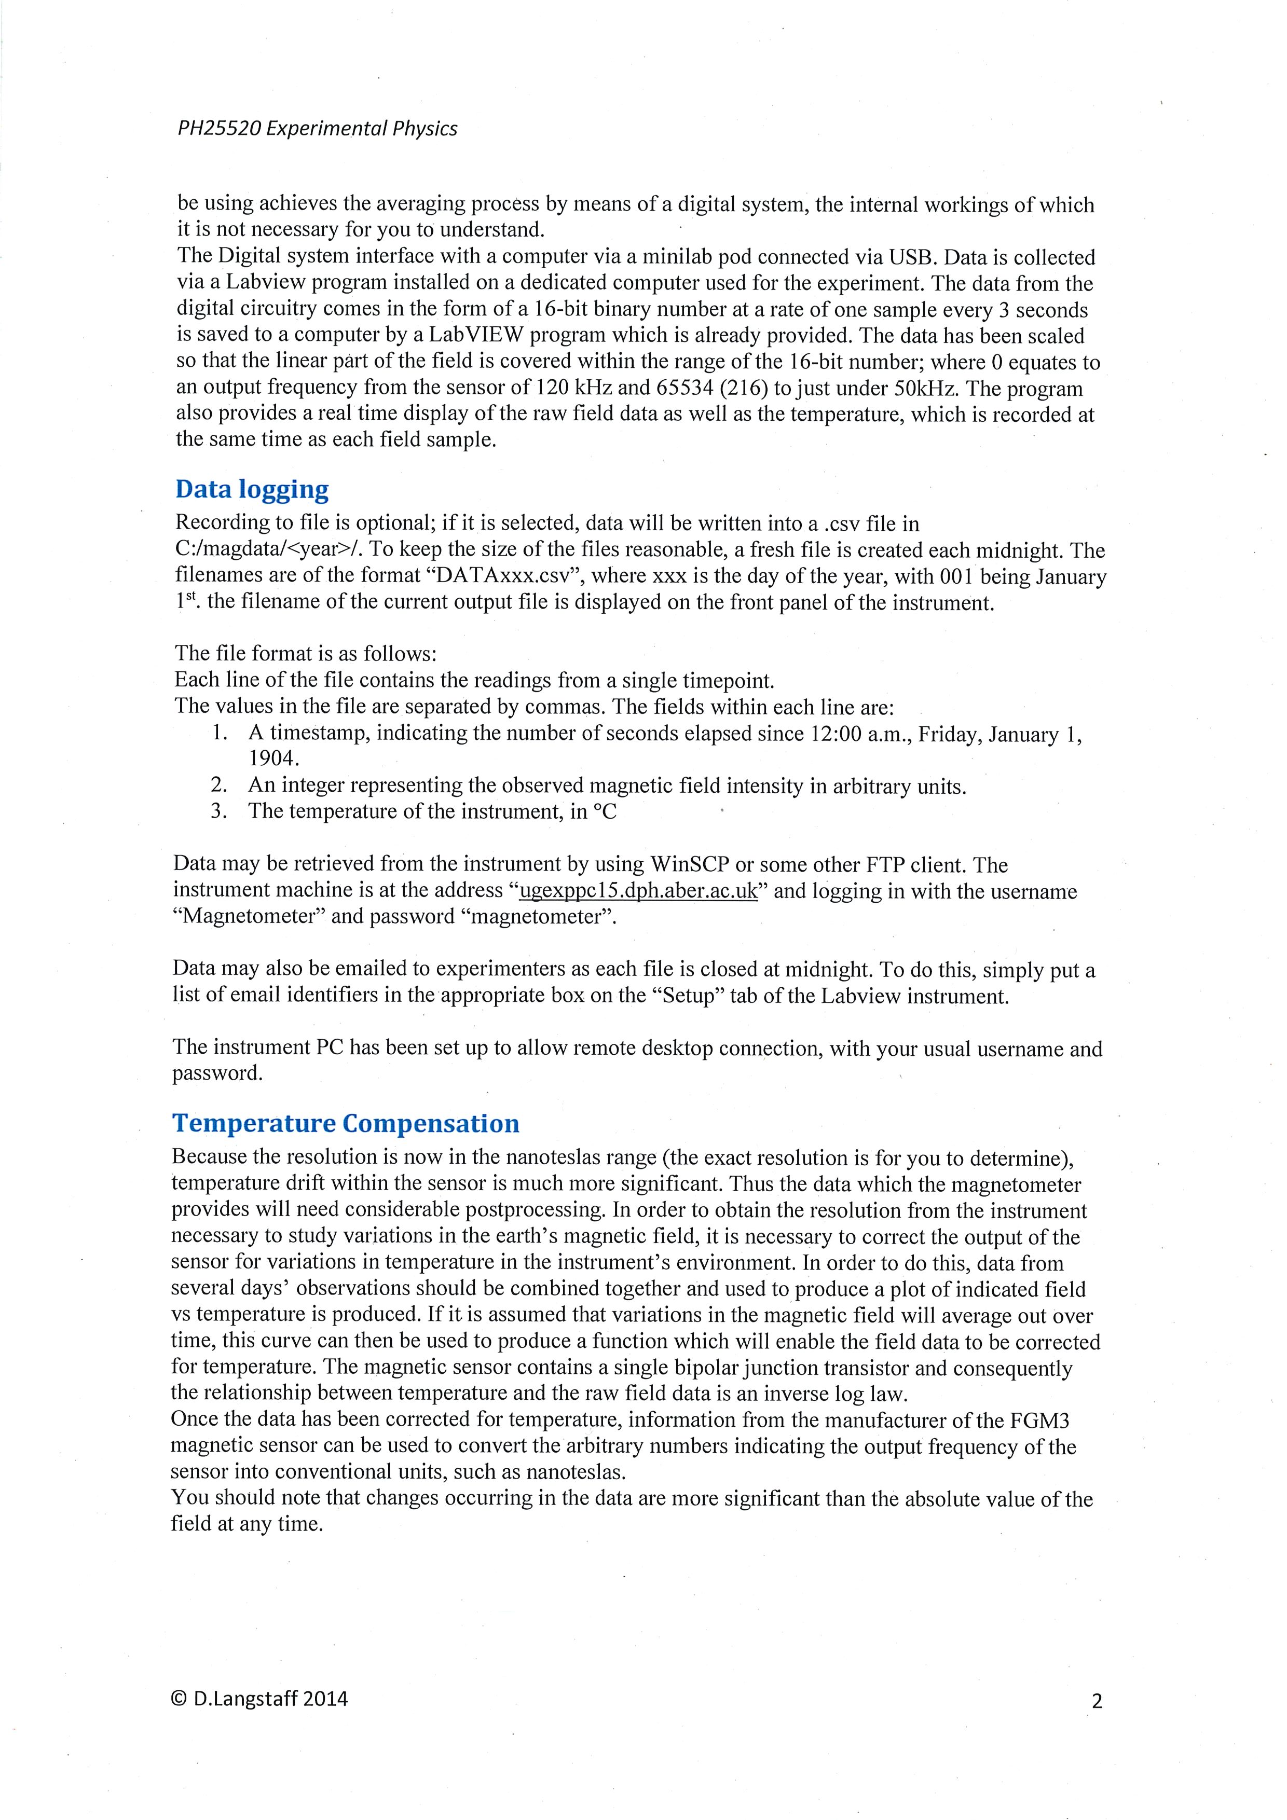

* 1. FGM-3 Magnetometer Technical Documentation

This appendix is a comprehensive technical document explaining the technical underpinnings of the FGM-3 magnetometer sensor.

While it is twenty-two pages long, it has been included for the reader’s convenience should they wish to learn more on the inner workings and functionality of the instrument, particularly since the materials are difficult to find online. It begins on the next page.

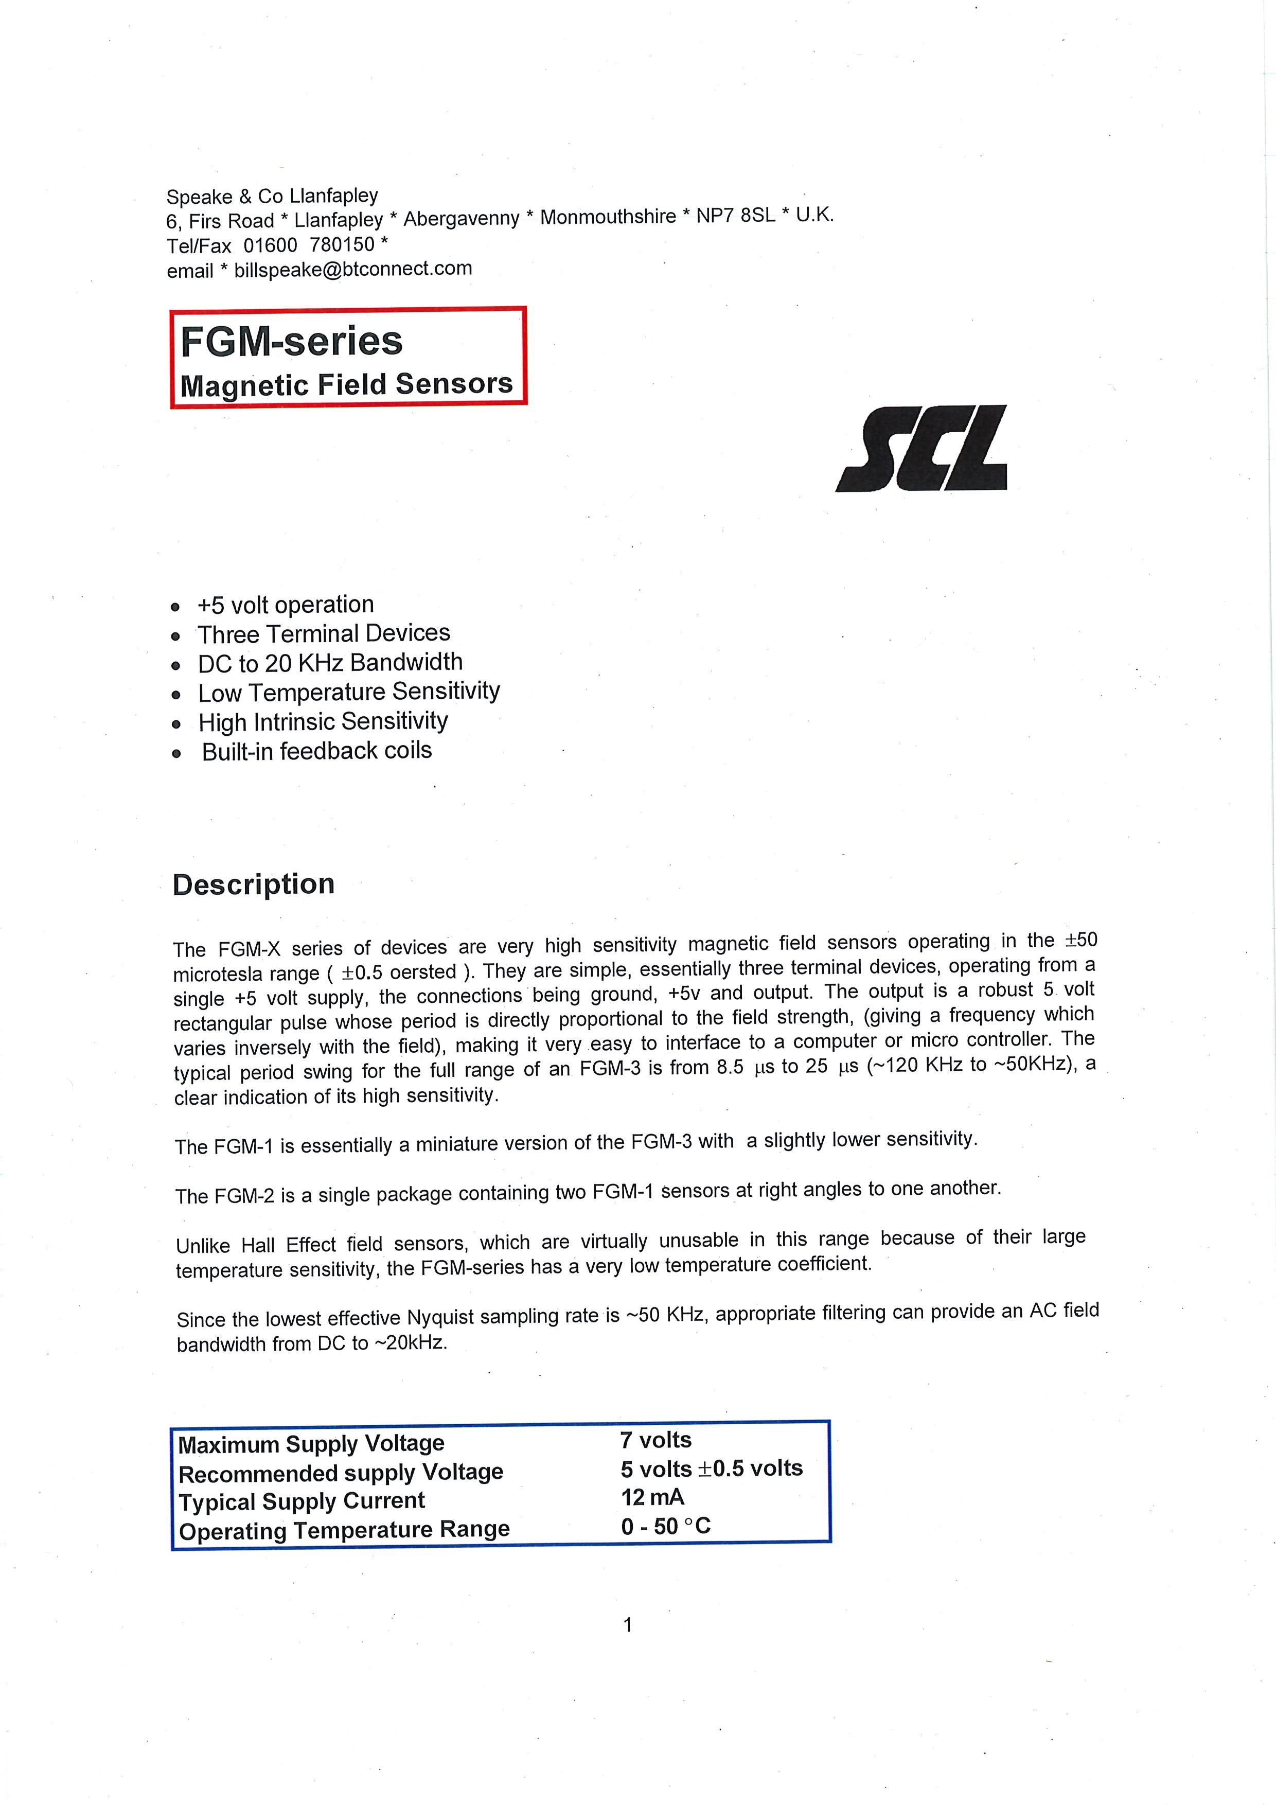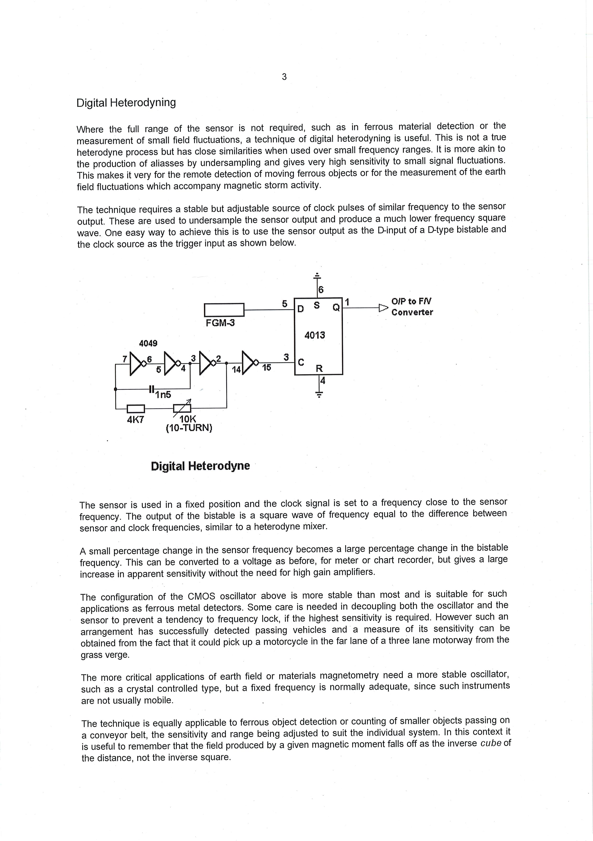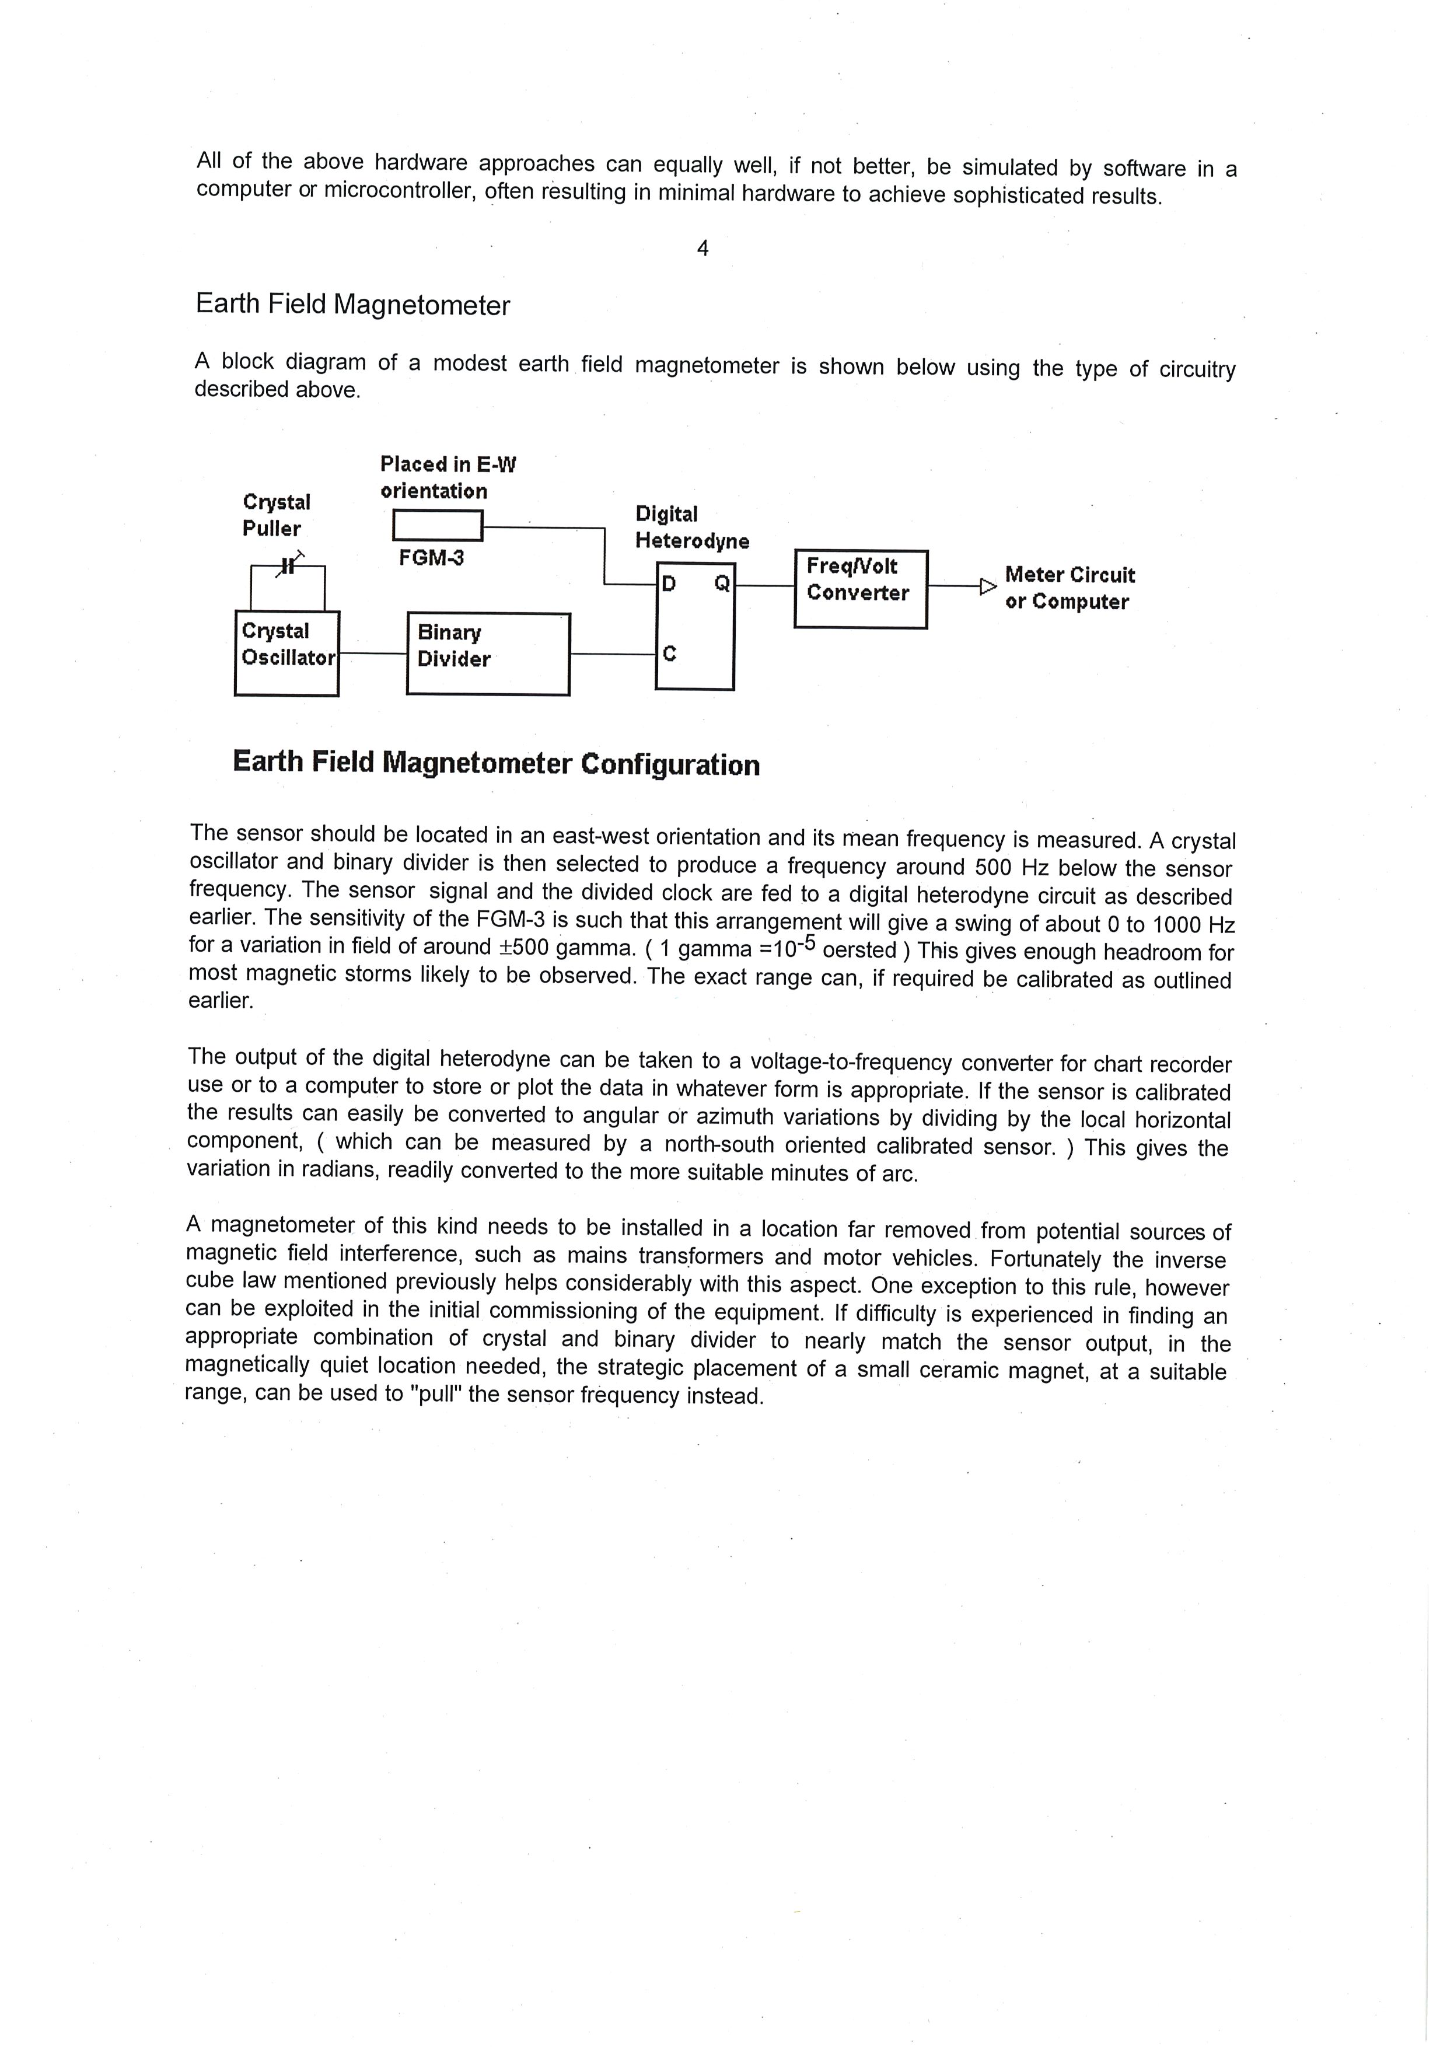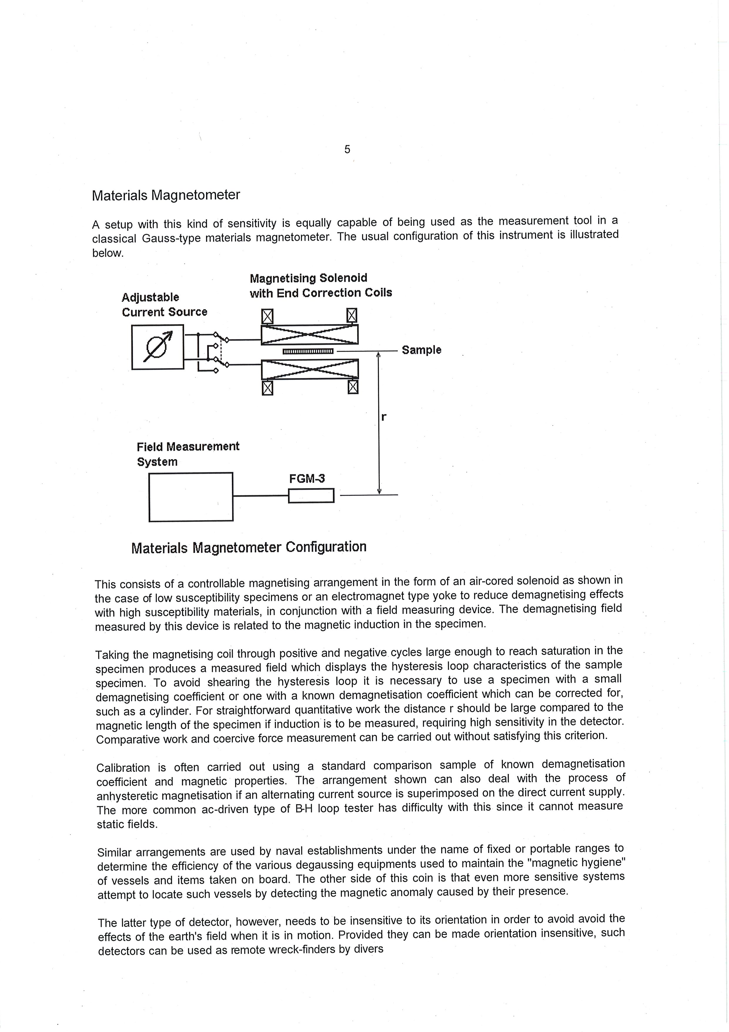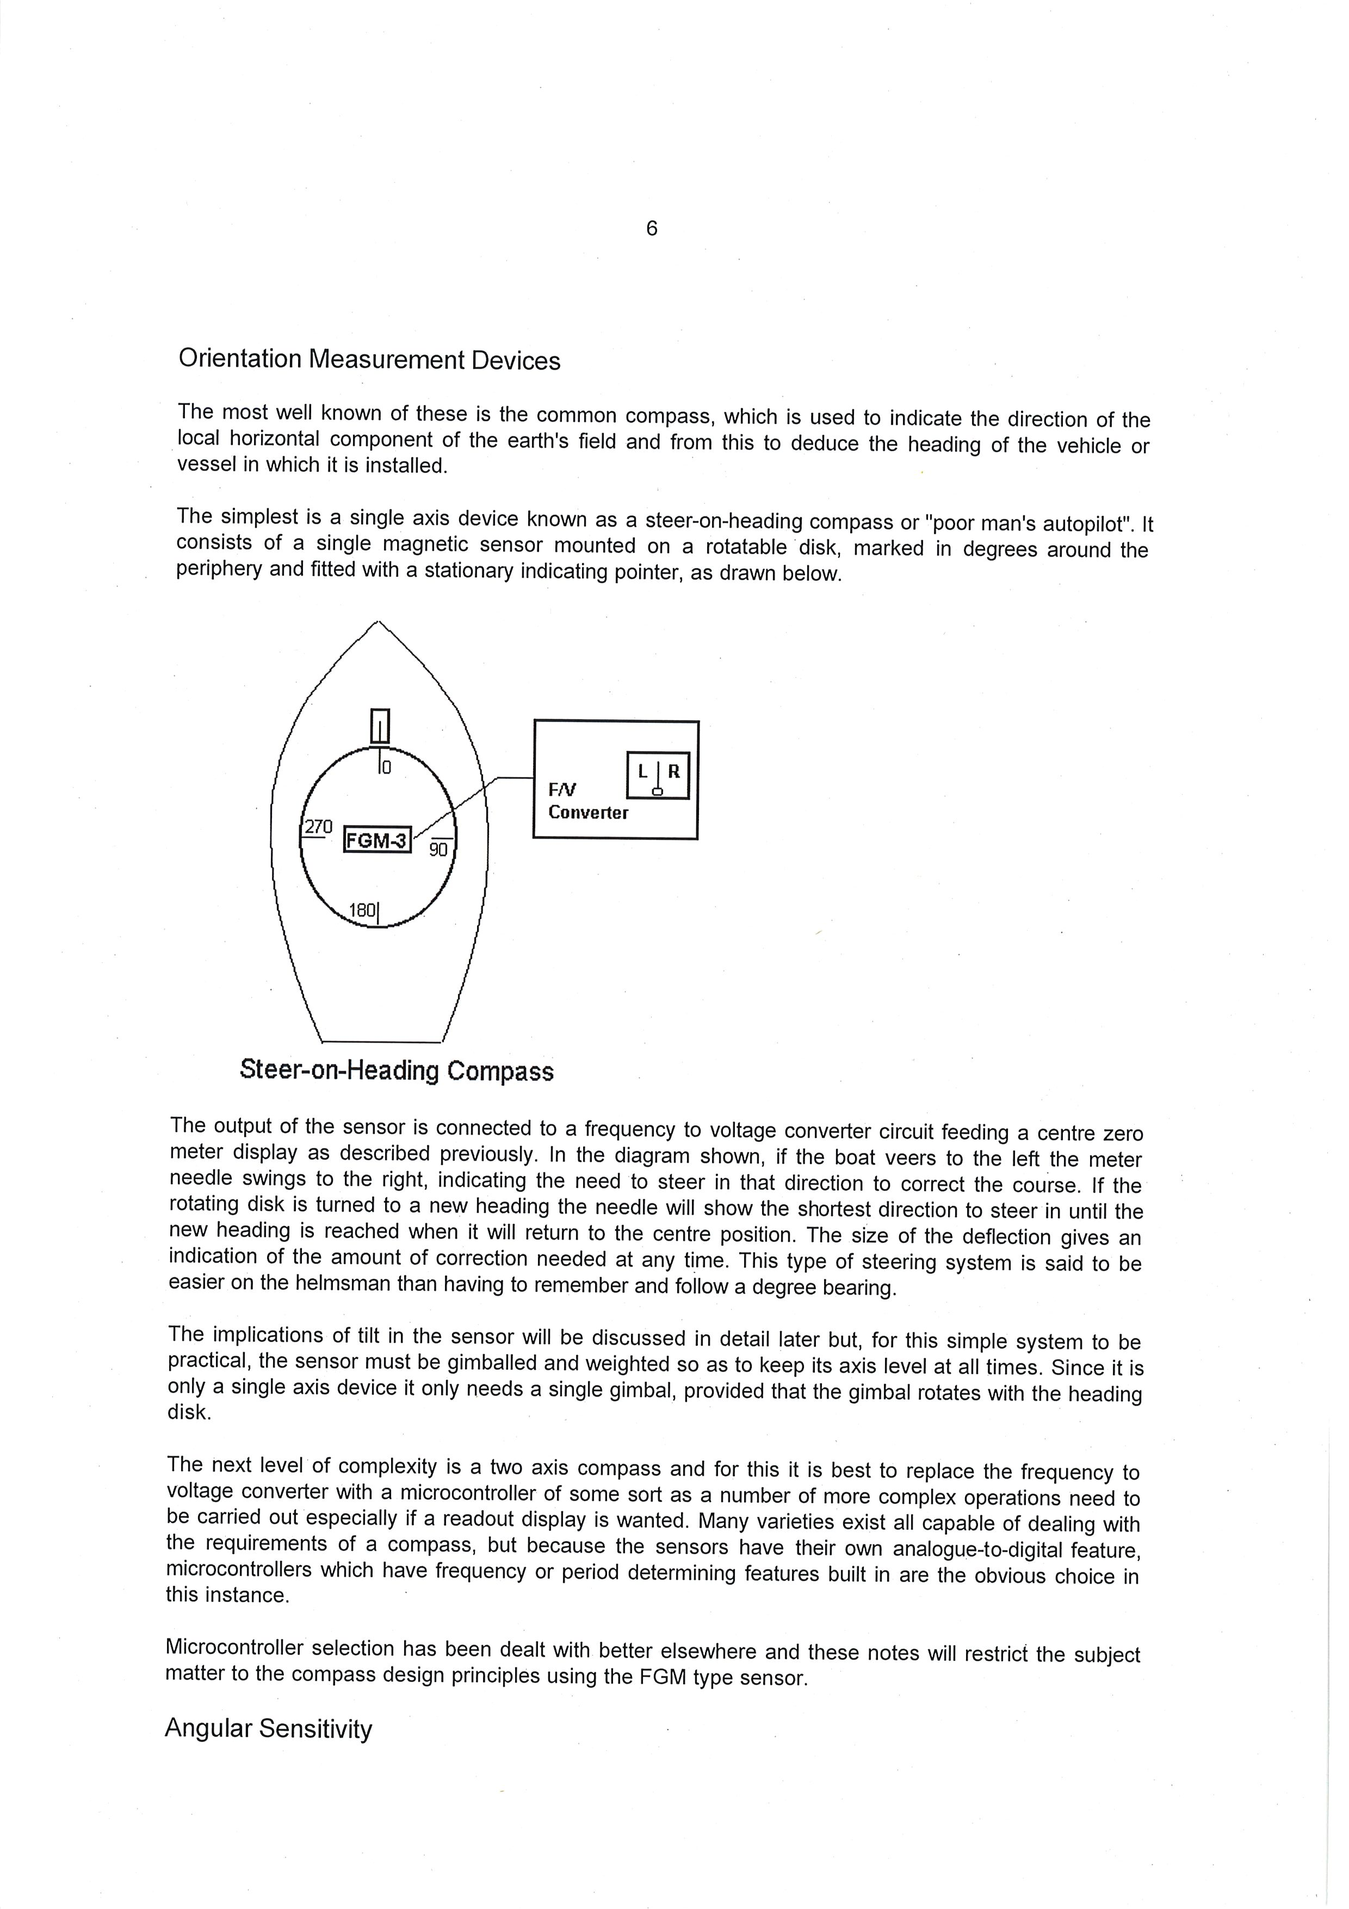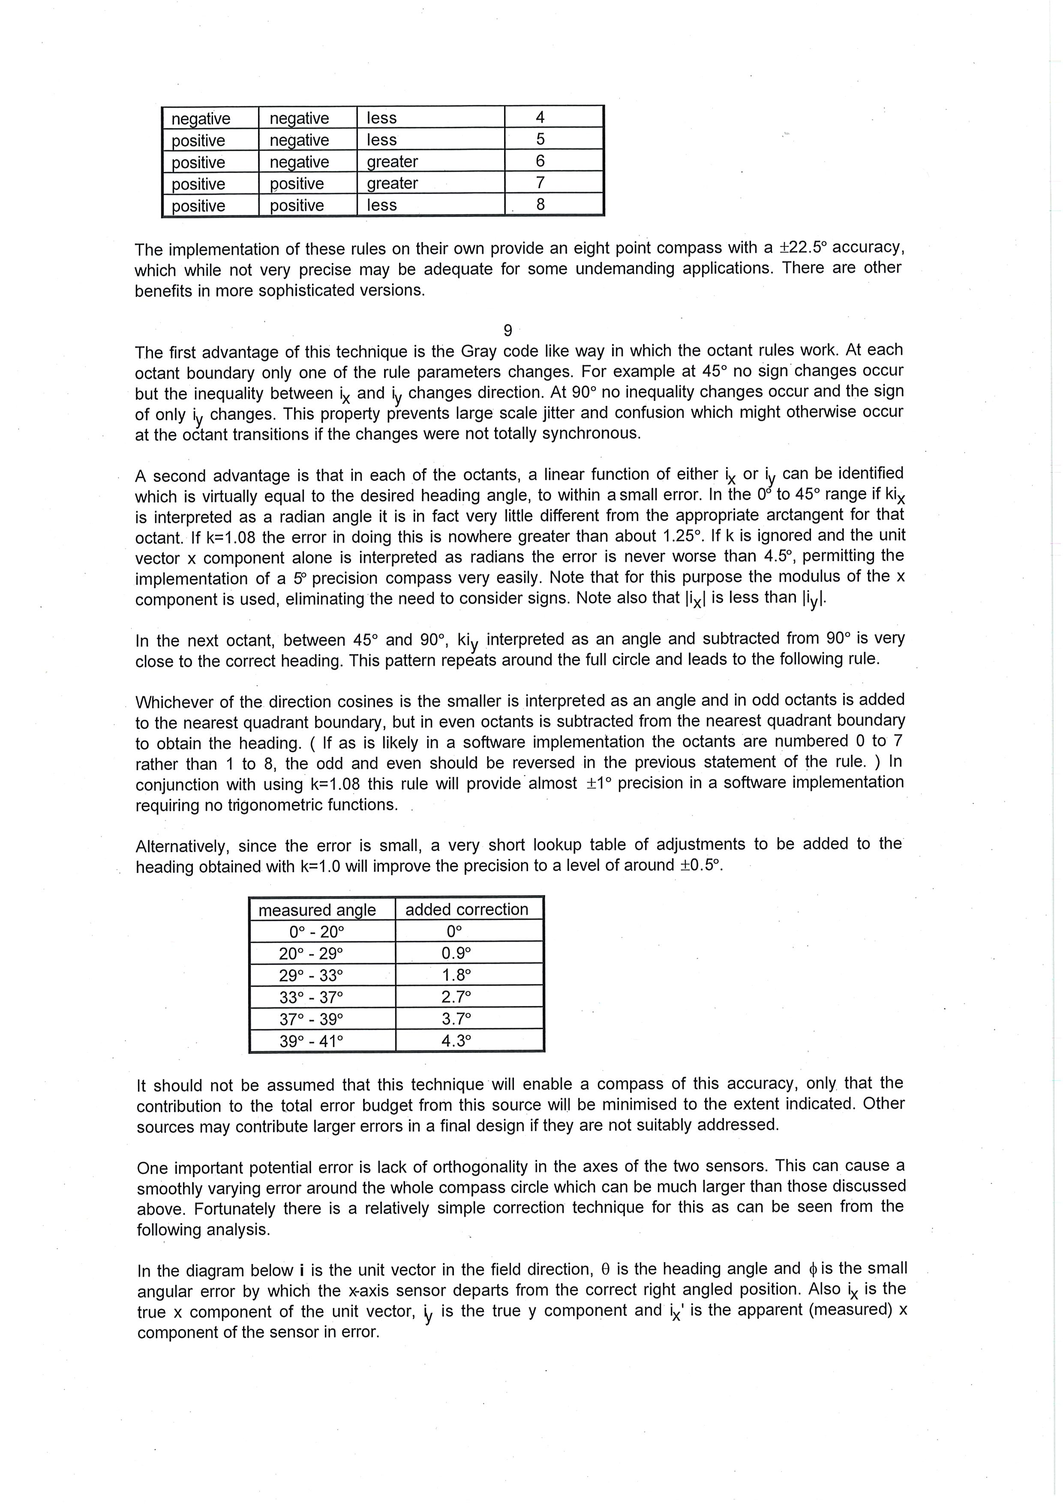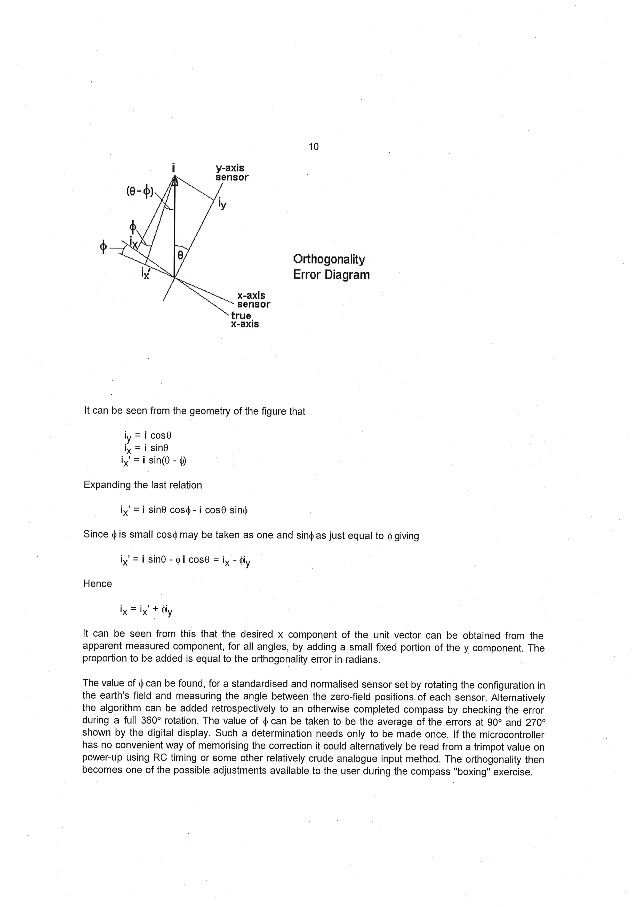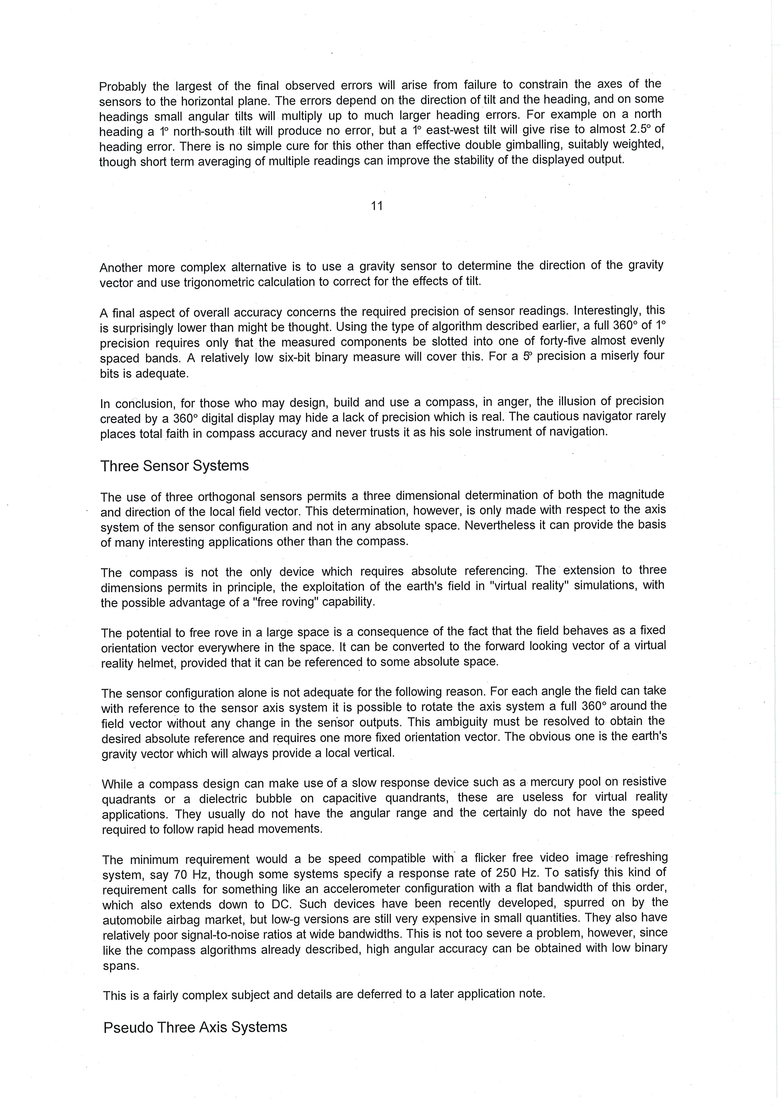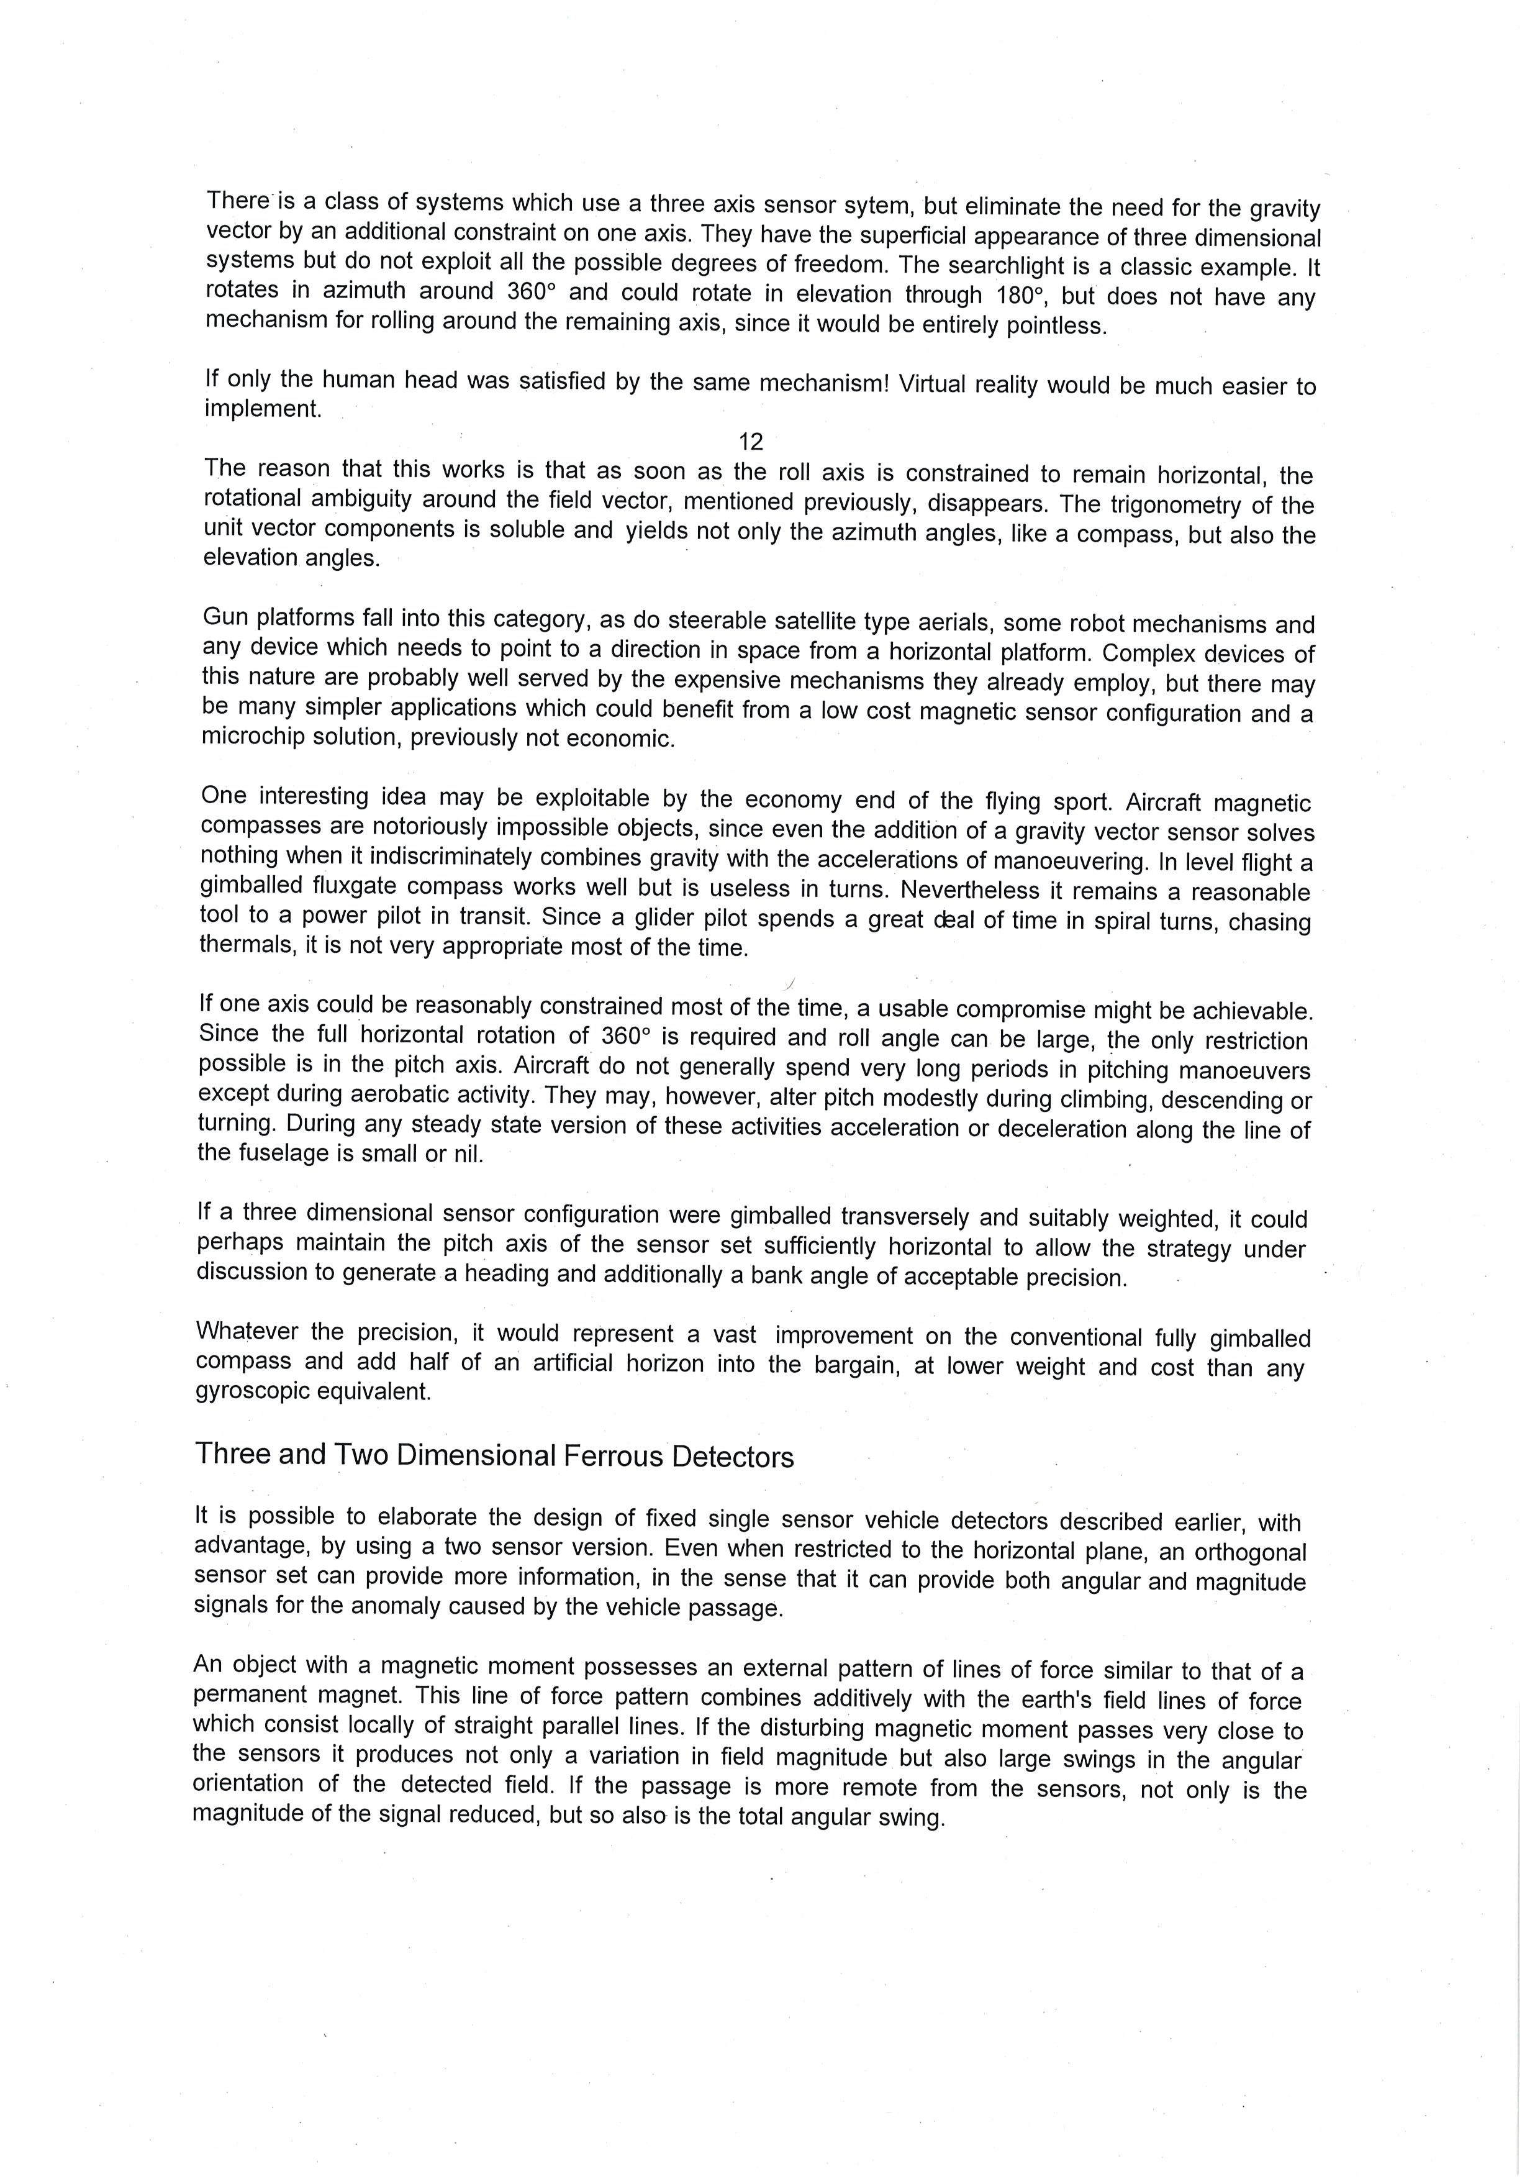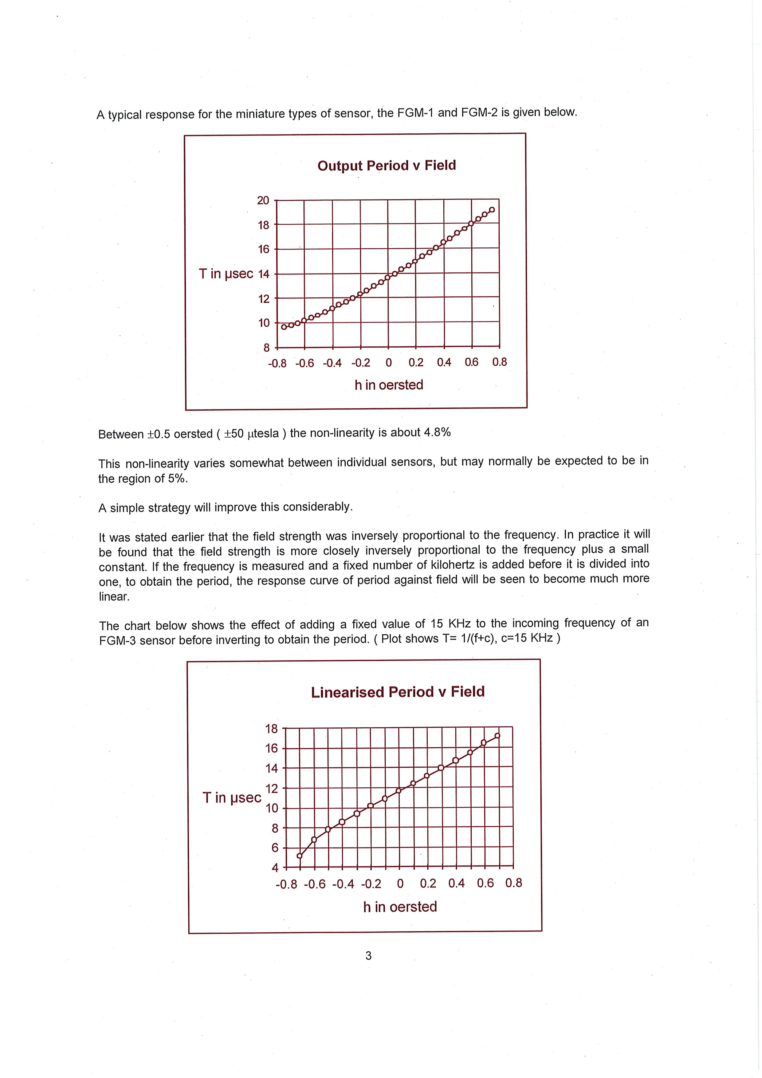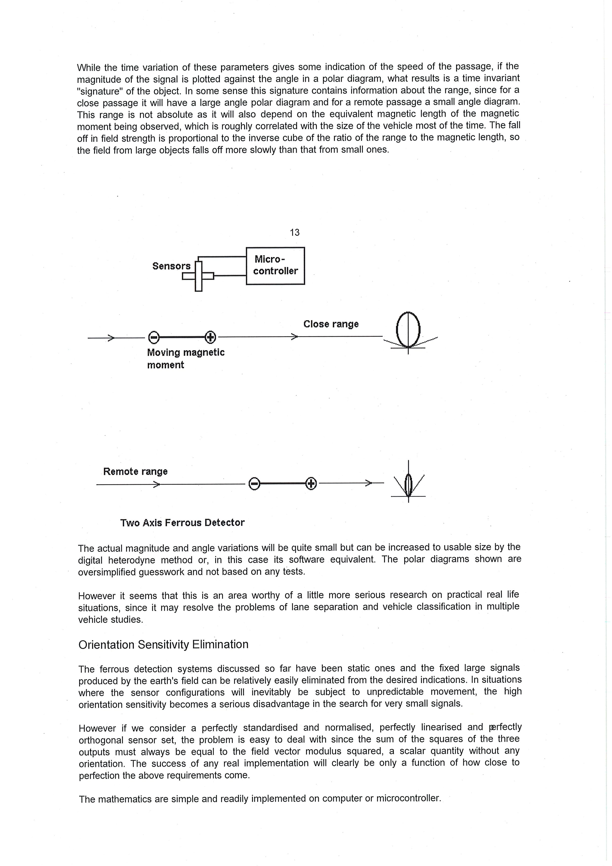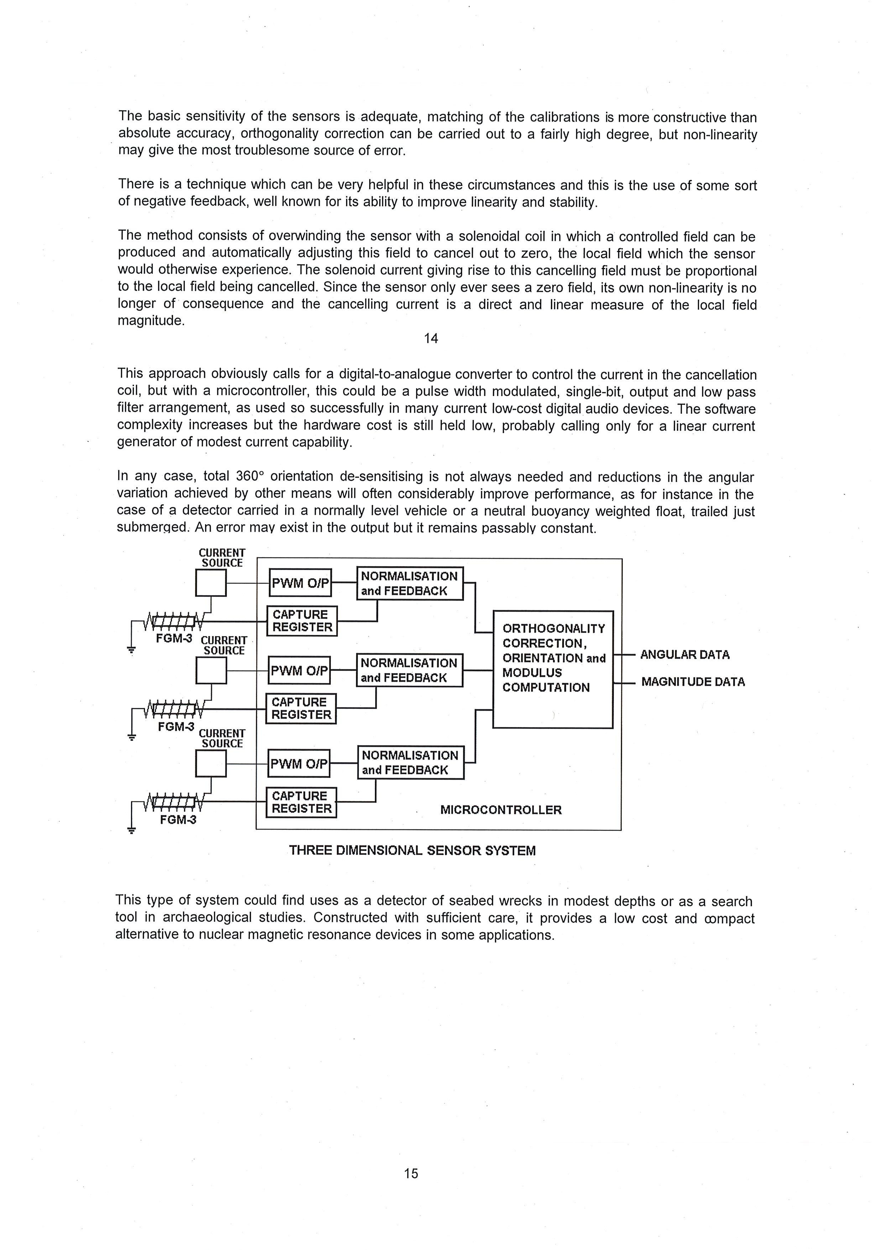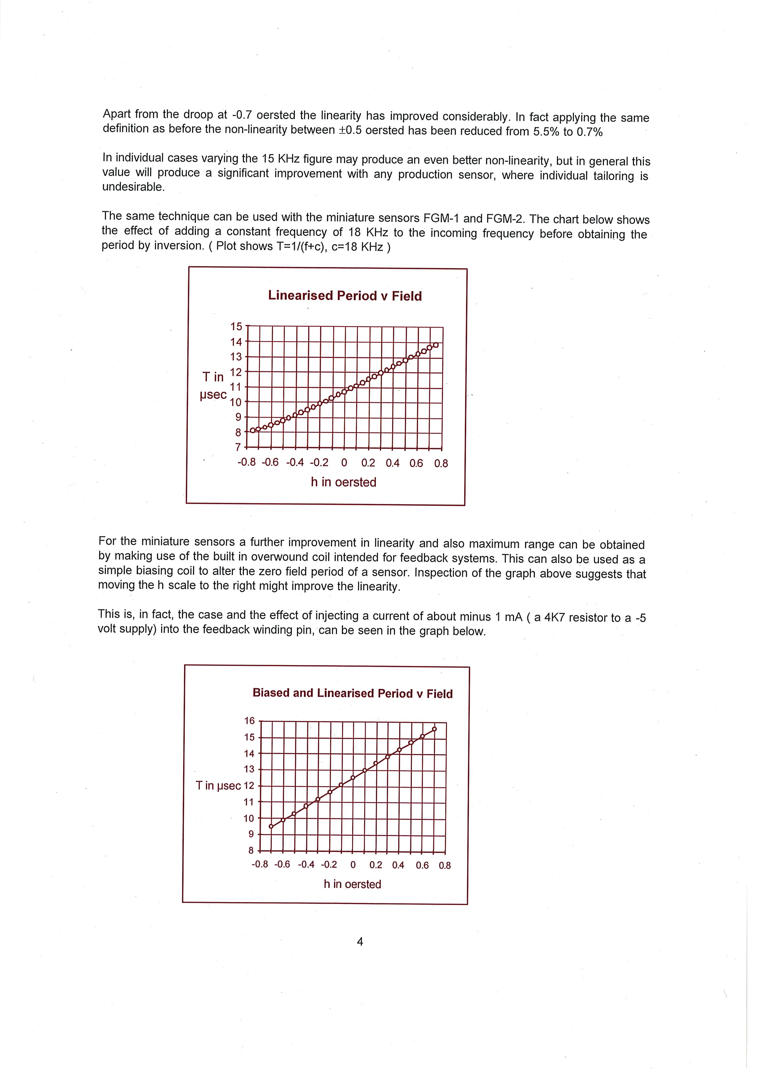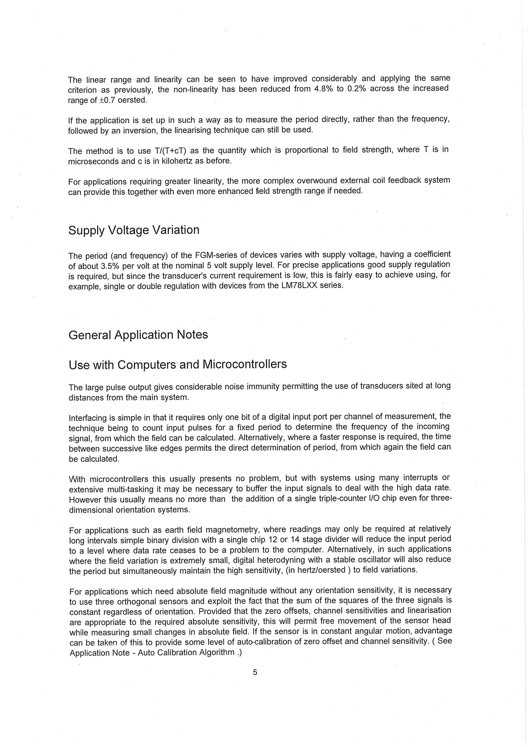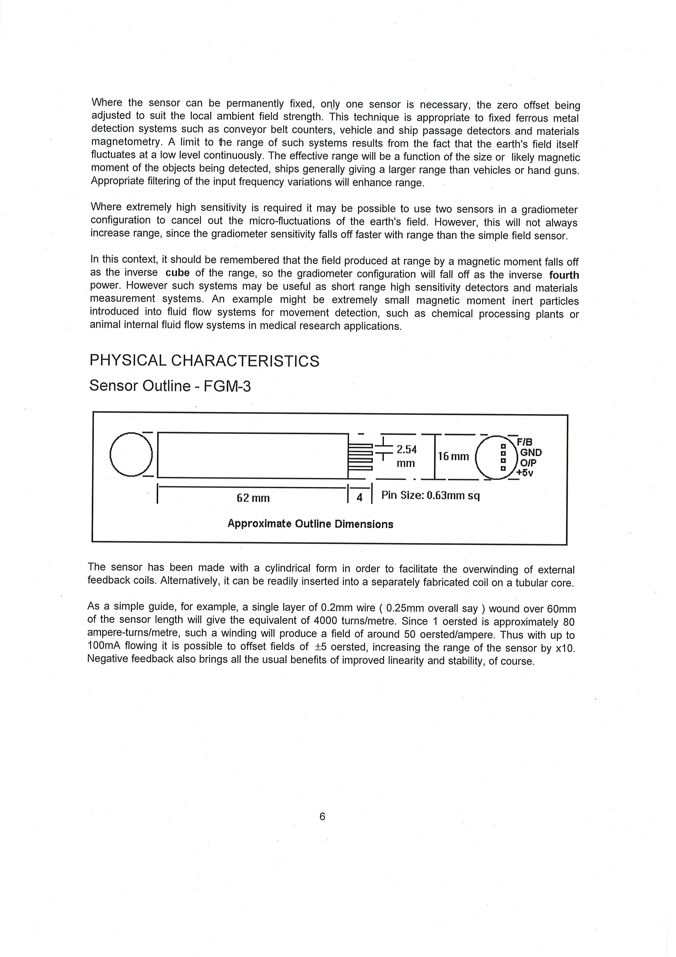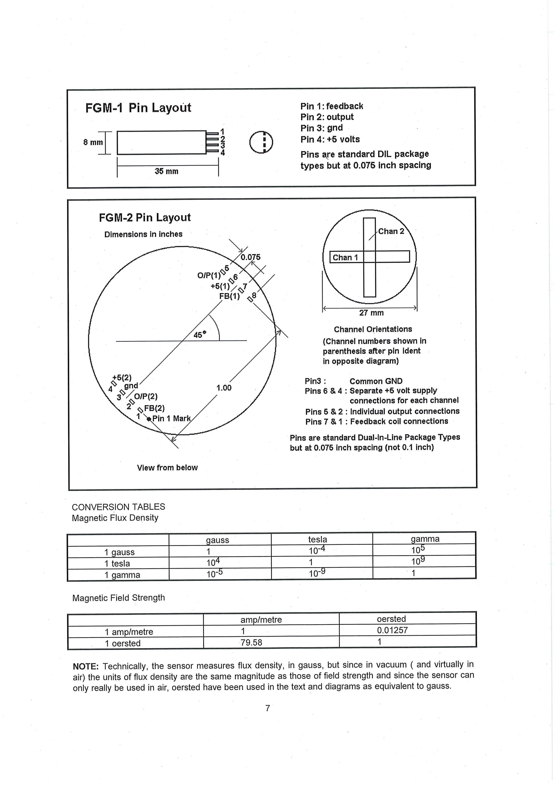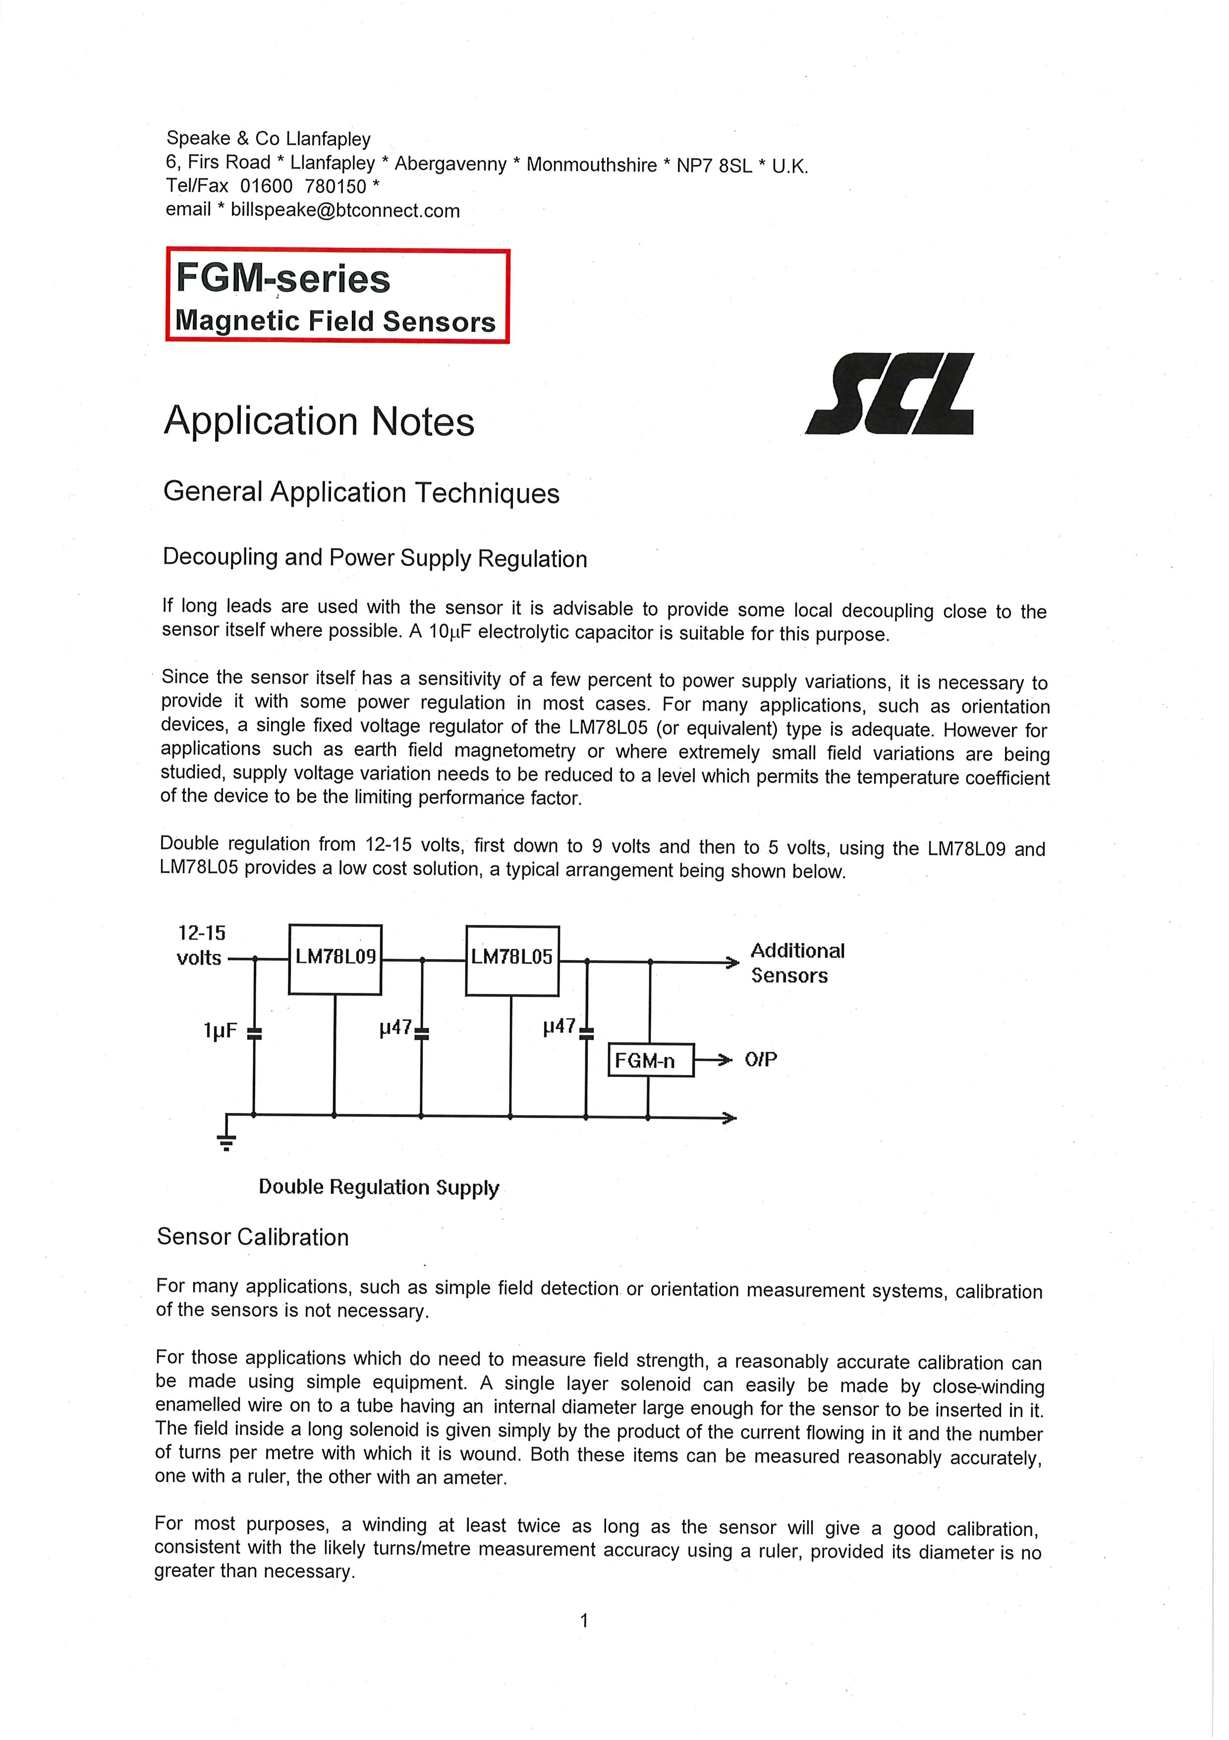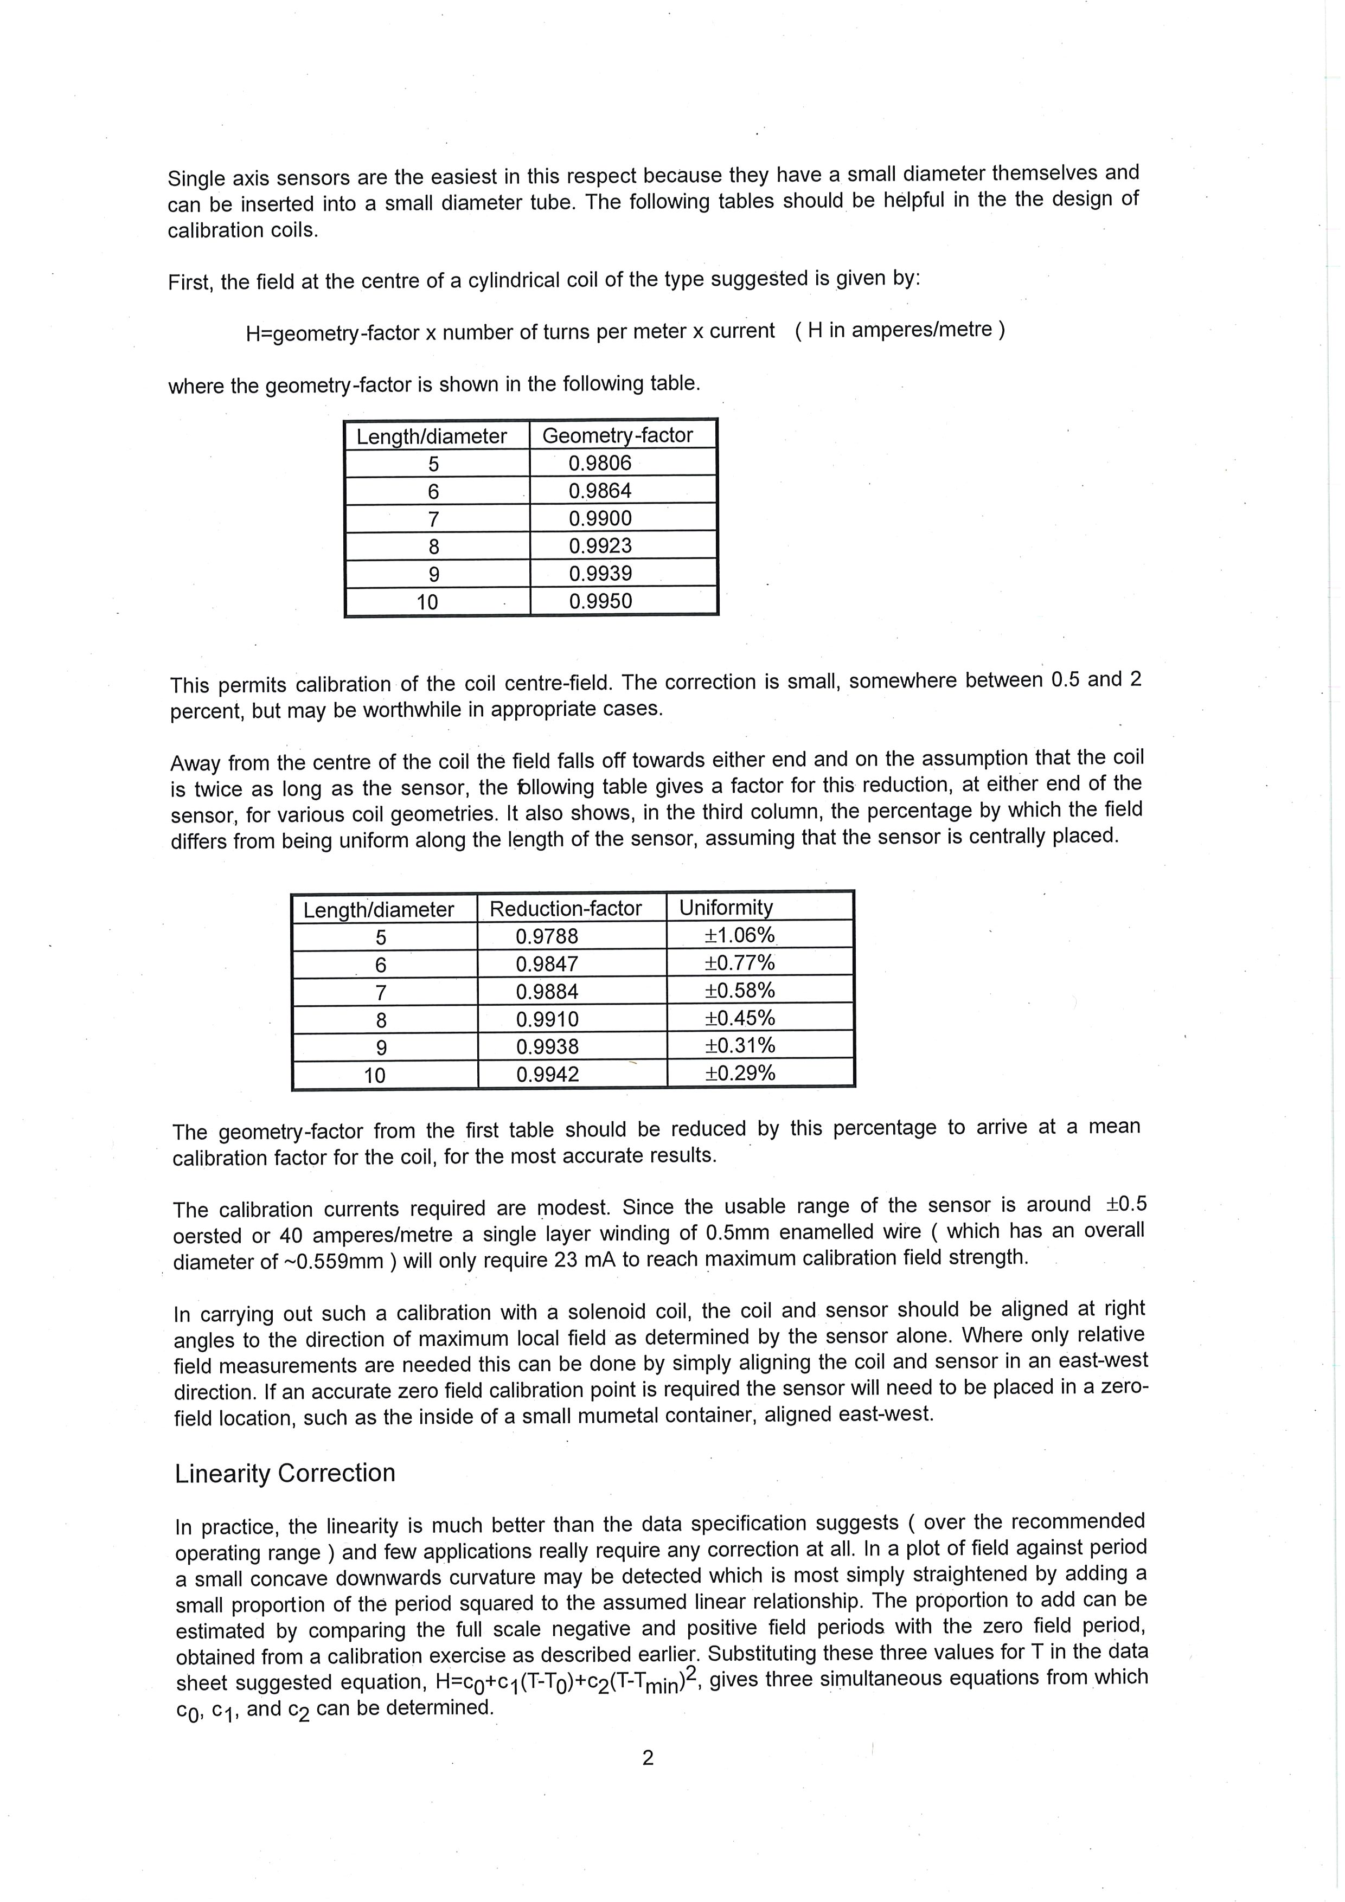

* 1. Hand-Drawn Conceptual Designs for Graphing Tool and Navigator Views

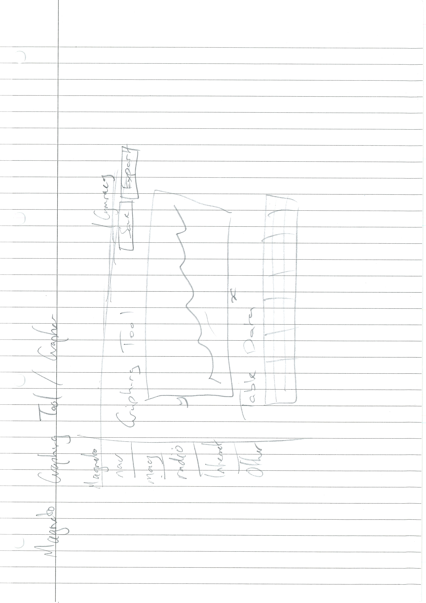

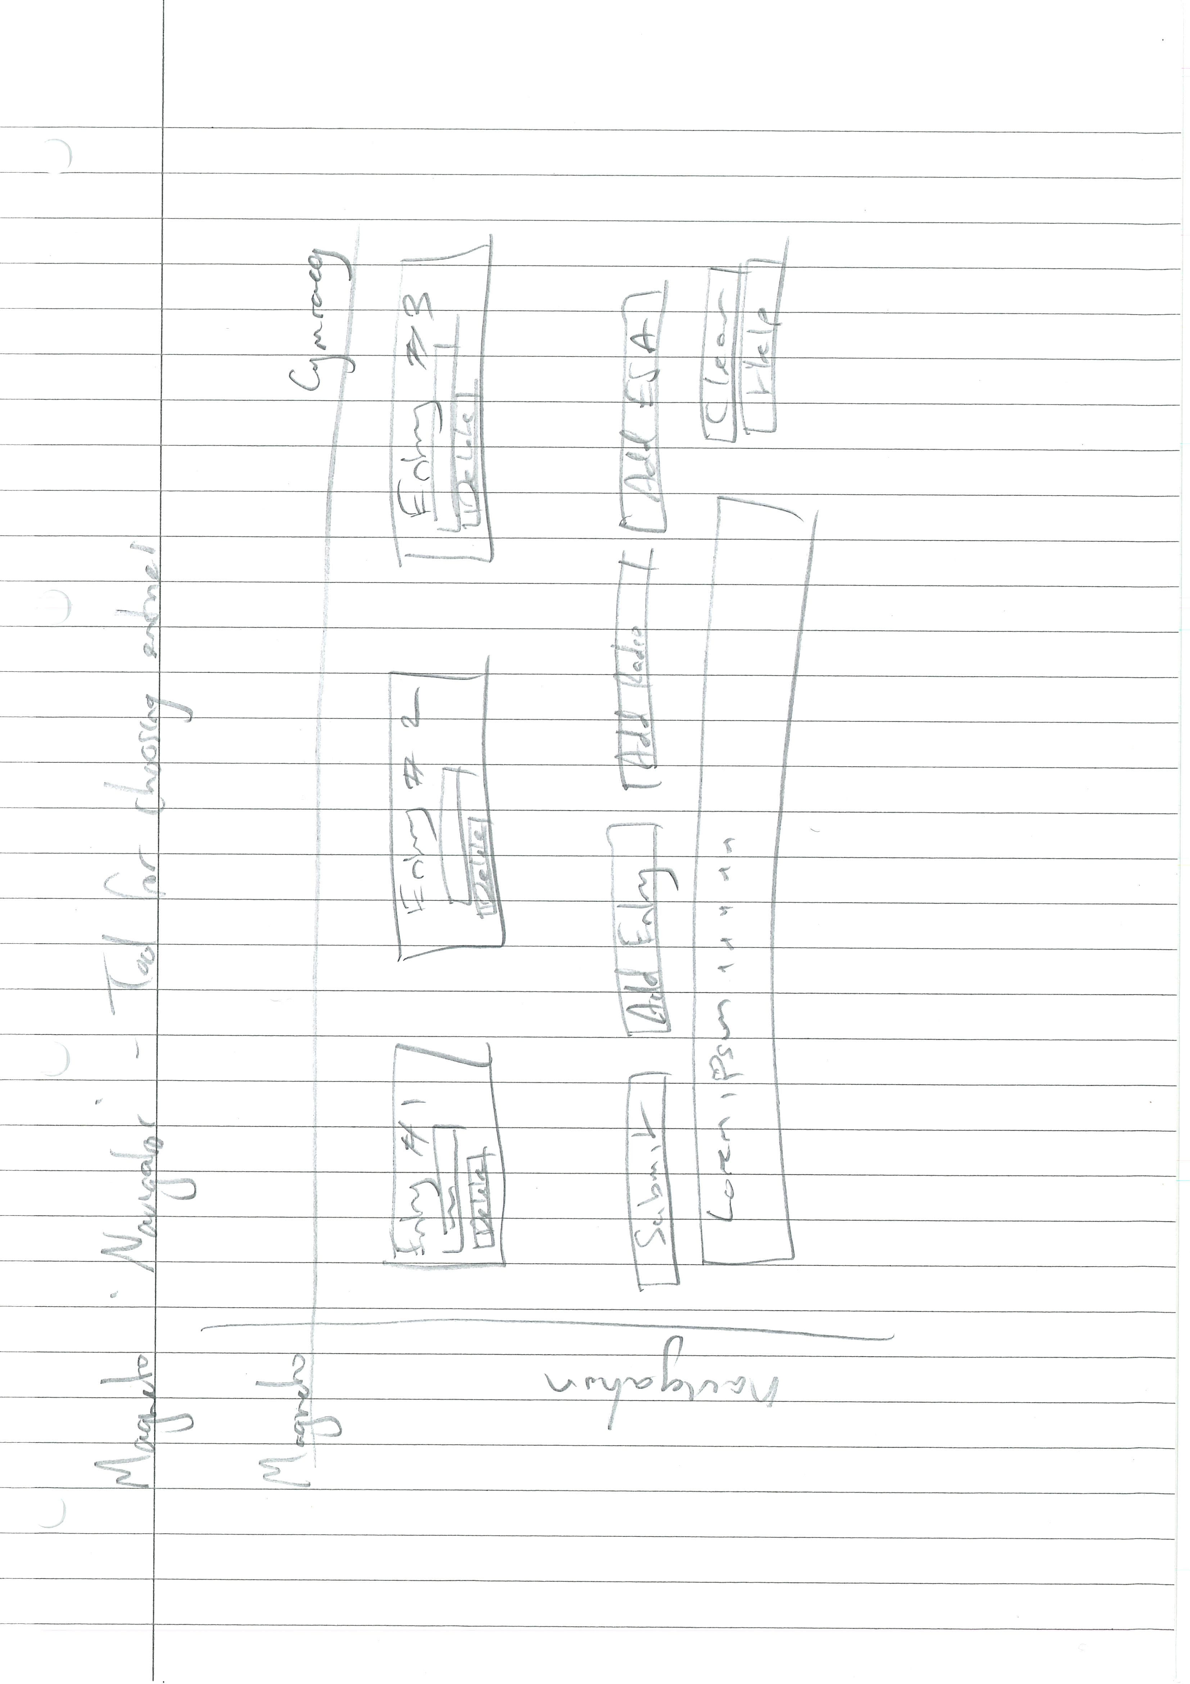

* 1. Apology email to Information Services following web server downtime caused by excessive data consumption

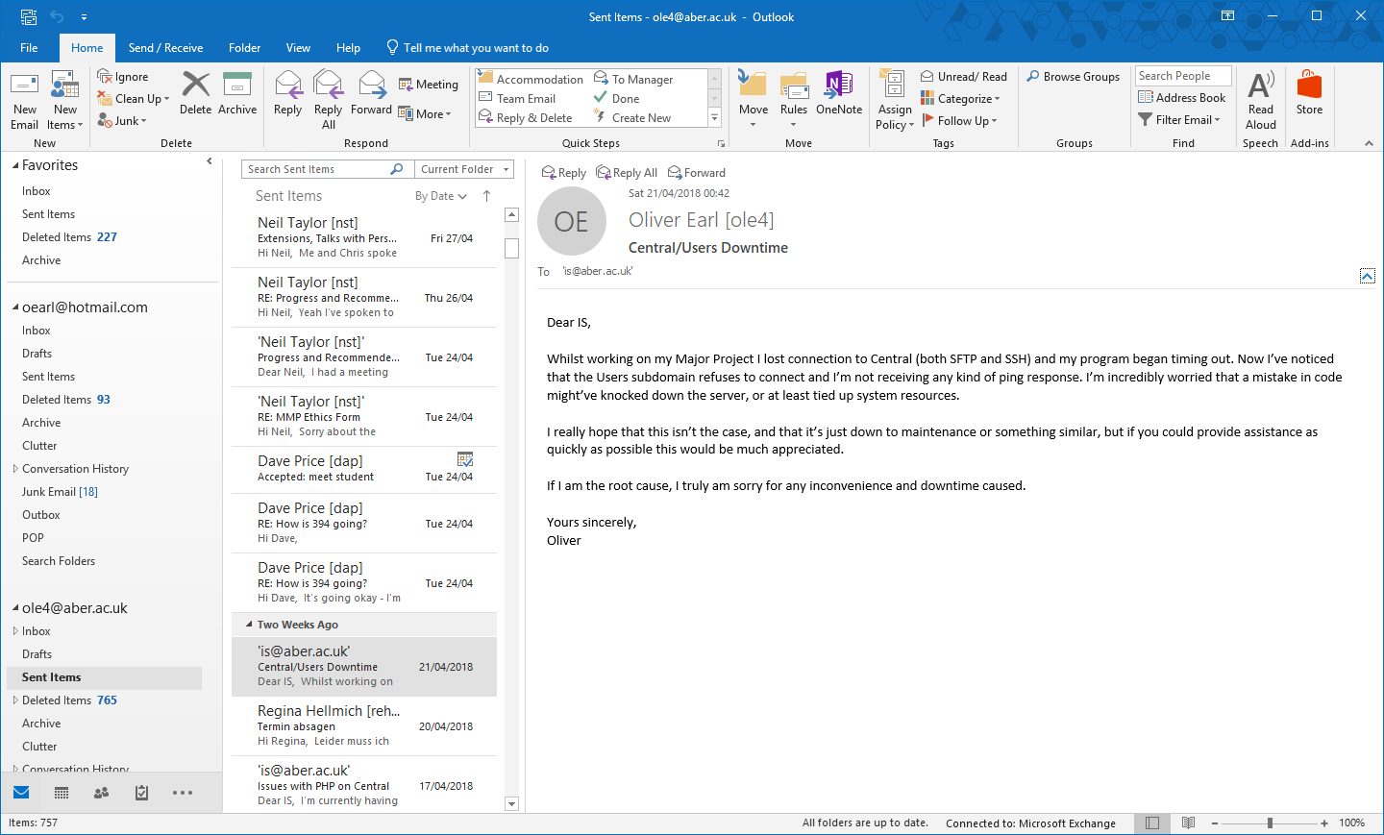

* 1. PHPUnit Test Results

|  |  |
| --- | --- |
| Development Machine, Windows 10 x64 Education | |
| ole4\Magneto\Tests\Config | |
| Get config | Pass |
| Get instance | Pass |
| Get debug entry | Pass |
| Update config entry | Pass |
| ole4\Magneto\Tests\Connector |  |
| Get instance | Fail |
| Reload database | Fail |
| ole4\Magneto\Tests\Magneto | |
| Sanitise int with alphanumeric characters | Pass |
| Sanitise int with HTML tags | Pass |
| Sanitise int with int | Pass |
| ole4\Magneto\Tests\Magnetometer | |
| Save Magnetometer Entry | Fail |
| Date to UNIX Timestamp | Pass |
| Convert UNIX to LabView | Pass |
| Convert LabView to UNIX | Pass |
| ole4\Magneto\Tests\Retriever |  |
| Get instance | Pass |
| Set retrieval date | Pass |
| Retrieve data from magnetometer | Fail |
| ole4\Magneto\Tests\Locale | |
| Get language | Pass |
| Get locale | Pass |
| Set language | Pass |
| Set locale | Pass |

* 1. Linting Results

|  |  |  |  |
| --- | --- | --- | --- |
| **#** | **File** | **Line** | **Problem** |
| 1 | D:\Dropbox\Major Project\src\Config\Config.php | 33 | Avoid using static access to class '\ole4\Magneto\Magneto' in method 'getConfig'. |
| 2 | D:\Dropbox\Major Project\src\Config\Config.php | 55 | Avoid using static access to class '\ole4\Magneto\Magneto' in method 'saveConfigToDisk'. |
| 3 | D:\Dropbox\Major Project\src\Controllers\MagnetometerController.php | 19 | Avoid variables with short names like $db. Configured minimum length is 3. |
| 4 | D:\Dropbox\Major Project\src\Controllers\MagnetometerController.php | 23 | Avoid using static access to class '\ole4\Magneto\Database\Connector' in method '__construct'. |
| 5 | D:\Dropbox\Major Project\src\Controllers\MagnetometerController.php | 26 | Avoid variables with short names like $id. Configured minimum length is 3. |
| 6 | D:\Dropbox\Major Project\src\Controllers\MagnetometerController.php | 28 | Avoid using static access to class '\ole4\Magneto\Magneto' in method 'getById'. |
| 7 | D:\Dropbox\Major Project\src\Controllers\MagnetometerController.php | 56 | Avoid variables with short names like $id. Configured minimum length is 3. |
| 8 | D:\Dropbox\Major Project\src\Controllers\MagnetometerController.php | 129 | The method getAll has a boolean flag argument $limit1, which is a certain sign of a Single Responsibility Principle violation. |
| 9 | D:\Dropbox\Major Project\src\Database\Connector.php | 12 | Avoid variables with short names like $db. Configured minimum length is 3. |
| 10 | D:\Dropbox\Major Project\src\Database\Connector.php | 30 | Avoid using static access to class '\ole4\Magneto\Config\Config' in method 'setInstance'. |
| 11 | D:\Dropbox\Major Project\src\Database\Connector.php | 36 | Avoid using static access to class '\ole4\Magneto\Magneto' in method 'setInstance'. |
| 12 | D:\Dropbox\Major Project\src\Magneto.php | 40 | Avoid using static access to class '\ole4\Magneto\Config\Config' in method '__construct'. |
| 13 | D:\Dropbox\Major Project\src\Magneto.php | 41 | Avoid using static access to class '\ole4\Magneto\i18n\Locale' in method '__construct'. |
| 14 | D:\Dropbox\Major Project\src\Magneto.php | 42 | Avoid using static access to class '\ole4\Magneto\i18n\Locale' in method '__construct'. |
| 15 | D:\Dropbox\Major Project\src\Magneto.php | 43 | Avoid using static access to class '\ole4\Magneto\Database\Connector' in method '__construct'. |
| 16 | D:\Dropbox\Major Project\src\Magneto.php | 46 | Avoid using static access to class 'ole4\Magneto\Retriever' in method '__construct'. |
| 17 | D:\Dropbox\Major Project\src\Magneto.php | 63 | csrfWatchdog accesses the super-global variable $_SESSION. |
| 18 | D:\Dropbox\Major Project\src\Magneto.php | 63 | csrfWatchdog accesses the super-global variable $_SESSION. |
| 19 | D:\Dropbox\Major Project\src\Magneto.php | 63 | csrfWatchdog accesses the super-global variable $_POST. |
| 20 | D:\Dropbox\Major Project\src\Magneto.php | 63 | csrfWatchdog accesses the super-global variable $_POST. |
| 21 | D:\Dropbox\Major Project\src\Magneto.php | 63 | csrfWatchdog accesses the super-global variable $_POST. |
| 22 | D:\Dropbox\Major Project\src\Magneto.php | 63 | csrfWatchdog accesses the super-global variable $_SESSION. |
| 23 | D:\Dropbox\Major Project\src\Magneto.php | 71 | Avoid using static access to class 'ole4\Magneto\Magneto' in method 'csrfWatchdog'. |
| 24 | D:\Dropbox\Major Project\src\Magneto.php | 87 | Avoid using static access to class '\ole4\Magneto\Config\Config' in method 'configureErrors'. |
| 25 | D:\Dropbox\Major Project\src\Magneto.php | 106 | configureSession accesses the super-global variable $_SESSION. |
| 26 | D:\Dropbox\Major Project\src\Magneto.php | 119 | error accesses the super-global variable $_SESSION. |
| 27 | D:\Dropbox\Major Project\src\Magneto.php | 126 | Avoid using static access to class '\ole4\Magneto\i18n\Locale' in method 'error'. |
| 28 | D:\Dropbox\Major Project\src\Models\Magnetometer.php | 18 | Avoid variables with short names like $id. Configured minimum length is 3. |
| 29 | D:\Dropbox\Major Project\src\Models\Magnetometer.php | 24 | Avoid variables with short names like $id. Configured minimum length is 3. |
| 30 | D:\Dropbox\Major Project\src\Models\Magnetometer.php | 38 | Avoid using static access to class '\ole4\Magneto\Database\Connector' in method 'saveMagnetometer'. |
| 31 | D:\Dropbox\Major Project\src\Models\Magnetometer.php | 38 | Avoid variables with short names like $db. Configured minimum length is 3. |
| 32 | D:\Dropbox\Major Project\src\Renderer.php | 52 | The method route() has a Cyclomatic Complexity of 10. The configured cyclomatic complexity threshold is 10. |
| 33 | D:\Dropbox\Major Project\src\Renderer.php | 52 | route accesses the super-global variable $_GET. |
| 34 | D:\Dropbox\Major Project\src\Renderer.php | 52 | route accesses the super-global variable $_GET. |
| 35 | D:\Dropbox\Major Project\src\Renderer.php | 118 | The method route uses an else expression. Else is never necessary and you can simplify the code to work without else. |
| 36 | D:\Dropbox\Major Project\src\Renderer.php | 132 | Avoid using static access to class 'ole4\Magneto\Magneto' in method 'loadPage'. |
| 37 | D:\Dropbox\Major Project\src\Renderer.php | 136 | The method additionalData() has a Cyclomatic Complexity of 12. The configured cyclomatic complexity threshold is 10. |
| 38 | D:\Dropbox\Major Project\src\Renderer.php | 136 | additionalData accesses the super-global variable $_POST. |
| 39 | D:\Dropbox\Major Project\src\Renderer.php | 136 | additionalData accesses the super-global variable $_POST. |
| 40 | D:\Dropbox\Major Project\src\Renderer.php | 136 | additionalData accesses the super-global variable $_POST. |
| 41 | D:\Dropbox\Major Project\src\Renderer.php | 136 | additionalData accesses the super-global variable $_POST. |
| 42 | D:\Dropbox\Major Project\src\Renderer.php | 136 | additionalData accesses the super-global variable $_GET. |
| 43 | D:\Dropbox\Major Project\src\Renderer.php | 136 | additionalData accesses the super-global variable $_GET. |
| 44 | D:\Dropbox\Major Project\src\Renderer.php | 136 | additionalData accesses the super-global variable $_GET. |
| 45 | D:\Dropbox\Major Project\src\Renderer.php | 136 | additionalData accesses the super-global variable $_GET. |
| 46 | D:\Dropbox\Major Project\src\Renderer.php | 140 | Avoid using static access to class '\ole4\Magneto\Config\Config' in method 'additionalData'. |
| 47 | D:\Dropbox\Major Project\src\Renderer.php | 146 | The method additionalData uses an else expression. Else is never necessary and you can simplify the code to work without else. |
| 48 | D:\Dropbox\Major Project\src\Renderer.php | 157 | Avoid using static access to class 'ole4\Magneto\Magneto' in method 'additionalData'. |
| 49 | D:\Dropbox\Major Project\src\Renderer.php | 165 | registerGlobals accesses the super-global variable $_SESSION. |
| 50 | D:\Dropbox\Major Project\src\Renderer.php | 167 | Avoid using static access to class '\ole4\Magneto\Config\Config' in method 'registerGlobals'. |
| 51 | D:\Dropbox\Major Project\src\Renderer.php | 168 | Avoid using static access to class '\ole4\Magneto\Database\Connector' in method 'registerGlobals'. |
| 52 | D:\Dropbox\Major Project\src\Renderer.php | 169 | Avoid using static access to class '\ole4\Magneto\i18n\Locale' in method 'registerGlobals'. |
| 53 | D:\Dropbox\Major Project\src\Renderer.php | 170 | Avoid using static access to class '\ole4\Magneto\i18n\Locale' in method 'registerGlobals'. |
| 54 | D:\Dropbox\Major Project\src\Renderer.php | 177 | addSession accesses the super-global variable $_SESSION. |
| 55 | D:\Dropbox\Major Project\src\Renderer.php | 177 | addSession accesses the super-global variable $_SESSION. |
| 56 | D:\Dropbox\Major Project\src\Renderer.php | 186 | resetSession accesses the super-global variable $_SESSION. |
| 57 | D:\Dropbox\Major Project\src\Renderer.php | 186 | resetSession accesses the super-global variable $_SESSION. |
| 58 | D:\Dropbox\Major Project\src\Renderer.php | 186 | resetSession accesses the super-global variable $_SESSION. |
| 59 | D:\Dropbox\Major Project\src\Renderer.php | 186 | resetSession accesses the super-global variable $_SESSION. |
| 60 | D:\Dropbox\Major Project\src\Renderer.php | 186 | resetSession accesses the super-global variable $_SESSION. |
| 61 | D:\Dropbox\Major Project\src\Renderer.php | 186 | resetSession accesses the super-global variable $_SESSION. |
| 62 | D:\Dropbox\Major Project\src\Renderer.php | 186 | resetSession accesses the super-global variable $_SESSION. |
| 63 | D:\Dropbox\Major Project\src\Renderer.php | 186 | resetSession accesses the super-global variable $_SESSION. |
| 64 | D:\Dropbox\Major Project\src\Renderer.php | 193 | The method resetSession uses an else expression. Else is never necessary and you can simplify the code to work without else. |
| 65 | D:\Dropbox\Major Project\src\Renderer.php | 202 | Avoid variables with short names like $i. Configured minimum length is 3. |
| 66 | D:\Dropbox\Major Project\src\Retriever.php | 38 | Avoid using static access to class '\ole4\Magneto\Config\Config' in method '__construct'. |
| 67 | D:\Dropbox\Major Project\src\Retriever.php | 39 | Avoid using static access to class '\ole4\Magneto\Config\Config' in method '__construct'. |
| 68 | D:\Dropbox\Major Project\src\Retriever.php | 40 | Avoid using static access to class '\ole4\Magneto\Config\Config' in method '__construct'. |
| 69 | D:\Dropbox\Major Project\src\Retriever.php | 41 | Avoid using static access to class '\ole4\Magneto\Config\Config' in method '__construct'. |
| 70 | D:\Dropbox\Major Project\src\Retriever.php | 42 | Avoid using static access to class '\ole4\Magneto\Config\Config' in method '__construct'. |
| 71 | D:\Dropbox\Major Project\src\Retriever.php | 49 | watchdog accesses the super-global variable $_GET. |
| 72 | D:\Dropbox\Major Project\src\Retriever.php | 49 | watchdog accesses the super-global variable $_GET. |
| 73 | D:\Dropbox\Major Project\src\Retriever.php | 49 | watchdog accesses the super-global variable $_GET. |
| 74 | D:\Dropbox\Major Project\src\Retriever.php | 57 | Avoid using static access to class 'ole4\Magneto\Magneto' in method 'watchdog'. |
| 75 | D:\Dropbox\Major Project\src\Retriever.php | 58 | The method watchdog uses an else expression. Else is never necessary and you can simplify the code to work without else. |
| 76 | D:\Dropbox\Major Project\src\Retriever.php | 59 | Avoid using static access to class 'ole4\Magneto\Magneto' in method 'watchdog'. |
| 77 | D:\Dropbox\Major Project\src\Retriever.php | 67 | Avoid using static access to class '\ole4\Magneto\Config\Config' in method 'setRetrieval'. |
| 78 | D:\Dropbox\Major Project\src\Retriever.php | 70 | retrieveData accesses the super-global variable $_SESSION. |
| 79 | D:\Dropbox\Major Project\src\Retriever.php | 94 | Avoid using static access to class 'ole4\Magneto\Magneto' in method 'retrieveData'. |
| 80 | D:\Dropbox\Major Project\src\Retriever.php | 100 | Avoid unused private methods such as 'oldProcessData'. |
| 81 | D:\Dropbox\Major Project\src\Retriever.php | 107 | Avoid using static access to class '\ole4\Magneto\Models\Magnetometer' in method 'oldProcessData'. |
| 82 | D:\Dropbox\Major Project\src\Retriever.php | 121 | processData accesses the super-global variable $_SESSION. |
| 83 | D:\Dropbox\Major Project\src\Retriever.php | 121 | processData accesses the super-global variable $_SESSION. |
| 84 | D:\Dropbox\Major Project\src\Retriever.php | 139 | Avoid using static access to class '\ole4\Magneto\Models\Magnetometer' in method 'processData'. |
| 85 | D:\Dropbox\Major Project\src\Retriever.php | 176 | Avoid using static access to class 'ole4\Magneto\Magneto' in method 'processData'. |
| 86 | D:\Dropbox\Major Project\src\i18n\Locale.php | 22 | setLanguage accesses the super-global variable $_GET. |
| 87 | D:\Dropbox\Major Project\src\i18n\Locale.php | 22 | setLanguage accesses the super-global variable $_GET. |
| 88 | D:\Dropbox\Major Project\src\i18n\Locale.php | 22 | setLanguage accesses the super-global variable $_GET. |
| 89 | D:\Dropbox\Major Project\src\i18n\Locale.php | 22 | setLanguage accesses the super-global variable $_SESSION. |
| 90 | D:\Dropbox\Major Project\src\i18n\Locale.php | 26 | The method setLanguage uses an else expression. Else is never necessary and you can simplify the code to work without else. |
| 91 | D:\Dropbox\Major Project\src\i18n\Locale.php | 37 | determineLanguage accesses the super-global variable $_SESSION. |
| 92 | D:\Dropbox\Major Project\src\i18n\Locale.php | 37 | determineLanguage accesses the super-global variable $_SESSION. |
| 93 | D:\Dropbox\Major Project\src\i18n\Locale.php | 37 | determineLanguage accesses the super-global variable $_SESSION. |
| 94 | D:\Dropbox\Major Project\src\i18n\Locale.php | 37 | determineLanguage accesses the super-global variable $_SERVER. |
| 95 | D:\Dropbox\Major Project\src\i18n\Locale.php | 46 | The method determineLanguage uses an else expression. Else is never necessary and you can simplify the code to work without else. |
| 96 | D:\Dropbox\Major Project\src\i18n\Locale.php | 50 | The method determineLanguage uses an else expression. Else is never necessary and you can simplify the code to work without else. |
| 97 | D:\Dropbox\Major Project\src\i18n\Locale.php | 80 | Avoid using static access to class '\ole4\Magneto\Magneto' in method 'setLocale'. |
| 98 | D:\Dropbox\Major Project\src\i18n\Locale.php | 85 | Avoid using static access to class '\ole4\Magneto\Magneto' in method 'setLocale'. |

* 1. Manual Testing Table

|  |  |  |  |
| --- | --- | --- | --- |
| # | Test | Expectation | Pass? |
| 1 | **General Interface** | | |
| 1.1 | Does the application load when its start point is opened in a web browser? | The homepage view is rendered, and the application is loaded. | Yes |
| 1.2 | Does the About page load when the ‘About’ navigation link is clicked? | The about page view is rendered | Yes |
| 1.3 | Does the Settings page load when the ‘Settings’ navigation link is clicked? | The settings page view is rendered | Yes |
| 1.4 | Does the Navigator load when the ‘Navigate Entries’ link is clicked? | The Navigator page view is rendered | Yes |
| 1.5 | Does the latest entry load when the ‘Latest Entry’ link is clicked? | The latest magnetometer entry is rendered in the Graphing View | Yes |
| 1.6 | Does all entries load when ‘Display All’ is clicked? | All data from the database is rendered in the Graphing View | Yes |
| 2 | **Locale** | | |
| 2.1 | Does the language switch into Welsh when the ‘Cymrage’ link is clicked? | The website switches into Welsh | Yes |
| 2.2 | Switch the language back into English by clicking the ‘Saesneg’ language link | The website switches back into English | Yes |
| 2.3 | The application autodetects browser on language as English on first load | The website loads initially in English | Yes |
| 2.4 | The application autodetects browser language as Welsh on first load | The website loads initially in Welsh | Yes |
| 2.5 | Entering language=’cy’ as GET parameter sets language into Welsh | The website loads into Welsh | Yes |
| 3 | **Navigator** | | |
| 3.1 | Click the option box to check whether there is a full range of dates from 2014 to today’s date | There is a full range of dates as expected | Yes |
| 3.2 | Does the number of entries on the Navigator view correspond to the Max Elements setting on the Settings page? | The number correlates to the setting | Yes |
| 3.3 | Are the elements in the Navigator view entries displayed in chronological order? | They are displayed in chronological order | Yes |
| 3.4 | Does clicking ‘Load Graphing Tool’ load the graphing view with the selected entries? | The Graphing Tool is displayed displaying the selected entries | Yes |
| 3.5 | Does clicking ‘Load Tables Only’ display the selected entries as a table? | The Tabular view is displayed displaying the selected entries | Yes |
| 3.6 | Does clicking ‘Add Magnetometer Entry’ add another selection box? | A new magnetometer entry box is added | No – this functionality is unimplemented |
| 3.7 | Does clicking ‘Add Radio Entry’ add a selection box for amateur radio entries? | A new amateur radio entry box is added | No – this functionality is unimplemented |
| 3.8 | Does clicking ‘Add ESA Entry’ add a selection box for Internet data entries? | A new Internet entry box is added | No – this functionality is unimplemented |
| 4 | **Graphing Tool (View)** | | |
| 4.1 | Is the loaded data displayed on a chart, with dates on the X axis and values on the Y axis? | Graph is displayed properly | Yes |
| 4.2 | Do the Bar View and Line View change the type of graph? | Graph changes when buttons are clicked | Yes |
| 4.3 | Does Export XML render the current data in XML? | XML is presented | Yes |
| 4.4 | Does Export JSON render the current data in JSON? | JSON is presented | Yes |
| 4.5 | Is the loaded data displayed as a table underneath the chart? | Tabular data is presented underneath the chart | Yes |
| 4.6 | When viewing only one entry, does the graph default to bar view? | Graph defaults to bar view | Yes |
| 4.7 | In Debug Mode, is the Graphing View Debugger displayed? | Debugger is displayed | Yes |
| 5 | **Table View / Tabular Data** | | |
| 5.1 | Is loaded data displayed in a table? | Table is loaded into a table | Yes |
| 6 | **Settings** | | |
| 6.1 | Does changing and submitting a different Max Elements value take effect? | Value is changed | Yes |
| 7 | Magnetometer |  |  |
| 7.1 | Retrieves data from magnetometer on daily basis | Data is retrieved | Yes |

* 1. Stress Test Table

|  |  |  |  |
| --- | --- | --- | --- |
| # | Test | Expectation | Pass? |
| 1 | **General Interface** | | |
| 1.1 | Does the app load the homepage when multiple page GET values are provided? | Homepage is rendered | Yes |
| 1.2 | Does the app load a valid page when two valid pages are provided as GET values? | One of the pages is loaded | Yes – the latter is used |
| 2 | **Locale** | | |
| 2.1 | Does the app successfully load English when the browser’s language is neither English or Welsh? | English is loaded | Yes |
| 2.2 | Does the app successfully load English when a false language is added to the GET? | English is loaded | Yes |
| 2.3 | Does the app load English when the language is tampered with in the session cookie? | English is loaded | Yes |
| 3 | **Navigator** | | |
| No additional tests. | | | |
| 4 | **Graphing Tool / View** | | |
| 4.1 | Does ‘Latest Entry’ and additional IDs load properly? | Latest Entry takes precedence and other IDs are ignored | Yes |
| 4.2 | Does ‘Display All’ and additional IDs load properly? | Display All takes precedence and other IDs are ignored | Yes |
| 4.3 | Graphing View is navigated to without data | Displays ‘No data’ | Yes |
| 4.4 | Does ‘Display All’ export JSON return the JSON of all entries? | JSON exported | No – URI too long |
| 4.5 | Does ‘Display All’ export XML return the XML of all entries? | XML exported | No – URI too long |
| 4.6 | Are invalid / tampered POST data entries displayed in the graph, or cause any issues? | Malformed entries are ignored | Yes |
| 4.7 | Are invalid / tampered GET data entries displayed in the graph, or cause any issues? | Malformed entries are ignored | Yes |
| 5 | Table View / Tabular Data | | |
| 5.1 | Table view is navigated to without data | Displays ‘No data’ | No – displays blank table |
| 5.2 | Are invalid / tampered POST data entries displayed in the table, or cause any issues? | Malformed entries are ignored | Yes |
| 5.3 | Are invalid / tampered GET data entries displayed in the graph, or cause any issues? | Malformed entries are ignored | Yes |
| 6 | Settings |  |  |
| 6.1 | Max Elements is non-numerical value | Input rejected | Yes |
| 6.2 | Max Elements is non-integer value | Input rejected | Yes |
| 7 | CSRF Protection | | |
| 7.1 | Navigator submitted without CSRF token | App halted | Yes |
| 7.2 | Navigator submitted with invalid token | App halted | Yes |
| 7.3 | Settings submitted without CSRF token | App halted | Yes |
| 7.4 | Settings submitted with invalid token | App halted | Yes |

* 1. API Testing Table

|  |  |  |  |
| --- | --- | --- | --- |
| # | Test | Expectation | Pass? |
| 1 | GET with valid values | JSON returned | Yes |
| 2 | POST with valid values | JSON returned | No – error 400 Bad Request |
| 3 | GET with non-existent values | ‘No magnetometer entries found’ | Yes |
| 4 | POST with non-existent values | ‘No magnetometer entries found’ | No – error 400 Bad Request |
| 5 | GET with valid values, XML flag on | XML returned | Yes |
| 6 | POST with valid values, XML flag on | XML returned | No – error 400 Bad Request |
| 7 | GET with non-existent values, XML flag on | <error>No magnetometer entries found’</error> | Yes |
| 8 | POST with non-existent values, XML flag on | <error>No magnetometer entries found’</error> | No – error 400 Bad Request |
| 9 | Access API entry-point with no values | Error 400 Bad Request | Yes |
| 10 | Latest flag | Return latest entry as JSON | Yes |
| 11 | Latest flag with XML flag | Return latest entry as XML | Yes |
| 12 | All flag | Return all database entries as JSON | Yes |
| 13 | All flag with XML flag | Return all database entries as XML | Yes |
| 14 | GET with both valid and non-existent values | Only valid entries are returned | Yes |
| 15 | GET with both valid and malformed values | Only valid entries are returned | Yes |
| 16 | POST with both valid and non-existent values | Only valid entries are returned | No – error 400 Bad Request |
| 17 | POST with both valid and malformed values | Only valid entries are returned | No – error 400 Bad Request |

# Annotated Bibliography

|  |  |  |
| --- | --- | --- |
| [1] |  | Z. Gorvett, “The Sun creates 'space weather' that affects us all,” BBC, 23 September 2015. [Online]. Available: http://www.bbc.co.uk/earth/story/20150923-the-sun-creates-space-weather-that-affects-us-all. [Accessed 24 April 2018].  *An interesting article from the BBC that explains space weather.* |
| [2] |  | MuleSoft, “What is an API? (Application Programming Interface),” MuleSoft, 20 April 2018. [Online]. Available: https://www.mulesoft.com/resources/api/what-is-an-api. [Accessed 24 April 2018].  *Helpful overview of what an API is.* |
| [3] |  | J. Lengstorf, “JSON: What It Is, How It Works & How to Use It,” CopterLabs, 2 July 2009. [Online]. Available: https://www.copterlabs.com/json-what-it-is-how-it-works-how-to-use-it/. [Accessed 24 April 2018].  *Overview of the JSON standard.* |
| [4] |  | M. O. D. Coul, “Mac HFS+ Timestamp Converter,” EpochConverter.com, 19 February 2016. [Online]. Available: https://www.epochconverter.com/mac. [Accessed 24 April 2018].  *Useful tool and background information on converting timestamps from one format into another and on differing epochs.* |
| [5] |  | J. Ratcliffe, “Solar Disturbances,” in *An Introduction to the Ionosphere and the Magnetosphere*, London, Cambridge University Press, 1972, p. 14.  *An interesting but incredibly in-depth book on the ionosphere and magnetosphere. The introductory chapters were useful on getting some background information, but the remainder was unfortunately too advanced.* |
| [6] |  | G. Holman and S. Benedict, “What is a Solar Flare?,” NASA; NASA Goddard Space Flight Center, 23 September 1996. [Online]. Available: https://hesperia.gsfc.nasa.gov/sftheory/flare.htm. [Accessed 24 April 2018].  *Insightful but very retro information on solar flares from NASA.* |
| [7] |  | Space Weather Prediction Center, “Coronal Mass Ejections,” National Oceanic and Atmospheric Administration, 27 December 2014. [Online]. Available: https://www.swpc.noaa.gov/phenomena/coronal-mass-ejections. [Accessed 24 April 2018].  *Interesting, and not too complex information on coronal mass ejections.* |
| [8] |  | R. Sharpe, “Just what is SMB?,” Samba, 8 October 2002. [Online]. Available: https://www.samba.org/cifs/docs/what-is-smb.html. [Accessed 24 April 2018].  *Background information on the SMB network protocol from the people at Samba.* |
| [9] |  | R. Boyd, “9 Scrum Metrics To Keep Your Team On Track,” Pragmatic Marketing, 21 November 2014. [Online]. Available: https://pragmaticmarketing.com/resources/articles/9-scrum-metrics-to-keep-your-team-on-track. [Accessed 24 April 2018].  *A helpful read about keeping motivated as a Scrum team.* |
| [10] |  | L. R. Quinn, “XML Essentials,” W3C, 2015. [Online]. Available: https://www.w3.org/standards/xml/core. [Accessed 24 April 2018].  *An overview and introduction to the XML mark-up language standard.* |
| [11] |  | Welsh Language Services, “https://www.aber.ac.uk/en/cgg/bilingual-policy/welsh-language-scheme/,” Aberystwyth University, 20 February 2014. [Online]. Available: https://www.aber.ac.uk/en/cgg/bilingual-policy/welsh-language-scheme/. [Accessed 24 April 2018].  *University policy document on Welsh Language provisions and bilingualism.* |
| [12] |  | D. N. Papitashvili, “Geomagnetic Data Master Catalogue,” World Data Centre for Geomagnetism (Edinburgh); NASA/GSFC, 1999. [Online]. Available: http://www.wdc.bgs.ac.uk/catalog/master.html. [Accessed 24 April 2018].  *An incredibly in-depth and constantly updated data resource for magnetometer readings and geomagnetic data. Makes this program seem extremely tiny.* |
| [13] |  | Stanford University, “Tracking Solar Flares - Ionosphere,” 4 June 2009. [Online]. Available: http://solar-center.stanford.edu/SID/activities/ionosphere.html. [Accessed 24 April 2018].  *Helpful background information specifically pertaining to the ionosphere.* |
| [14] |  | GNU Radio Foundation, “About GNU Radio,” 17 March 2018. [Online]. Available: https://gnuradio.org/about/. [Accessed 24 April 2018].  *General information on what GNU Radio is.* |
| [15] |  | The Apache Software Foundation, “Apache Module mod_rewrite,” 30 March 2018. [Online]. Available: https://httpd.apache.org/docs/2.4/howto/htaccess.html. [Accessed 24 April 2018].  *Technical documentation on how mod_rewrite works by Apache.* |
| [16] |  | A. Mezenin, “Can Laravel 5.1 application run without .htaccess rewrite?,” StackOverflow, 10 March 2016. [Online]. Available: https://stackoverflow.com/questions/35924798/can-laravel-5-1-application-run-without-htaccess-rewrite. [Accessed 24 April 2018].  *A discussion on Stack Overflow as to whether the Laravel PHP framework can operate without .htaccess – the answer is no.* |
| [17] |  | Google, “Top Ways Websites Get Hacked By Spammers,” 22 December 2017. [Online]. Available: https://developers.google.com/web/fundamentals/security/hacked/top_ways_websites_get_hacked_by_spammers. [Accessed 24 April 2018].  *Editorial by Google for use by webmasters on how to prevent their websites and content platforms being targeted by exploits, spammers, etc.* |
| [18] |  | D. Dede, “Understanding .htaccess attacks - Part 1,” Sucuri, 27 May 2011. [Online]. Available: https://blog.sucuri.net/2011/05/understanding-htaccess-attacks-part-1.html. [Accessed 24 April 2018].  *A detailed look as to how malicious code attacks .htaccess to push maliciously generated content.* |
| [19] |  | M. Pinola, “How to Map a Network Drive in Windows 10,” Purch, 25 August 2015. [Online]. Available: https://www.laptopmag.com/articles/map-network-drive-windows-10. [Accessed 24 April 2018].  *Basic editorial on how to map network drives within Windows 10.* |
| [20] |  | The PHP Group, “FTP Manual,” 16 April 2008. [Online]. Available: http://php.net/manual/en/book.ftp.php. [Accessed 24 April 2018].  *PHP documentation section on FTP related functionality.* |
| [21] |  | 1. Sevilleja, “The Ins and Outs of Token Based Authentication,” Scotch.io LLC, 21 January 2015. [Online]. Available: https://scotch.io/tutorials/the-ins-and-outs-of-token-based-authentication. [Accessed 25 April 2018].   *Exploring token-based authentication used in RESTful services.* |
| [22] |  | G. Boer, “What is Scrum?,” Microsoft Corporation, 2018. [Online]. Available: https://www.visualstudio.com/learn/what-is-scrum/. [Accessed 26 April 2018].  *Microsoft’s own take on the Scrum methodology. An interesting read.* |
| [23] |  | H. Takeuhci and I. Nonaka, “The New New Product Development Game,” Harvard Business Report, January 1986. [Online]. Available: https://hbr.org/1986/01/the-new-new-product-development-game. [Accessed 2018 April 26].  *An article from the Harvard Business Report back when Scrum was just emerging in the 80s. Really interesting read.* |
| [24] |  | 1. Starr, “Distributed Scrum,” Microsoft Corporation; Scrum.org, July 2012. [Online]. Available: https://docs.microsoft.com/en-us/previous-versions/visualstudio/visual-studio-2013/jj620910(v=vs.120). [Accessed 26 April 2018].   *A small article talking about the challenges Distributed Scrum teams face.* |
| [25] |  | R. Kasturi, “Scrum Communication,” Scrum Alliance Inc., 14 October 2014. [Online]. Available: https://www.scrumalliance.org/community/articles/2014/october/scrum-communication. [Accessed 26 April 2018].  *An article discussing the importance of communication within the Scrum methodology.* |
| [26] |  | F. Attanasio, “Playing the ScrumMaster Role,” Scrum Alliance, Inc., 13 December 2013. [Online]. Available: https://www.scrumalliance.org/community/articles/2013/december/playing-the-scrummaster-role. [Accessed 26 April 2018].  *A brief overview of the Scrum Master role and what’s involved.* |
| [27] |  | NC State University, “The Agile Landscape,” 26 November 2011. [Online]. Available: http://wiki.expertiza.ncsu.edu/index.php/CSC/ECE_517_Fall_2011/ch6_6d_sk. [Accessed 27 April 2018].  *An educational document from a wiki that covers several agile methodologies, including Feature-Driven Development.* |
| [28] |  | S. W. Ambler, “Feature Driven Development (FDD) and Agile Modeling,” Ambysoft, Inc., 17 January 2018. [Online]. Available: http://agilemodeling.com/essays/fdd.htm. [Accessed 27 April 2018].  *In-depth exploration of Feature-Driven development.* |
| [29] |  | L. Karam, “Feature Driven Development (FDD) Processes and Comparison To Other Agile Methodologies,” Apiumhub, 5 May 2017. [Online]. Available: https://www.upwork.com/hiring/for-clients/agile-methodologies/. [Accessed 27 April 2018].  *The processes and sections of Feature-Driven Development broken down bit-by-bit. Interesting read.* |
| [30] |  | The PHP Group, “History of PHP,” 2018. [Online]. Available: http://php.net/manual/en/history.php.php. [Accessed 25 April 2018].  *Official PHP documentation on the history of the language and how it came about. Once a very ugly looking language.* |
| [31] |  | K. Yank, “Which Server Side Language Is Right For You?,” Sitepoint, 9 October 2001. [Online]. Available: https://www.sitepoint.com/server-side-language-right/. [Accessed 25 April 2018].  *A dated but still valid comparison of server-side programming languages.* |
| [32] |  | The PHP Group, “Supported Versions,” 2018. [Online]. Available: http://php.net/supported-versions.php. [Accessed 25 April 2018].  *The current timeline of supported PHP versions.* |
| [33] |  | T. Reenskaug and J. O. Coplien, “The DCI Architecture: A New Vision of Object-Oriented Programming,” Artima Inc, 20 March 2009. [Online]. Available: https://www.artima.com/articles/dci_vision.html. [Accessed 25 April 2018].  *Discussing the shortcomings of object-oriented programming and why MVC as an architectural pattern makes sense on the web. Interesting but long read.* |
| [34] |  | T. Otwell, “Laravel 5.6 Documentation,” 2018. [Online]. Available: https://laravel.com/docs/5.6. [Accessed 25 April 2018].  *Official Laravel 5.6 documentation.* |
| [35] |  | Python Software Foundation, “History of the Software - Python Reference Manual,” 22 June 2001. [Online]. Available: https://docs.python.org/2.0/ref/node92.html. [Accessed 25 April 2018].  *Dated documentation but a helpful overview of the history of the Python language.* |
| [36] |  | N. Diakopoulos and S. Cass, “Interactive: The Top Programming Languages 2017,” IEEE Spectrum, 18 July 2017. [Online]. Available: https://spectrum.ieee.org/static/interactive-the-top-programming-languages-2017. [Accessed 25 April 2018].  *Incredibly interesting – the top ranked programming languages in multiple categories of 2017.* |
| [37] |  | Django Software Foundation, “Django Documentation,” 2018. [Online]. Available: https://docs.djangoproject.com/en/2.0/. [Accessed 25 April 2018].  *Official Django framework documentation.* |
| [38] |  | CodeAcademy, “JavaScript and Node.js,” 2018. [Online]. Available: https://www.codecademy.com/articles/what-is-node. [Accessed 25 April 2018].  *An overview of what Node.js is and how it pertains to JavaScript.* |
| [39] |  | Altexsoft Inc, “The Good and the Bad of JavaScript Full Stack Development,” 18 January 2018. [Online]. Available: https://www.codecademy.com/articles/what-is-node. [Accessed 25 April 2018].  *Another interesting read on the pros and cons of using JavaScript everywhere on the stack – both on the front and back ends.* |
| [40] |  | S. Basu, “Ruby on Rails Study Guide: The History of Rails,” Envato Pty Ltd., 22 January 2013. [Online]. Available: https://code.tutsplus.com/articles/ruby-on-rails-study-guide-the-history-of-rails--net-29439. [Accessed 25 April 2018].  *A brief history on the history of Rails, its relationship with Ruby, and its developers.* |
| [41] |  | D. Q, “Dan: Why I Volunteer with Three Rings,” Three Rings CIC, December 2016. [Online]. Available: https://www.threerings.org.uk/our-team/volunteer/dans-story/. [Accessed 25 April 2018].  *An article by a developer from Three Rings CIC – an Aber alumnus and former volunteer of Aberystwyth Nightline, who wrote the Three Rings application using Ruby on Rails and is now used by hundreds of volunteer organisations across the UK.* |
| [42] |  | Chart.js, “Chart.js Homepage,” 2018. [Online]. Available: http://www.chartjs.org/. [Accessed 25 April 2018].  *Chart.js official documentation.* |
| [43] |  | M. Otto and J. Thornton, “Introduction - Bootstrap,” Twitter Inc., 25 April 2018. [Online]. Available: https://getbootstrap.com/docs/4.1/getting-started/introduction/. [Accessed 25 April 2018].  *Bootstrap official documentation.* |
| [44] |  | K. Sierra, “When the "best tool for the job"... isn't,” Creating Passionate Users, 1 August 2006. [Online]. Available: http://headrush.typepad.com/creating_passionate_users/2006/08/when_the_best_t.html. [Accessed 25 April 2018].  *An incredibly enlightening read arguing striking a balance between finding the right tool for the job and using what feels best to the developer. After all, they have to be the one to use it.* |
| [45] |  | The PHP Group, “PDO Introduction,” 25 April 2008. [Online]. Available: http://php.net/manual/en/intro.pdo.php. [Accessed April 25 2018].  *Official PHP documentation on the PDO object.* |
| [46] |  | JetBrains s.r.o, “PhpStorm - Features,” 2018. [Online]. Available: https://www.jetbrains.com/phpstorm/features/. [Accessed 25 April 2018].  *Official PhpStorm documentation.* |
| [47] |  | G. Menegaz, “SQL Injection Attack: What it is, and how to prevent it,” ZDNet, 13 July 2012. [Online]. Available: https://www.zdnet.com/article/sql-injection-attack-what-is-it-and-how-to-prevent-it/. [Accessed 26 April 2018].  *A surprisingly detailed overview on SQL injection attacks.* |
| [48] |  | C. Shiflett, “Cross-Site Request Forgeries,” in *Essential PHP Security*, Sebastopol, CA, O'Reilly Media, Inc., 2006, pp. 24-28.  *A helpful guide from a rather dated textbook – still valid provided you cross-reference with materials online.* |
| [49] |  | Atlassian, “What is Git,” 2018. [Online]. Available: https://www.atlassian.com/git/tutorials/what-is-git. [Accessed 25 April 2018].  *Helpful introduction to what Git is by Atlassian.* |
| [50] |  | Atlassian, “Bitbucket: What is Bitbucket?,” 7 March 2018. [Online]. Available: https://confluence.atlassian.com/confeval/development-tools-evaluator-resources/bitbucket/bitbucket-what-is-bitbucket. [Accessed 252 April 2018].  *Official Bitbucket documentation.* |
| [51] |  | Dropbox, “What is Dropbox?,” (YouTube Video), 21 May 2015. [Online]. Available: https://www.youtube.com/watch?v=QADSH8XYx_A. [Accessed 25 April 2018].  *A brief YouTube video that describes what Dropbox is and how it works.* |
| [52] |  | 1. Miessler, “An MVC Primer,” 6 October 2017. [Online]. Available: https://danielmiessler.com/study/mvc/. [Accessed 27 April 2018].   *An immensely helpful overview with graphics on how MVC works.* |
| [53] |  | DSDM Consortium, “MoSCoW Prioritisation - DSDM Atern Handbook (2008),” Agile Business Consortium Limited, July 2008. [Online]. Available: https://www.agilebusiness.org/content/moscow-prioritisation-0. [Accessed 28 April 2018].  *Useful information on how MosCoW works – forms part of a greater handbook on the DSDM/Atern frameworks.* |
| [54] |  | N. Adermann, J. Boggiano and C. Community, “Introduction - Composer,” 2018. [Online]. Available: https://getcomposer.org/doc/00-intro.md. [Accessed 28 April 2018].  *Official Composer documentation.* |
| [55] |  | N. Adermann, J. Boggiano and C. Community, “Autoloading - Basic Usage - Composer,” 2018. [Online]. Available: https://getcomposer.org/doc/01-basic-usage.md#autoloading. [Accessed 28 April 2018].  *Guide on how the autoloading functionality works in Composer.* |
| [56] |  | P. M. Jones, P. Sturgeon and L. Garfield, “PSR-4 Autoloader,” PHP Framework Interop Group, 11 April 2018. [Online]. Available: https://www.php-fig.org/psr/psr-4/. [Accessed 28 April 2018].  *An excerpt from the PSR coding standards covering PSR-4 Autoloading. A must-read for any PHP developer.* |
| [57] |  | J. Boggiano, “Monolog - Logging for PHP,” 19 June 2017. [Online]. Available: https://github.com/Seldaek/monolog. [Accessed 29 April 2018].  *GitHub repository and information for the Monolog library.* |
| [58] |  | C. R. Dougherty, Carnegie Mellon University (CMU) Software Engineering Institute; CERT, 31 December 2008. [Online]. Available: https://www.kb.cert.org/vuls/id/836068. [Accessed 28 April 2018].  *Security advisory on the now insecure MD5 algorithm and why it shouldn’t be used.* |
| [59] |  | J. Roper, “Cracking Random Number Generators - Part 1,” 20 September 2018. [Online]. Available: https://jazzy.id.au/2010/09/20/cracking_random_number_generators_part_1.html. [Accessed 28 April 2018].  *An interesting, if lengthy editorial on random number generators, their predictability, and how to beat them.* |
| [60] |  | The PHP Group, “uniqid,” 2018. [Online]. Available: http://php.net/manual/en/function.uniqid.php. [Accessed 28 April 2018].  *Official PHP documentation.* |
| [61] |  | OODesign.com, “Singleton Pattern,” 25 April 2018. [Online]. Available: http://www.oodesign.com/singleton-pattern.html. [Accessed 29 April 2018].  *Brief overview of the singleton design pattern/antipattern.* |
| [62] |  | The PHP Group, “Gettext - Human Language and Character Encoding Support,” 2018. [Online]. Available: https://secure.php.net/manual/en/book.gettext.php. [Accessed 29 April 2018].  *Official PHP documentation.* |
| [63] |  | Interaction Design Foundation, “KISS (Keep it Simple, Stupid) - A Design Principle,” 3 April 2018. [Online]. Available: https://www.interaction-design.org/literature/article/kiss-keep-it-simple-stupid-a-design-principle. [Accessed 29 April 2018].  *An in-depth article on the KISS design principle. Useful read.* |
| [64] |  | SensioLabs, “Twig - The flexible, fast, and secure template engine for PHP,” 2018. [Online]. Available: https://twig.symfony.com. [Accessed 29 April 2018].  *Official Twig documentation.* |
| [65] |  | CupRacer, “How to pass a php variable to twig template,” StackOverflow, 3 February 2016. [Online]. Available: https://stackoverflow.com/questions/35161380/how-to-pass-a-php-variable-to-twig-template. [Accessed 29 April 2018].  *A discussion on Stack Overflow on how to pass PHP variables into Twig.* |
| [66] |  | T. Berners-Lee, “Cool URIs don't change,” W3 Consortium, 1998. [Online]. Available: https://www.w3.org/Provider/Style/URI.html. [Accessed 29 April 2018].  *A must-read report from Berners-Lee about fancy/tidy URLs. Except he talked about this in 1998, way before most modern frameworks and rewrite engines.* |
| [67] |  | Refactoring Guru, “Switch Statements,” 27 April 2018. [Online]. Available: https://refactoring.guru/smells/switch-statements. [Accessed 29 April 2018].  *Switch statements and how they are often an indicating factor of code smells in OOP languages.* |
| [68] |  | J. Skeet, “Polymorphism - Define In Just Two Sentences,” StackOverflow, 7 November 2013. [Online]. Available: https://stackoverflow.com/questions/409969/polymorphism-define-in-just-two-sentences. [Accessed 29 April 2018].  *Possibly one of the best explanations for polymorphism.* |
| [69] |  | S. Grabaum and R. Appelman, “Steffen-99/SMB - SMB,” GitHub, Inc., 11 November 2015. [Online]. Available: https://github.com/Steffen-99/SMB. [Accessed 29 April 2018].  *GitHub repository for the SMB library.* |
| [70] |  | The PHP Group, “What is PEAR?,” 29 April 2018. [Online]. Available: https://pear.php.net/manual/en/about.pear.php. [Accessed 29 April 2018].  *Official PHP documentation.* |
| [71] |  | D. Marcus, “PHP PDO Prepared Statements Tutorial to Prevent SQL Injection,” WebsiteBeaver, 26 November 2017. [Online]. Available: https://websitebeaver.com/php-pdo-prepared-statements-to-prevent-sql-injection. [Accessed 29 April 2018].  *Useful information on using PDO prepared statements.* |
| [72] |  | Mozilla; Mozilla Contributors, “MDN Web Docs: 400 Bad Request,” 27 November 2017. [Online]. Available: https://developer.mozilla.org/en-US/docs/Web/HTTP/Status/400. [Accessed 30 April 2018].  *Mozilla documentation on HTTP response codes.* |
| [73] |  | A. Mourzenko, “Should I include PHP code in HTML or HTML in PHP?,” StackOverflow, 4 August 2015. [Online]. Available: https://softwareengineering.stackexchange.com/questions/291819/should-i-include-php-code-in-html-or-html-in-php. [Accessed 1 May 2018].  *A discussion shedding light on whether mixing code and mark-up is bad practice or not.* |
| [74] |  | The PHP Group, “Alternative syntax for control structures,” 2018. [Online]. Available: http://php.net/manual/en/control-structures.alternative-syntax.php. [Accessed 1 May 2018].  *Official PHP documentation.* |
| [75] |  | P. Ajtai, “Single vs double quotes in PHP,” PHP.earth, 21 January 2018. [Online]. Available: https://php.earth/docs/faq/misc/single-vs-double-quotes. [Accessed 1 May 2018].  *Something that all PHP developers should understand; the usage of single and double quotation marks.* |
| [76] |  | 1. Marcotte, “Responsive Web Design,” A List Apart, 25 May 2010. [Online]. Available: http://alistapart.com/article/responsive-web-design/. [Accessed 1 May 2018].   *The first known instance of the term ‘responsive design’ being used on the Internet, and an overview of what it means. Must read.* |
| [77] |  | SensioLabs; Twig, “Introduction - Twig,” 2018. [Online]. Available: https://twig.symfony.com/doc/1.x/intro.html. [Accessed 1 May 2018].  *Official Twig documentation.* |
| [78] |  | Ł. Adamczuk, “7 Reasons to use a PHP template engine for your webpage,” Schibsted Tech Polska, 3 June 2015. [Online]. Available: https://www.schibsted.pl/blog/7-reasons-to-use-a-php-template-engine-for-your-webpage/. [Accessed 1 May 2018].  *The benefits of using a templating engine such as Twig.* |
| [79] |  | D. Rodger and T. P. D. , “What are the real advantages of templating engines over just using PHP?,” StackOverflow, 25 February 2010. [Online]. Available: https://stackoverflow.com/questions/2334643/what-are-the-real-advantages-of-templating-engines-over-just-using-php. [Accessed 1 May 2018].  *Further discussion on the benefits of using a templating engine.* |
| [80] |  | Bootstrap; Twitter, Inc., “Dashboard Template,” 2018. [Online]. Available: https://getbootstrap.com/docs/4.0/examples/dashboard/. [Accessed 1 May 2018].  *Dashboard example from Bootstrap that was later incorporated into the project itself.* |
| [81] |  | C. House, “A Complete Guide to Grid,” CSS-Tricks, 25 April 2018. [Online]. Available: https://css-tricks.com/snippets/css/complete-guide-grid/. [Accessed 1 May 2018].  *A helpful guide to the new CSS grid.* |
| [82] |  | R. Data, “XML and XSLT,” W3schools, 2018. [Online]. Available: https://www.w3schools.com/xml/xml_xslt.asp. [Accessed 1 May 2018].  *Basic overview of XSLT and how to format XML.* |
| [83] |  | B. Moon, “Using ini files for PHP application settings,” 19 January 2010. [Online]. Available: http://brian.moonspot.net/using-ini-files-for-php-application-settings. [Accessed 1 May 2018].  *Interesting guide for using INI files for PHP programs.* |
| [84] |  | The PHP Group, “parse_ini_file Manual,” 2018. [Online]. Available: http://php.net/manual/en/function.parse-ini-file.php. [Accessed 1 May 2018].  *Official PHP documentation.* |
| [85] |  | Magicalex, “Writeinifile,” GitHub, Inc., 21 March 2017. [Online]. Available: https://github.com/Magicalex/WriteiniFile. [Accessed 1 May 2018].  *GitHub repository for library originally intended to be used within the program for writing to INI files for configuration.* |
| [86] |  | C. LaViska, “A Better Way to Write Config Files in PHP,” ABeautifulSite LLC, 2 May 2016. [Online]. Available: https://www.abeautifulsite.net/a-better-way-to-write-config-files-in-php. [Accessed 1 May 2018].  *The config solution that was ultimately implemented to allow for easy writing to file.* |
| [87] |  | S. Ford, “Old Code, New Tricks,” Agile Alliance, 2015. [Online]. Available: https://www.agilealliance.org/resources/sessions/old-code-new-tricks/. [Accessed 1 May 2018].  *An excerpt from a talk regarding working with legacy code.* |
| [88] |  | S. Aghaei, M. A. Nematbakhsh and H. K. Farsani, “Evolution of the World Wide Web: From Web 1.0 to Web 4.0,” *International Journal of Web & Semantic Technology (IJWesT),* vol. 3, no. 1, p. 10, January 2012.  *Interesting journal entry on the evolution of the Internet.* |
| [89] |  | J. Gros-Dubois, “Statically typed vs dynamically typed languages,” Hackernoon, 29 April 2017. [Online]. Available: https://hackernoon.com/statically-typed-vs-dynamically-typed-languages-e4778e1ca55. [Accessed 01 May 2018].  *Basic rundown on the differences between statically typed and dynamically typed languages.* |
| [90] |  | M. Asay, “JavaScript for squares: The incredible rise of TypeScript,” InfoWorld, 21 July 2017. [Online]. Available: https://www.infoworld.com/article/3209652/application-development/javascript-for-squares-the-incredible-rise-of-typescript.html. [Accessed 1 May 2018].  *An interesting article outlining the success that TypeScript is currently enjoying, thanks in part to the popularity of the Angular JavaScript framework.* |
| [91] |  | M. Teutsch, “Introduction to PhpDoc,” Sitepoint, 9 January 2012. [Online]. Available: https://www.sitepoint.com/introduction-to-phpdoc/. [Accessed 1 May 2018].  *A basic introduction to the PHPDoc standard.* |
| [92] |  | CMARIX TechnoLabs Pvt. Ltd., “Benefits of using PHPUnit,” 14 December 2016. [Online]. Available: http://www.cmarix.com/benefits-of-using-phpunit/. [Accessed 3 May 2018].  *The perks of using a unit testing framework like PHPUnit.* |
| [93] |  | J. Atwood, “In Programming, One Is The Lonelinest Number,” Coding Horror, 19 June 2007. [Online]. Available: https://blog.codinghorror.com/in-programming-one-is-the-loneliest-number/. [Accessed 7 May 2017].  *An incredibly insightful read on the unexpected dangers of coding independently and the challenges a solo developer might face.* |
| [94] |  | D. McNicol, “Extreme Programming For One,” C2.com, 11 November 2005. [Online]. Available: http://c2.com/xp/ExtremeProgrammingForOne.html. [Accessed 7 May 2018].  *A discussion on adapting Extreme Programming for solo developers.* |
| [95] |  | P. Johnson, “Can a lone developer use Agile?,” ITworld, 20 November 2012. [Online]. Available: https://www.itworld.com/article/2714022/it-management/can-a-lone-developer-use-agile-.html. [Accessed 7 May 2018].  *An interesting article on how to make use of agile methodologies as efficiently as possible even when working alone.* |